Program: ZDEMO_JANA_FIRST_PROGRAM

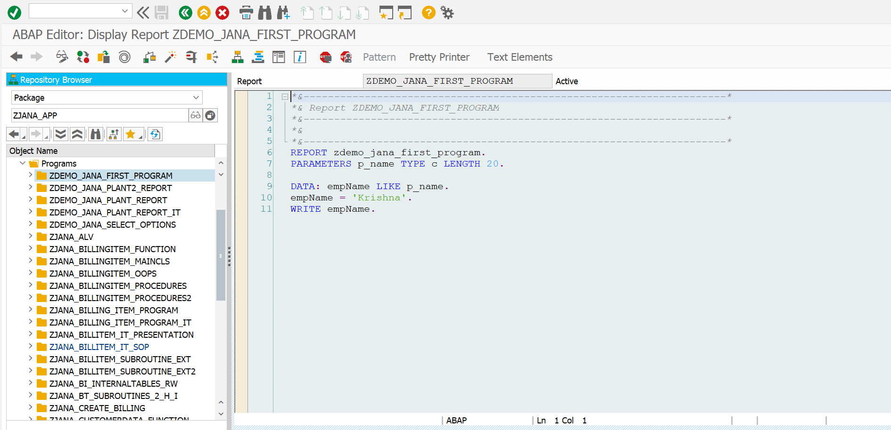

*\*&---------------------------------------------------------------------\**  
*\*& Report ZDEMO_JANA_FIRST_PROGRAM*  
*\*&---------------------------------------------------------------------\**  
*\*&*  
*\*&---------------------------------------------------------------------\**  
REPORT zdemo_jana_first_program.  
PARAMETERS p_name TYPE c LENGTH 20.  
  
DATA: empName LIKE p_name.  
empName = 'Krishna'.  
WRITE empName.

**Result:**

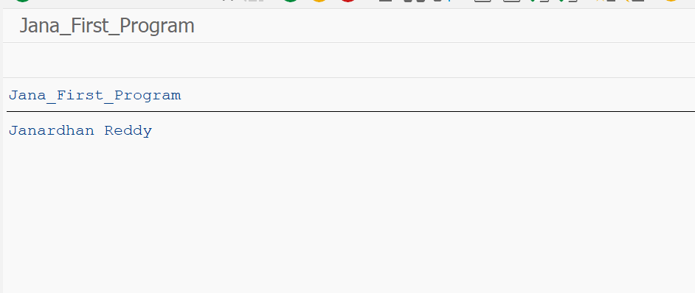

Program: ZDEMO_JANA_PLANT2_REPORT

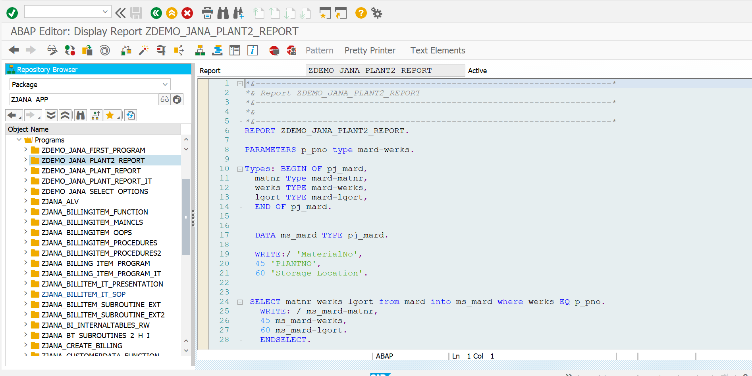

*\*&---------------------------------------------------------------------\**  
*\*& Report ZDEMO_JANA_PLANT2_REPORT*  
*\*&---------------------------------------------------------------------\**  
*\*&*  
*\*&---------------------------------------------------------------------\**  
REPORT ZDEMO_JANA_PLANT2_REPORT.  
  
PARAMETERS p_pno type mard-werks.  
  
Types: BEGIN OF pj_mard,  
 matnr Type mard-matnr,  
 werks TYPE mard-werks,  
 lgort TYPE mard-lgort,  
 END OF pj_mard.  
  
  
 DATA ms_mard TYPE pj_mard.  
  
 WRITE:/ 'MaterialNo',  
 45 'PlANTNO',  
 60 'Storage Location'.  
  
  
 SELECT matnr werks lgort from mard into ms_mard where werks EQ p_pno.  
 WRITE: / ms_mard-matnr,  
 45 ms_mard-werks,  
 60 ms_mard-lgort.  
 ENDSELECT.

**RESULT:**

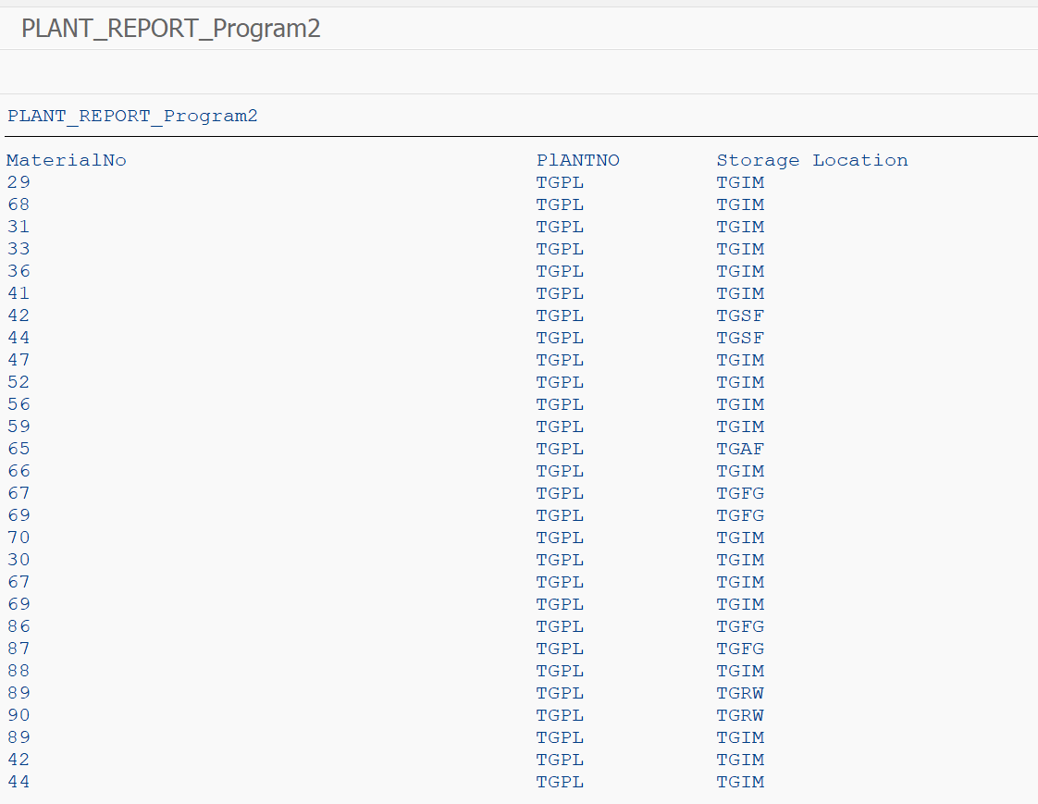

Program: ZDEMO_JANA_PLANT_REPORT

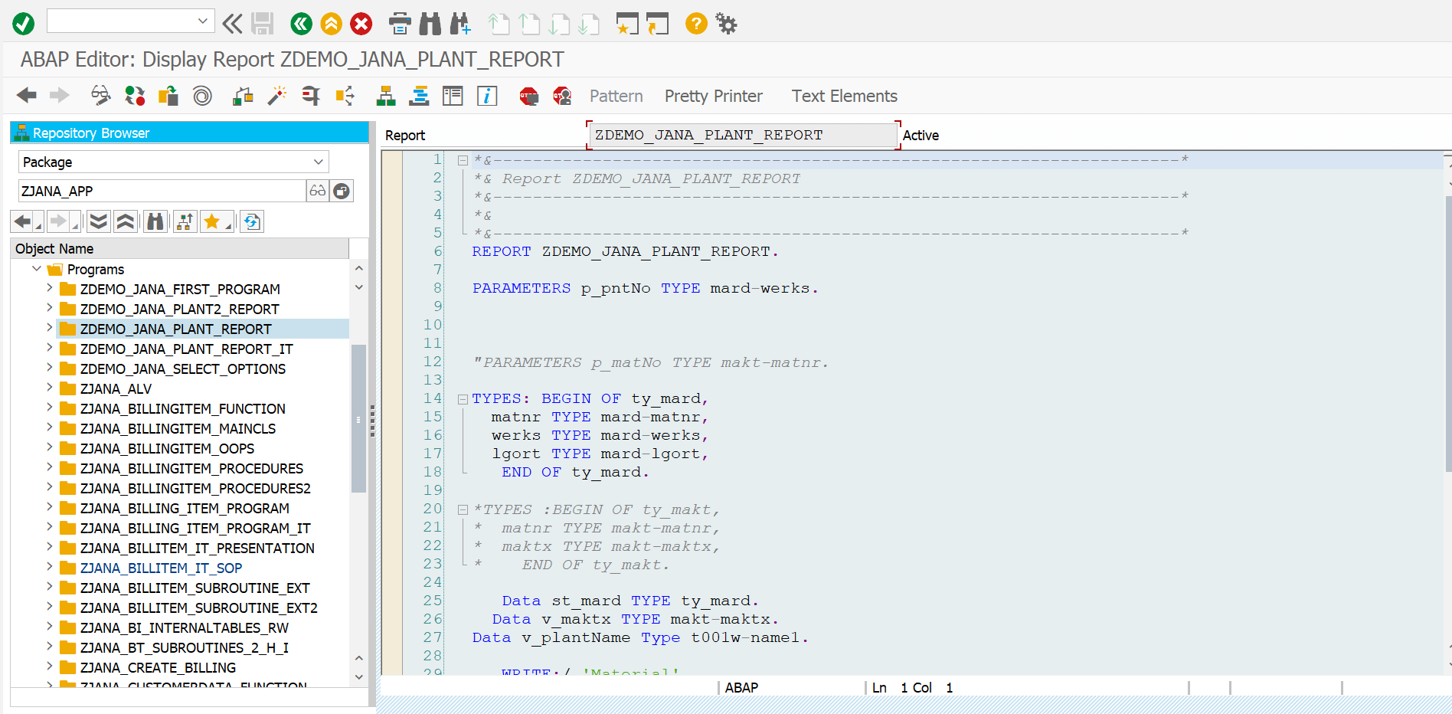

*\*&---------------------------------------------------------------------\**  
*\*& Report ZDEMO_JANA_PLANT_REPORT*  
*\*&---------------------------------------------------------------------\**  
*\*&*  
*\*&---------------------------------------------------------------------\**  
REPORT ZDEMO_JANA_PLANT_REPORT.  
  
PARAMETERS p_pntNo TYPE mard-werks.  
  
  
  
*"PARAMETERS p_matNo TYPE makt-matnr.*  
  
TYPES: BEGIN OF ty_mard,  
 matnr TYPE mard-matnr,  
 werks TYPE mard-werks,  
 lgort TYPE mard-lgort,  
 END OF ty_mard.  
  
*\*TYPES :BEGIN OF ty_makt,*  
*\* matnr TYPE makt-matnr,*  
*\* maktx TYPE makt-maktx,*  
*\* END OF ty_makt.*  
  
 Data st_mard TYPE ty_mard.  
 Data v_maktx TYPE makt-maktx.  
Data v_plantName Type t001w-name1.  
  
 WRITE:/ 'Material',  
 20 'MaterialDescription',  
 60 'PLANTNO',  
 80 'PLANTNAME',  
 100 'StorageLocation'.  
  
SELECT SINGLE name1 from t001w into v_plantName where werks EQ p_pntNo.  
 SELECT matnr werks lgort from mard INTO st_mard where werks EQ p_pntNo.  
 SELECT SINGLE maktx from makt into v_maktx where matnr EQ st_mard-matnr and spras EQ sy-langu.  
 write:/ st_mard-matnr,  
 20 v_maktx,  
 60 st_mard-werks,  
 80 v_plantName,  
 100 st_mard-lgort.  
 *" ENDSELECT.*  
 ENDSELECT.

Result:

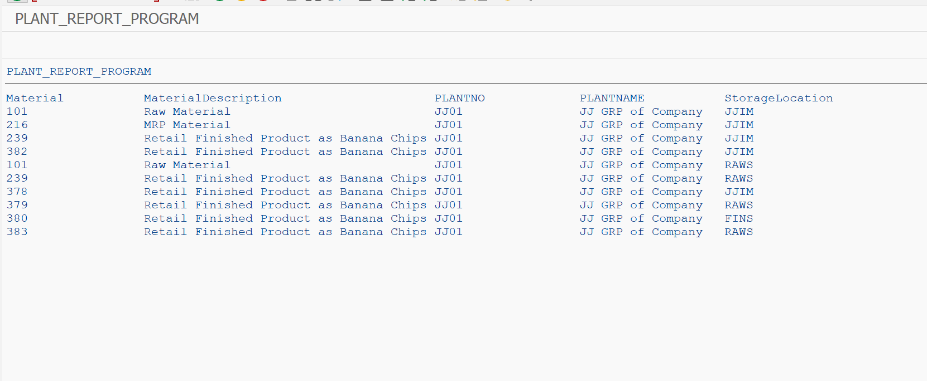

PROGRAM: ZDEMO_JANA_PLANT_REPORT_IT

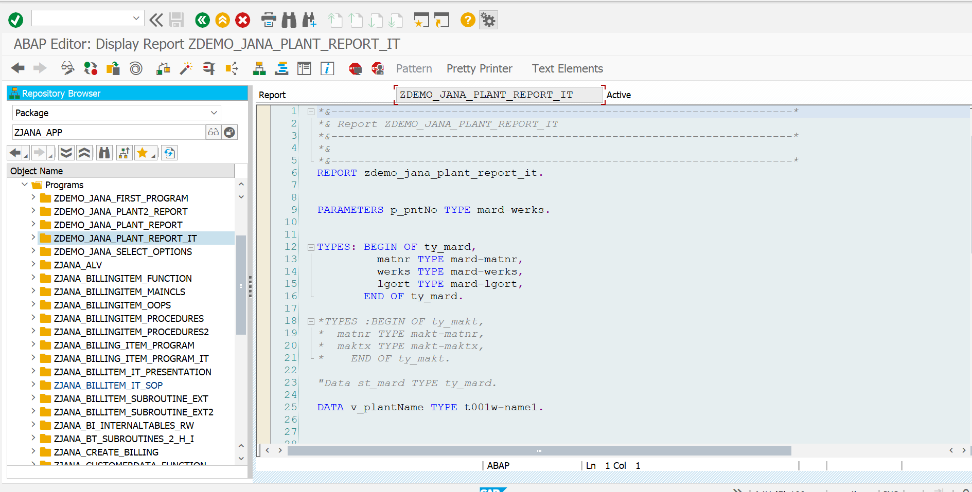

*\*&---------------------------------------------------------------------\**  
*\*& Report ZDEMO_JANA_PLANT_REPORT_IT*  
*\*&---------------------------------------------------------------------\**  
*\*&*  
*\*&---------------------------------------------------------------------\**  
REPORT zdemo_jana_plant_report_it.  
  
  
PARAMETERS p_pntNo TYPE mard-werks.  
  
  
TYPES: BEGIN OF ty_mard,  
 matnr TYPE mard-matnr,  
 werks TYPE mard-werks,  
 lgort TYPE mard-lgort,  
 END OF ty_mard.  
  
*\*TYPES :BEGIN OF ty_makt,*  
*\* matnr TYPE makt-matnr,*  
*\* maktx TYPE makt-maktx,*  
*\* END OF ty_makt.*  
  
*"Data st_mard TYPE ty_mard.*  
  
DATA v_plantName TYPE t001w-name1.  
  
  
  
TYPES: BEGIN OF ty_makt,  
 matnr TYPE makt-matnr,  
 maktx TYPE makt-maktx,  
 END OF ty_makt.  
  
  
DATA: it_mard TYPE TABLE OF ty_mard,  
 wa_mard LIKE LINE OF it_mard.  
  
  
DATA: it_makt TYPE TABLE OF ty_makt,  
 wa_makt LIKE LINE OF it_makt.  
  
  
WRITE:/ 'Material',  
20 'MaterialDescription',  
60 'PLANTNO',  
80 'PLANTNAME',  
100 'StorageLocation'.  
  
SELECT SINGLE name1 FROM t001w INTO v_plantName WHERE werks EQ p_pntNo.  
  
  
SELECT matnr werks lgort FROM mard INTO TABLE it_mard WHERE werks EQ p_pntNo.  
SELECT matnr maktx FROM makt INTO TABLE it_makt FOR ALL ENTRIES IN it_mard WHERE matnr EQ it_mard-matnr AND spras EQ sy-langu.  
  
LOOP AT it_mard INTO wa_mard.  
 READ TABLE it_makt INTO wa_makt WITH KEY matnr = wa_mard-matnr.  
 WRITE:/ wa_mard-matnr,  
 20 wa_makt-maktx,  
 60 wa_mard-werks,  
 80 v_plantName,  
 120 wa_mard-lgort.  
  
ENDLOOP.

**RESULT:**

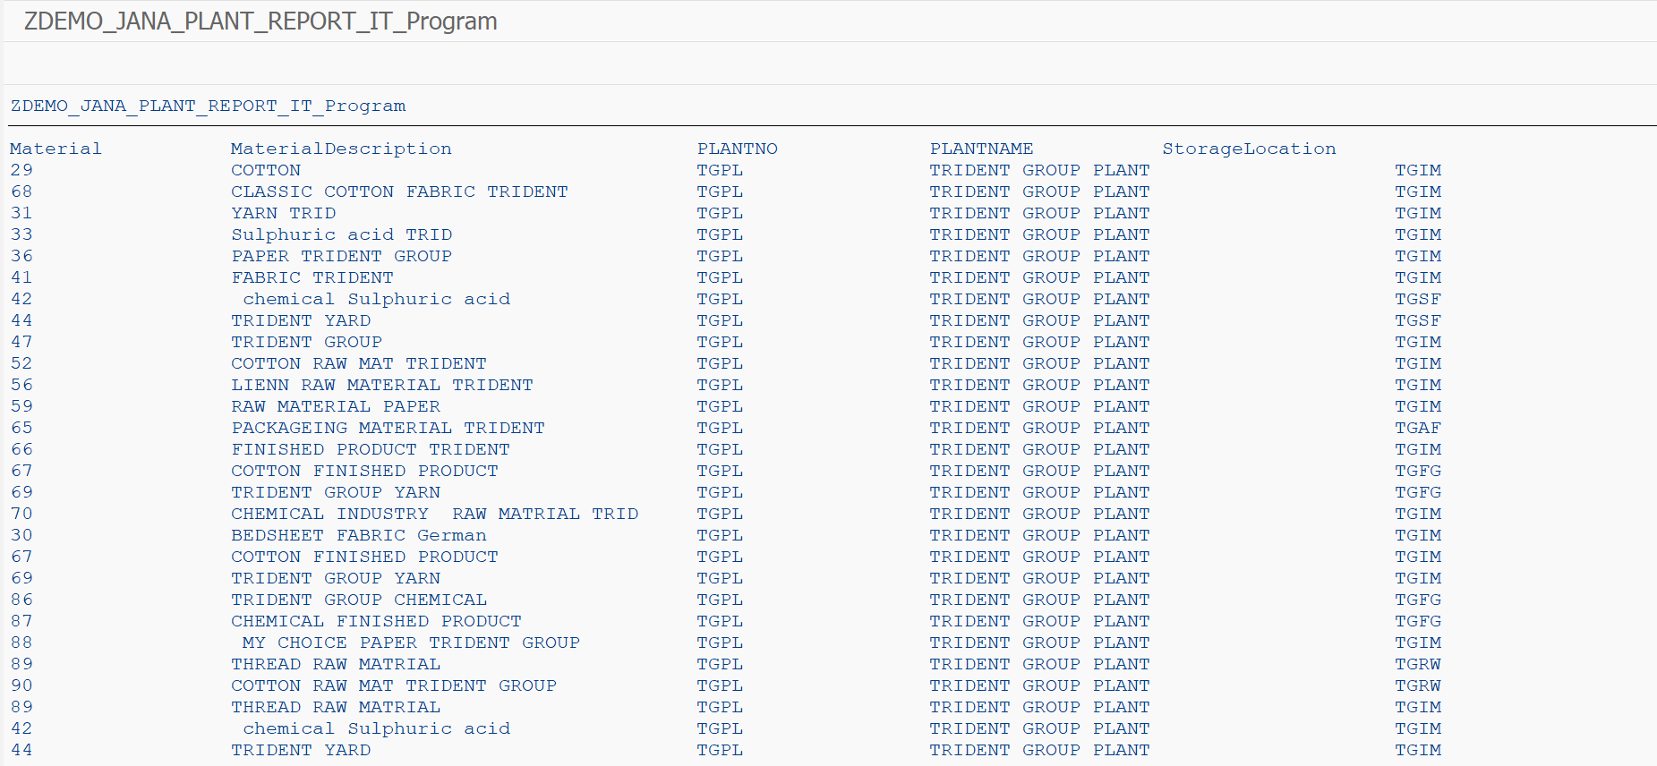

PROGRAM: ZDEMO_JANA_SELECT_OPTIONS

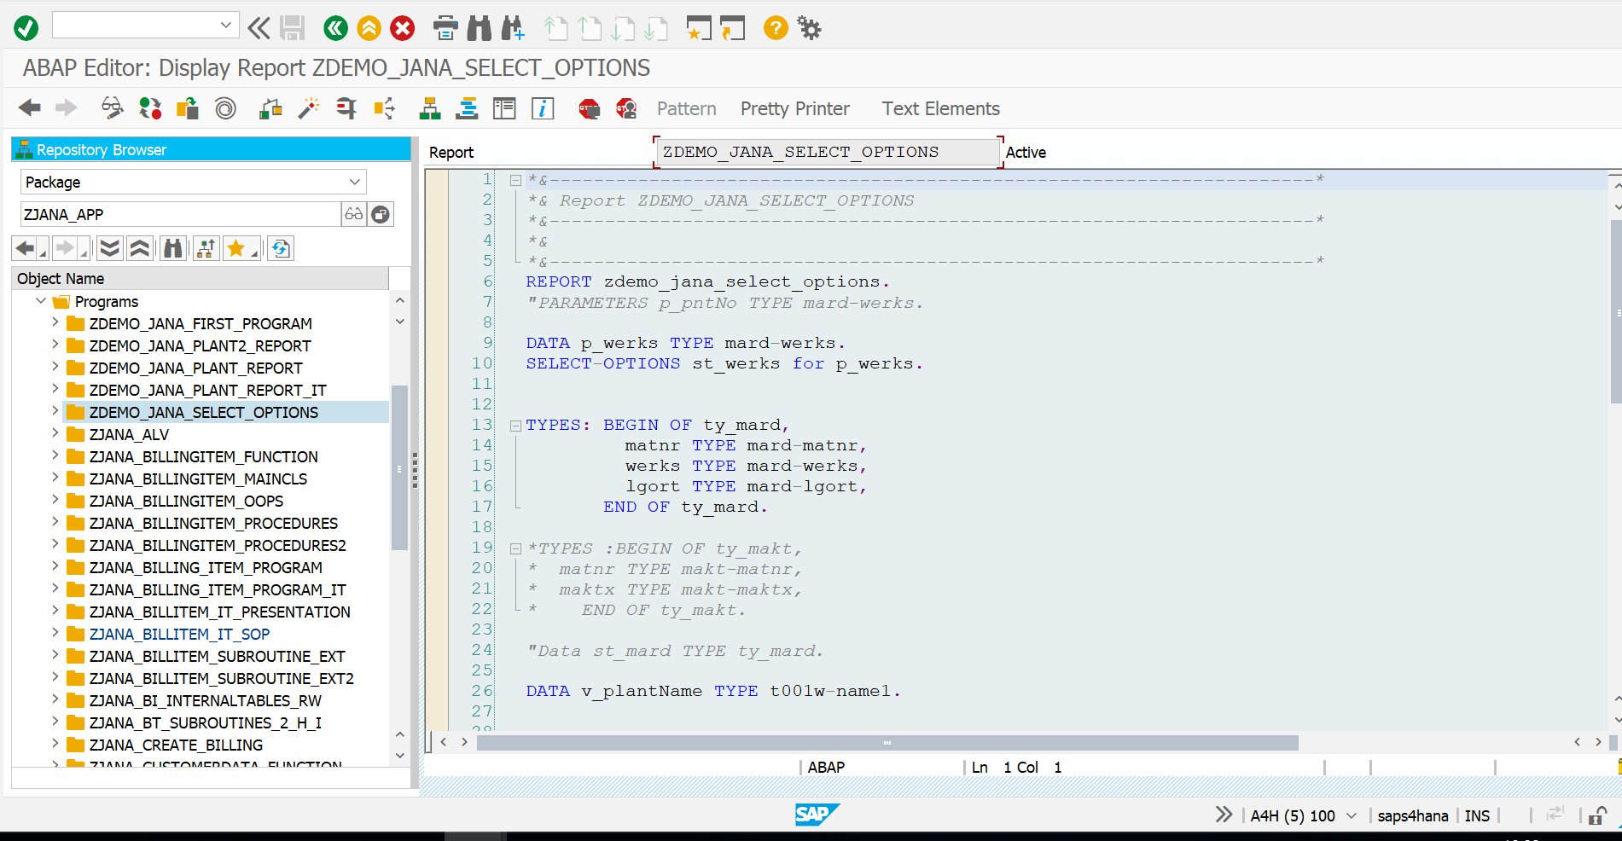

*\*&---------------------------------------------------------------------\**  
*\*& Report ZDEMO_JANA_SELECT_OPTIONS*  
*\*&---------------------------------------------------------------------\**  
*\*&*  
*\*&---------------------------------------------------------------------\**  
REPORT zdemo_jana_select_options.  
*"PARAMETERS p_pntNo TYPE mard-werks.*  
  
DATA p_werks TYPE mard-werks.  
SELECT-OPTIONS st_werks for p_werks.  
  
  
TYPES: BEGIN OF ty_mard,  
 matnr TYPE mard-matnr,  
 werks TYPE mard-werks,  
 lgort TYPE mard-lgort,  
 END OF ty_mard.  
  
*\*TYPES :BEGIN OF ty_makt,*  
*\* matnr TYPE makt-matnr,*  
*\* maktx TYPE makt-maktx,*  
*\* END OF ty_makt.*  
  
*"Data st_mard TYPE ty_mard.*  
  
DATA v_plantName TYPE t001w-name1.  
  
  
  
TYPES: BEGIN OF ty_makt,  
 matnr TYPE makt-matnr,  
 maktx TYPE makt-maktx,  
 END OF ty_makt.  
  
  
DATA: it_mard TYPE TABLE OF ty_mard,  
 wa_mard LIKE LINE OF it_mard.  
  
  
DATA: it_makt TYPE TABLE OF ty_makt,  
 wa_makt LIKE LINE OF it_makt.  
  
  
WRITE:/ 'Material',  
20 'MaterialDescription',  
60 'PLANTNO',  
80 'PLANTNAME',  
100 'StorageLocation'.  
  
SELECT SINGLE name1 FROM t001w INTO v_plantName WHERE werks in st_werks[].  
SELECT matnr werks lgort FROM mard INTO TABLE it_mard WHERE werks in st_werks[].  
IF it_mard IS NOT INITIAL.  
  
 SELECT matnr maktx FROM makt INTO TABLE it_makt FOR ALL ENTRIES IN it_mard WHERE matnr EQ it_mard-matnr AND spras EQ sy-langu.  
  
ENDIF.  
  
  
LOOP AT it_mard INTO wa_mard.  
 READ TABLE it_makt INTO wa_makt WITH KEY matnr = wa_mard-matnr.  
 WRITE:/ wa_mard-matnr,  
 20 wa_makt-maktx,  
 60 wa_mard-werks,  
 80 v_plantName,  
 120 wa_mard-lgort.  
  
ENDLOOP.

**RESULT:**

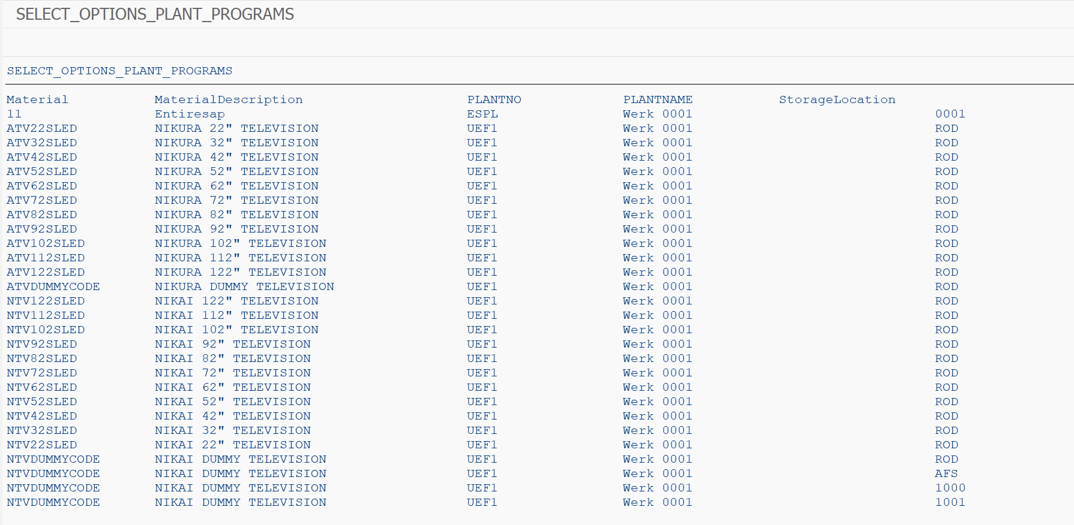

Program: ZJANA_BILLINGITEM_FUNCTION

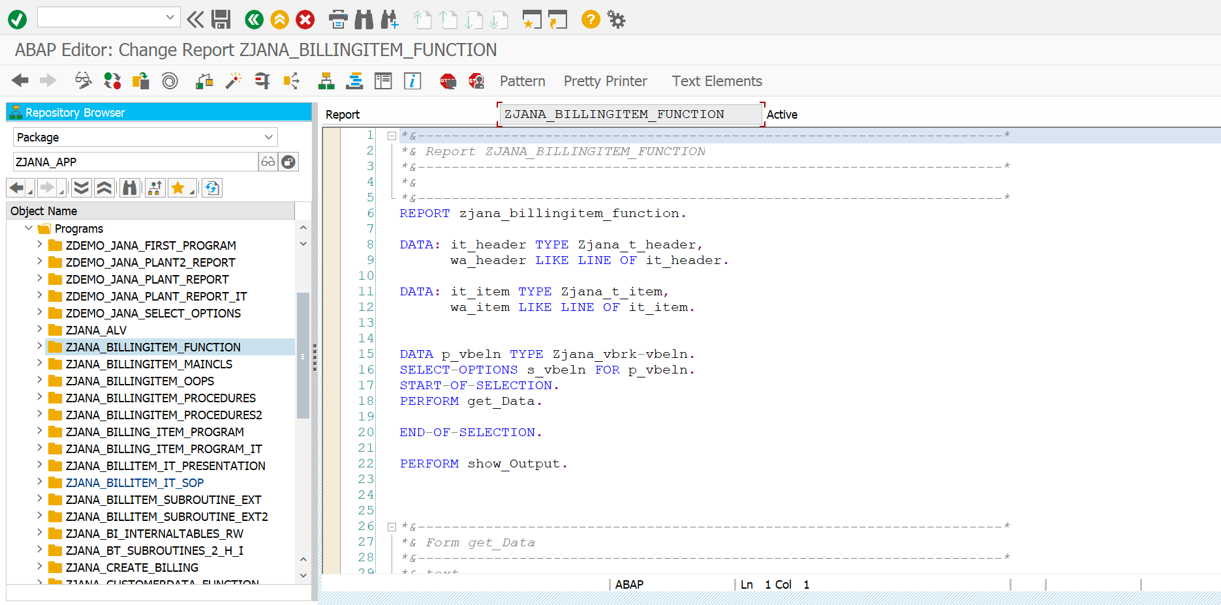

*\*&---------------------------------------------------------------------\**  
*\*& Report ZJANA_BILLINGITEM_FUNCTION*  
*\*&---------------------------------------------------------------------\**  
*\*&*  
*\*&---------------------------------------------------------------------\**  
REPORT zjana_billingitem_function.  
  
DATA: it_header TYPE Zjana_t_header,  
 wa_header LIKE LINE OF it_header.  
  
DATA: it_item TYPE Zjana_t_item,  
 wa_item LIKE LINE OF it_item.  
  
  
DATA p_vbeln TYPE Zjana_vbrk-vbeln.  
SELECT-OPTIONS s_vbeln FOR p_vbeln.  
START-OF-SELECTION.  
PERFORM get_Data.  
  
END-OF-SELECTION.  
  
PERFORM show_Output.  
  
  
  
*\*&---------------------------------------------------------------------\**  
*\*& Form get_Data*  
*\*&---------------------------------------------------------------------\**  
*\*& text*  
*\*&---------------------------------------------------------------------\**  
*\*& --> p1 text*  
*\*& <-- p2 text*  
*\*&---------------------------------------------------------------------\**  
  
  
  
FORM get_data .  
  
 CALL FUNCTION 'ZJANA_FM'  
 EXPORTING  
 im_vbeln = s_vbeln[]  
 IMPORTING  
 EX_HEADER = it_header  
 EX_ITEM = it_item.  
ENDFORM.  
  
 .  
  
  
  
*\*&---------------------------------------------------------------------\**  
*\*& Form show_Output*  
*\*&---------------------------------------------------------------------\**  
*\*& text*  
*\*&---------------------------------------------------------------------\**  
*\*& --> p1 text*  
*\*& <-- p2 text*  
*\*&---------------------------------------------------------------------\**  
Form show_Output.  
  
CALL FUNCTION 'ZJANA_SHOW_OUTPUT'.  
*\*EXPORTING*  
*\* it_header = EX_HEADER*  
*\* it_item = EX_ITEM*  
  
  
ENDFORM.

**RESULT:**

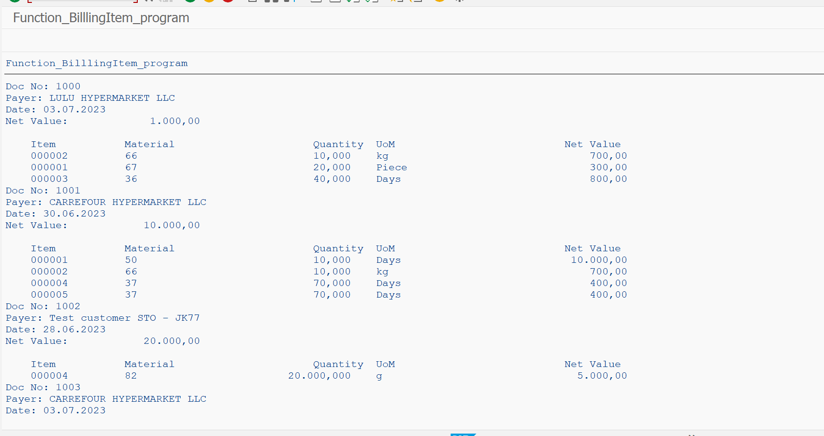

Program: ZJANA_BILLINGITEM_OOPS

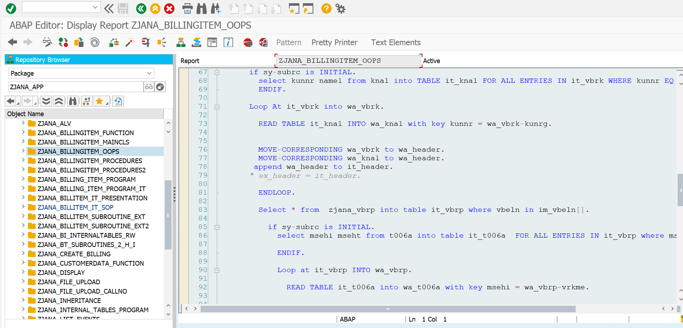

*\*&---------------------------------------------------------------------\**  
*\*& Report ZJANA_BILLINGITEM_OOPS*  
*\*&---------------------------------------------------------------------\**  
*\*&*  
*\*&---------------------------------------------------------------------\**  
REPORT zjana_billingitem_oops.  
DATA p_vbeln TYPE zjana_vbrk-vbeln.  
SELECT-OPTIONS s_vbeln FOR p_vbeln.  
  
CLASS BillingItem_oops DEFINITION.  
 PUBLIC SECTION.  
  
  
 METHODS get_data IMPORTING im_vbeln TYPE zjana_t_range.  
  
  
 Methods display_Result.  
  
  
 PRIVATE SECTION.  
 DATA it_header TYPE zjana_t_header.  
 DATA wa_header LIKE LINE OF it_header.  
  
 DATA it_item TYPE zjana_t_item.  
 DATA wa_item LIKE LINE OF it_item.  
  
  
 TYPES:BEGIN OF ty_kna1,  
 kunnr TYPE kna1-kunnr,  
 name1 TYPE kna1-name1,  
 END OF ty_kna1.  
  
 DATA: it_vbrk TYPE TABLE OF zjana_vbrk,  
 wa_vbrk LIKE LINE OF it_vbrk.  
 DATA: it_kna1 TYPE TABLE OF ty_kna1,  
 wa_kna1 LIKE LINE OF it_kna1.  
  
 TYPES: BEGIN OF ty_t006a,  
 msehi TYPE t006a-msehi,  
 mseht TYPE t006a-mseht,  
 END OF ty_t006a.  
  
  
  
 DATA: it_vbrp TYPE TABLE OF zjana_vbrp,  
 wa_vbrp LIKE LINE OF it_vbrp.  
 DATA: it_t006a TYPE STANDARD TABLE OF ty_t006a,  
 wa_t006a LIKE LINE OF it_t006a.  
  
  
ENDCLASS.  
*\**  
*\*SELECTION-SCREEN BEGIN OF BLOCK b1 WITH FRAME TITLE text-001.*  
*\* SELECT-OPTIONS s_vbeln FOR p_vbeln MEMORY ID vbe.*  
*\**  
*\*SELECTION-SCREEN END OF BLOCK b1.*  
  
  
CLASS billingitem_oops IMPLEMENTATION.  
  
  
  
 METHOD get_data.  
  
 select * FROM zjana_vbrk into table it_vbrk where vbeln in im_vbeln[].  
  
 if sy-subrc is INITIAL.  
 select kunnr name1 from kna1 into TABLE it_kna1 FOR ALL ENTRIES IN it_vbrk WHERE kunnr EQ it_vbrk-kunrg.  
 ENDIF.  
  
 Loop At it_vbrk into wa_vbrk.  
  
 READ TABLE it_kna1 INTO wa_kna1 with key kunnr = wa_vbrk-kunrg.  
  
  
 MOVE-CORRESPONDING wa_vbrk to wa_header.  
 MOVE-CORRESPONDING wa_kna1 to wa_header.  
 append wa_header to it_header.  
 *" ex_header = it_header.*  
  
 ENDLOOP.  
  
 Select * from zjana_vbrp into table it_vbrp where vbeln in im_vbeln[].  
  
 if sy-subrc is INITIAL.  
 select msehi mseht from t006a into table it_t006a FOR ALL ENTRIES IN it_vbrp where msehi = it_vbrp-vrkme.  
  
 ENDIF.  
  
 Loop at it_vbrp INTO wa_vbrp.  
  
 READ TABLE it_t006a into wa_t006a with key msehi = wa_vbrp-vrkme.  
  
  
 MOVE-CORRESPONDING wa_vbrp to wa_item.  
 MOVE-CORRESPONDING wa_t006a to wa_item.  
  
  
 APPEND wa_item to it_item.  
 *" ex_item = it_item.*  
  
 ENDLOOP.  
  
  
  
 ENDMETHOD.  
  
 METHOD display_Result.  
  
 Sort it_item by vbeln.  
  
 Loop At it_item INTO wa_item.  
  
 AT NEW vbeln.  
 READ TABLE it_header into wa_header with key vbeln = wa_vbrp-vbeln.  
  
 Write: /'DocumentNo:',wa_header-vbeln.  
 Write:/'payer name:',wa_header-name1.  
 write:/'Date:',wa_header-fkdat.  
 write:/'net value:',wa_header-netwr.  
 WRITE : /5 'Item',  
 20 'Material',  
 50 'Quantity',  
 60 'UoM',  
 90 'Net Value'.  
 ENDAT.  
  
  
  
 WRITE : /5 wa_item-posnr,  
 20 wa_item-matnr,  
 40 wa_item-fkimg,  
 60 wa_item-mseht,  
 80 wa_item-netwr.  
  
  
 ENDLOOP.  
  
 ENDMETHOD.  
  
  
ENDCLASS.  
  
DATA O_billingItem_OOPS type REF TO billingitem_oops.  
  
  
START-OF-SELECTION.  
create OBJECT o_billingitem_oops.  
  
o_billingitem_oops->get_data(  
EXPORTING im_vbeln = s_vbeln[]  
).  
  
o_billingItem_oops->display_Result( ).

**RESULT:**

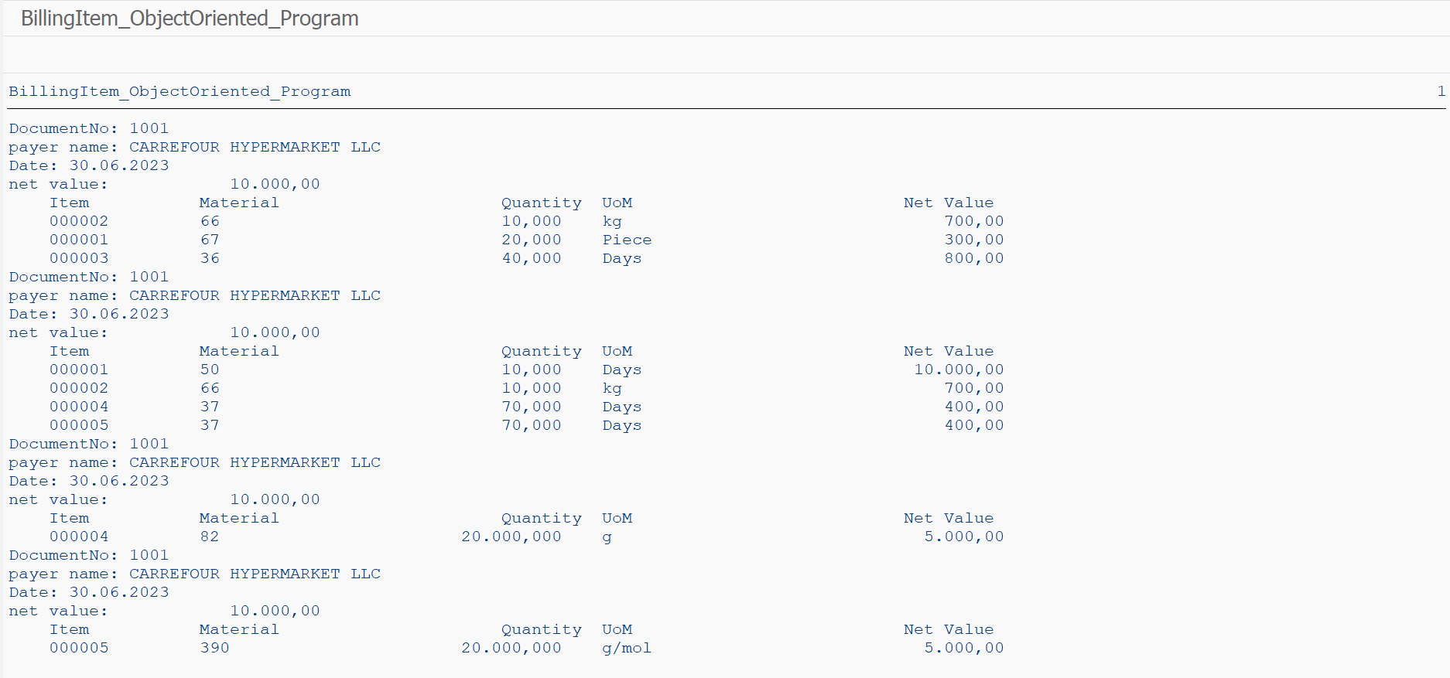

Program: ZJANA_BILLINGITEM_PROCEDURES

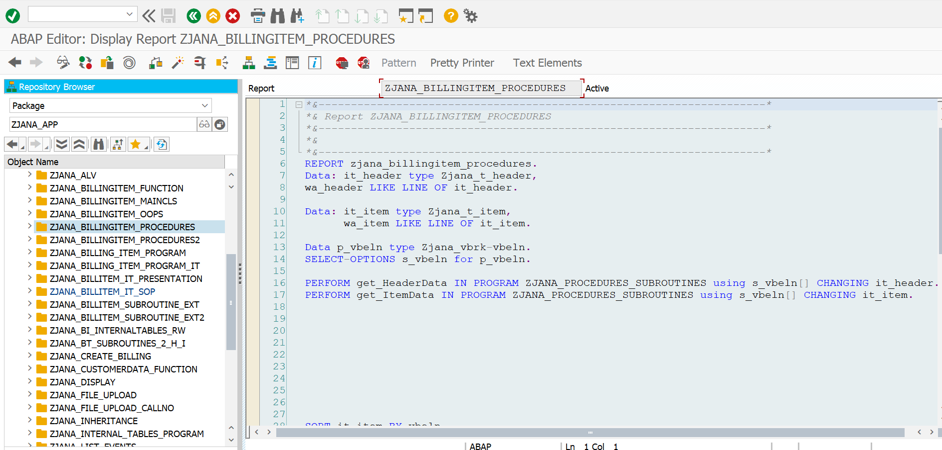

*\*&---------------------------------------------------------------------\**  
*\*& Report ZJANA_BILLINGITEM_PROCEDURES*  
*\*&---------------------------------------------------------------------\**  
*\*&*  
*\*&---------------------------------------------------------------------\**  
REPORT zjana_billingitem_procedures.  
Data: it_header type Zjana_t_header,  
wa_header LIKE LINE OF it_header.  
  
Data: it_item type Zjana_t_item,  
 wa_item LIKE LINE OF it_item.  
  
Data p_vbeln type Zjana_vbrk-vbeln.  
SELECT-OPTIONS s_vbeln for p_vbeln.  
  
PERFORM get_HeaderData IN PROGRAM ZJANA_PROCEDURES_SUBROUTINES using s_vbeln[] CHANGING it_header.  
PERFORM get_ItemData IN PROGRAM ZJANA_PROCEDURES_SUBROUTINES using s_vbeln[] CHANGING it_item.  
  
  
SORT it_item BY vbeln.  
  
loop At it_item INTO wa_item.  
AT new vbeln.  
 READ TABLE it_header INTO wa_header WITH KEY vbeln = wa_item-vbeln.  
 WRITE : / 'Doc No:', wa_header-vbeln,  
 / 'Payer:', wa_header-name1,  
 / 'Date:', wa_header-fkdat,  
 / 'Net Value:', wa_header-netwr.  
 SKIP.  
  
  
  
 WRITE : /5 'Item',  
 20 'Material',  
 50 'Quantity',  
 60 'UoM',  
 90 'Net Value'.  
  
 endat.  
 WRITE : /5 wa_item-posnr,  
 20 wa_item-matnr,  
 40 wa_item-fkimg,  
 60 wa_item-mseht,  
 80 wa_item-netwr.  
ENDLOOP.  
  
  
  
 *"READ TABLE it_t006a INTO wa_t006a WITH KEY msehi = wa_vbrp-vrkme.*

**RESULT:**

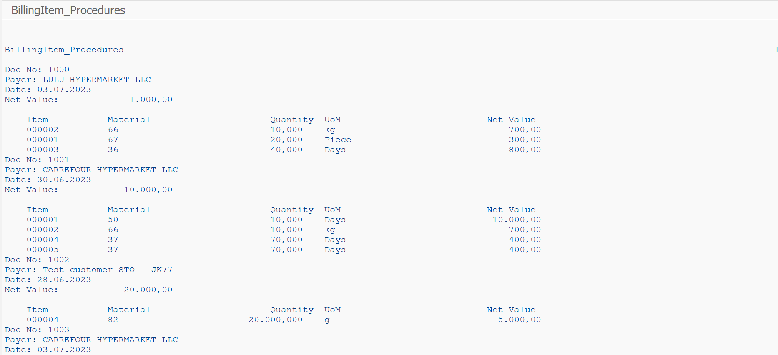

**Program: ZJANA_BILLINGITEM_PROCEDURES2**

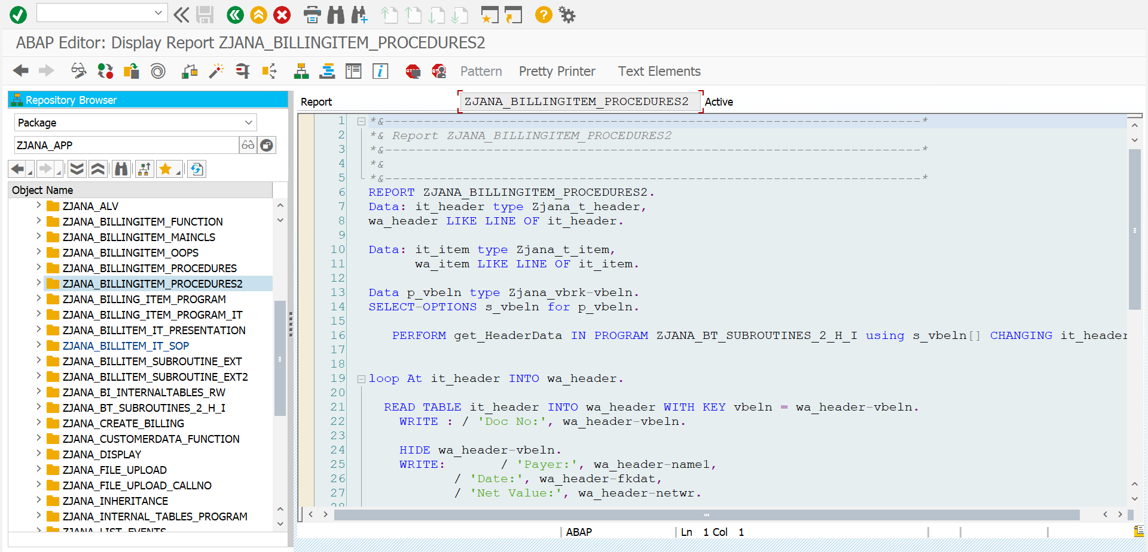

*\*&---------------------------------------------------------------------\**  
*\*& Report ZJANA_BILLINGITEM_PROCEDURES2*  
*\*&---------------------------------------------------------------------\**  
*\*&*  
*\*&---------------------------------------------------------------------\**  
REPORT ZJANA_BILLINGITEM_PROCEDURES2.  
Data: it_header type Zjana_t_header,  
wa_header LIKE LINE OF it_header.  
  
Data: it_item type Zjana_t_item,  
 wa_item LIKE LINE OF it_item.  
  
Data p_vbeln type Zjana_vbrk-vbeln.  
SELECT-OPTIONS s_vbeln for p_vbeln.  
  
 PERFORM get_HeaderData IN PROGRAM ZJANA_BT_SUBROUTINES_2_H_I using s_vbeln[] CHANGING it_header.  
  
  
loop At it_header INTO wa_header.  
  
 READ TABLE it_header INTO wa_header WITH KEY vbeln = wa_header-vbeln.  
 WRITE : / 'Doc No:', wa_header-vbeln.  
  
 HIDE wa_header-vbeln.  
 WRITE: / 'Payer:', wa_header-name1,  
 / 'Date:', wa_header-fkdat,  
 / 'Net Value:', wa_header-netwr.  
  
 SKIP.  
 clear wa_header.  
  
  
ENDLOOP.  
clear wa_header.  
  
AT LINE-SELECTION.  
 *"Read LINE sy-lilli.*  
PERFORM get_ItemData IN PROGRAM ZJANA_BT_SUBROUTINES_2_H_I using wa_header-vbeln CHANGING it_item.  
WRITE : /5 'Item',  
 20 'Material',  
 50 'Quantity',  
 60 'UoM',  
 90 'Net Value'.  
LOOP AT it_item INTO wa_item where vbeln EQ wa_header-vbeln.  
  
 WRITE : /5 wa_item-posnr,  
 20 wa_item-matnr,  
 40 wa_item-fkimg,  
 60 wa_item-mseht,  
 80 wa_item-netwr.  
  
 CLEAR wa_item.  
 ENDLOOP.  
 CLEAR wa_item.

**RESULT:**

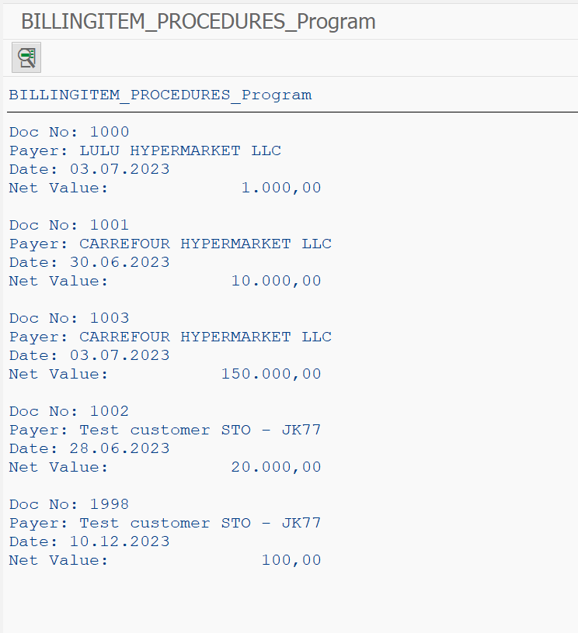

Program: ZJANA_BILLING_ITEM_PROGRAM_IT

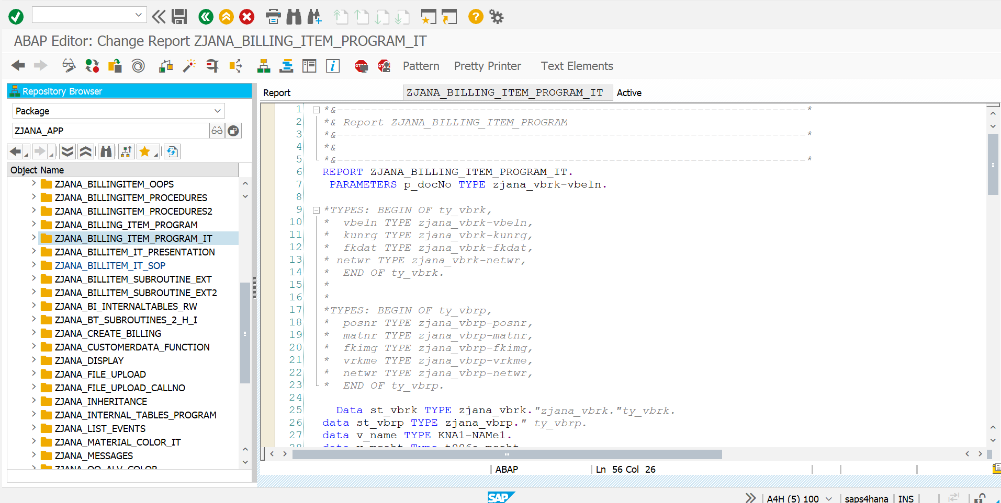

*\*&---------------------------------------------------------------------\**  
*\*& Report ZJANA_BILLING_ITEM_PROGRAM*  
*\*&---------------------------------------------------------------------\**  
*\*&*  
*\*&---------------------------------------------------------------------\**  
REPORT zjana_billing_item_program_it.  
PARAMETERS p_docNo TYPE zjana_vbrk-vbeln.  
  
*\*TYPES: BEGIN OF ty_vbrk,*  
*\* vbeln TYPE zjana_vbrk-vbeln,*  
*\* kunrg TYPE zjana_vbrk-kunrg,*  
*\* fkdat TYPE zjana_vbrk-fkdat,*  
*\* netwr TYPE zjana_vbrk-netwr,*  
*\* END OF ty_vbrk.*  
*\**  
*\**  
*\*TYPES: BEGIN OF ty_vbrp,*  
*\* posnr TYPE zjana_vbrp-posnr,*  
*\* matnr TYPE zjana_vbrp-matnr,*  
*\* fkimg TYPE zjana_vbrp-fkimg,*  
*\* vrkme TYPE zjana_vbrp-vrkme,*  
*\* netwr TYPE zjana_vbrp-netwr,*  
*\* END OF ty_vbrp.*  
  
DATA st_vbrk TYPE zjana_vbrk.*"zjana_vbrk."ty_vbrk.*  
DATA st_vbrp TYPE zjana_vbrp.*" ty_vbrp.*  
DATA v_name TYPE kna1-NAMe1.  
DATA v_mseht TYPE t006a-mseht.  
  
TYPES: BEGIN OF ty_t006a,  
 msehi TYPE t006a-msehi,  
 mseht TYPE t006a-mseht,  
 END OF ty_t006a.  
  
  
DATA: it_zjana_vbrp TYPE TABLE OF zjana_vbrp,  
 wa_zjana_vbrp LIKE LINE OF it_zjana_vbrp.  
  
DATA: it_zjana_vbrk TYPE TABLE OF zjana_vbrk,  
 wa_zjana_vbrk LIKE LINE OF it_zjana_vbrk.  
  
DATA: it_t006a TYPE TABLE OF ty_t006a,  
 wa_t006a LIKE LINE OF it_t006a.  
  
  
  
*\*DATA v_name TYPE c LENGTH 10.*  
DATA(v_name1) = 'kiran'.  
v_name1 = 'KiranBandari'.  
  
SELECT SINGLE vbeln, kunrg, fkdat, netwr FROM zjana_vbrk INTO @DATA(st_vbrk1) WHERE vbeln EQ @p_docNo.  
  
*\* SELECT SINGLE vbeln kunrg fkdat netwr from zjana_vbrk into st_vbrk where vbeln EQ p_docNo.*  
SELECT SINGLE name1 FROM kna1 INTO v_name WHERE kunnr EQ st_vbrk-kunrg.  
  
  
WRITE:'Document No:',st_vbrk1-vbeln.  
WRITE:/'Payer_NAMe:',v_name.  
WRITE:/'Date:',st_vbrk1-fkdat.  
WRITE:/'Net value:',st_vbrk1-netwr.  
  
  
*\*SELECT SINGLE vbeln kunrg fkdat netwr from zjana_vbrk INTO TABLE it_zjana_vbrk where vbeln EQ p_docNo.*  
*\* SELECT SINGLE name1 from kna1 into v_name WHERE kunnr EQ st_vbrk-kunrg.*  
*\* LOOP AT it_zjana_vbrk into wa_zjana_vbrk.*  
*\* "WRITE: / wa_vbrk-vbeln,wa_vbrk-kunrg, wa_vbrk-fkdat, wa_vbrk-netwr.*  
*\**  
*\* WRITE: / 'Document No:',wa_zjana_vbrk-vbeln.*  
*\* WRITE:/'Payer_NAMe:',wa_zjana_vbrk-kunrg.*  
*\* WRITE:/'Date:',wa_zjana_vbrk-fkdat.*  
*\* WRITE:/'NetWorth:',wa_zjana_vbrk-netwr.*  
*\* ENDSELECT.*  
  
  
  
  
  
*\* WRITE:/'ITEM',*  
*\* 20 'MATERIAL',*  
*\* 40 'QTY',*  
*\* 60 'UOM',*  
*\* 80 'NETVALUE'.*  
*\* select * from zjana_vbrp into st_vbrp where vbeln EQ p_docNo.*  
*\* Select SINGLE mseht from t006a into v_mseht where spras eq sy-langu and msehi EQ st_vbrp-vrkme.*  
*\* Write:/ st_vbrp-posnr,*  
*\* 20 st_vbrp-matnr,*  
*\* 40 st_vbrp-fkimg LEFT-JUSTIFIED,*  
*\* 60 v_mseht LEFT-JUSTIFIED,*  
*\* 80 st_vbrp-netwr LEFT-JUSTIFIED.*  
*\* ENDSELECT.*  
  
  
  
  
WRITE:/'ITEM',  
20 'MATERIAL',  
40 'QTY',  
60 'UOM',  
80 'NETVALUE'.  
SELECT * FROM zjana_vbrp INTO TABLE it_zjana_vbrp WHERE vbeln EQ p_docNo.  
SELECT msehi mseht FROM t006a INTO TABLE it_t006a FOR ALL ENTRIES IN it_zjana_vbrp WHERE spras EQ sy-langu AND msehi EQ it_zjana_vbrp-vrkme.  
LOOP AT it_zjana_vbrp INTO wa_zjana_vbrp.  
 READ TABLE it_t006a INTO wa_t006a WITH KEY msehi = wa_zjana_vbrp-vrkme.  
  
 WRITE:/ wa_zjana_vbrp-posnr,  
 20 wa_zjana_vbrp-matnr,  
 40 wa_zjana_vbrp-fkimg LEFT-JUSTIFIED,  
 60 wa_t006a-mseht LEFT-JUSTIFIED,  
 80 wa_zjana_vbrp-netwr LEFT-JUSTIFIED.  
ENDLOOP.

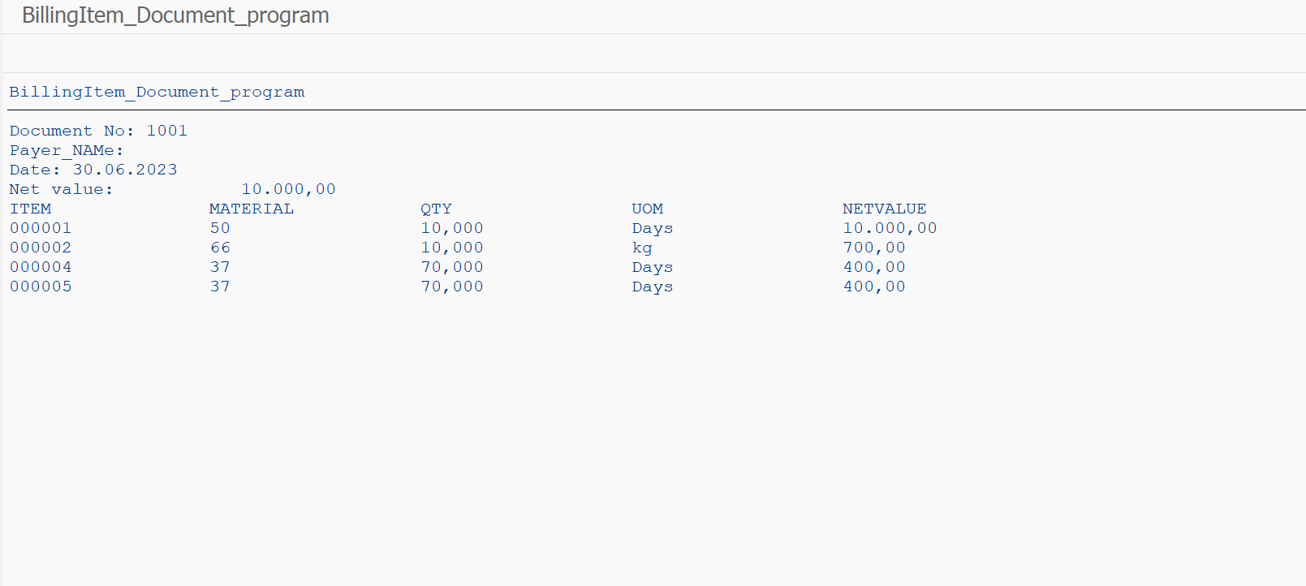

Program: ZJANA_BILLITEM_IT_PRESENTATION

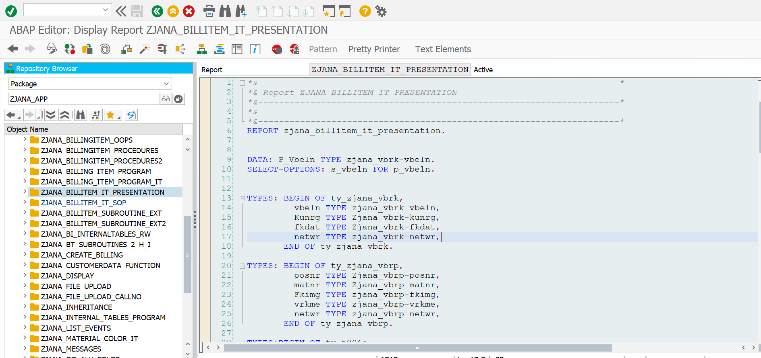

*\*&---------------------------------------------------------------------\**  
*\*& Report ZJANA_BILLITEM_IT_PRESENTATION*  
*\*&---------------------------------------------------------------------\**  
*\*&*  
*\*&---------------------------------------------------------------------\**  
REPORT zjana_billitem_it_presentation.  
  
  
DATA: P_Vbeln TYPE zjana_vbrk-vbeln.  
SELECT-OPTIONS: s_vbeln FOR p_vbeln.  
  
  
TYPES: BEGIN OF ty_zjana_vbrk,  
 vbeln TYPE zjana_vbrk-vbeln,  
 Kunrg TYPE Zjana_vbrk-kunrg,  
 fkdat TYPE Zjana_vbrk-fkdat,  
 netwr TYPE zjana_vbrk-netwr,  
 END OF ty_zjana_vbrk.  
  
TYPES: BEGIN OF ty_zjana_vbrp,  
 posnr TYPE Zjana_vbrp-posnr,  
 matnr TYPE Zjana_vbrp-matnr,  
 Fkimg TYPE zjana_vbrp-fkimg,  
 vrkme TYPE zjana_vbrp-vrkme,  
 netwr TYPE zjana_vbrp-netwr,  
 END OF ty_zjana_vbrp.  
  
TYPES:BEGIN OF ty_t006a,  
 msehi TYPE t006a-msehi,  
 mseht TYPE t006a-mseht,  
 END OF ty_t006a.  
  
TYPES:BEGIN OF ty_kna1,  
 kunnr TYPE kna1-kunnr,  
 name1 TYPE kna1-name1,  
 END OF ty_kna1.  
  
  
  
DATA: it_vbrk TYPE TABLE OF zjana_vbrk,  
 wa_vbrk LIKE LINE OF it_vbrk,  
 it_vbrp TYPE TABLE OF zjana_vbrp,  
 wa_vbrp LIKE LINE OF it_vbrp,  
 it_t006a TYPE TABLE OF ty_t006a,  
 wa_t006a LIKE LINE OF it_t006a,  
  
 it_kna1 TYPE TABLE OF ty_kna1,  
 wa_kna1 LIKE LINE OF it_kna1.  
  
  
SELECT * FROM zjana_vbrk INTO TABLE it_vbrk WHERE vbeln IN s_vbeln.  
SELECT * FROM zjana_vbrp INTO TABLE it_vbrp WHERE vbeln IN s_vbeln.  
SELECT msehi mseht FROM t006a INTO TABLE it_t006a FOR ALL ENTRIES IN it_vbrp WHERE msehi EQ it_vbrp-vrkme AND spras EQ sy-langu.  
SELECT kunnr name1 FROM kna1 INTO TABLE it_kna1 FOR ALL ENTRIES IN it_vbrk WHERE kunnr EQ it_vbrk-Kunrg.  
SORT it_vbrp BY vbeln.  
  
LOOP AT it_vbrp INTO wa_vbrp.  
 READ TABLE it_t006a INTO wa_t006a WITH KEY msehi = wa_vbrp-vrkme.  
  
  
 AT FIRST.  
  
 *"this code will be executed only in the first loop pass*  
  
 WRITE:/'The Billing Item Document Report'.  
SKIP.  
 ENDAT.  
  
  
 AT NEW vbeln.  
 *"this code will be executed if the value of the field vbeln is differed from the previous loop pass.*  
  
 READ TABLE it_vbrk INTO wa_vbrk WITH KEY vbeln = wa_vbrp-vbeln.  
 READ TABLE it_kna1 INTO wa_kna1 WITH KEY kunnr = wa_vbrk-kunrg.  
  
 WRITE AT: /5 'Billing Document:' LEFT-JUSTIFIED.  
 WRITE AT: 30 wa_vbrk-vbeln LEFT-JUSTIFIED COLOR 2.  
 WRITE AT:/5'payer name:' LEFT-JUSTIFIED.  
 WRITE AT: 30 wa_kna1-name1 LEFT-JUSTIFIED COLOR 3.  
 WRITE AT:/5'date:' LEFT-JUSTIFIED.  
 WRITE AT: 30 wa_vbrk-fkdat LEFT-JUSTIFIED COLOR 5.  
 WRITE AT:/5'Net value:' LEFT-JUSTIFIED.  
 WRITE AT: 30 wa_vbrk-netwr LEFT-JUSTIFIED COLOR 6.  
  
 SKIP.  
 WRITE AT:/5 'Item No',  
 20 'Material No',  
 40 'Qunatity',  
 60 'UOM',  
 80 'Net Value'.  
 ENDAT.  
  
 WRITE AT:/5 wa_vbrp-posnr LEFT-JUSTIFIED,  
 20 wa_vbrp-matnr LEFT-JUSTIFIED,  
 40 wa_vbrp-fkimg LEFT-JUSTIFIED,  
 60 wa_t006a-mseht LEFT-JUSTIFIED,  
 80 wa_vbrp-netwr LEFT-JUSTIFIED.  
  
  
  
 AT END OF vbeln.  
 *"this code will be executed If the value of vbeln will different in the next loop pass*  
 SUM.  
 WRITE: /60 'TOTAL NET VALUE:', wa_vbrp-netwr LEFT-JUSTIFIED COLOR 7.  
 ENDAT.  
 AT LAST.  
 *" the code here will be excuted in the last loop pass*  
 WRITE: /'END OF REPORT'.  
 ENDAT.  
  
ENDLOOP.

RESULT:

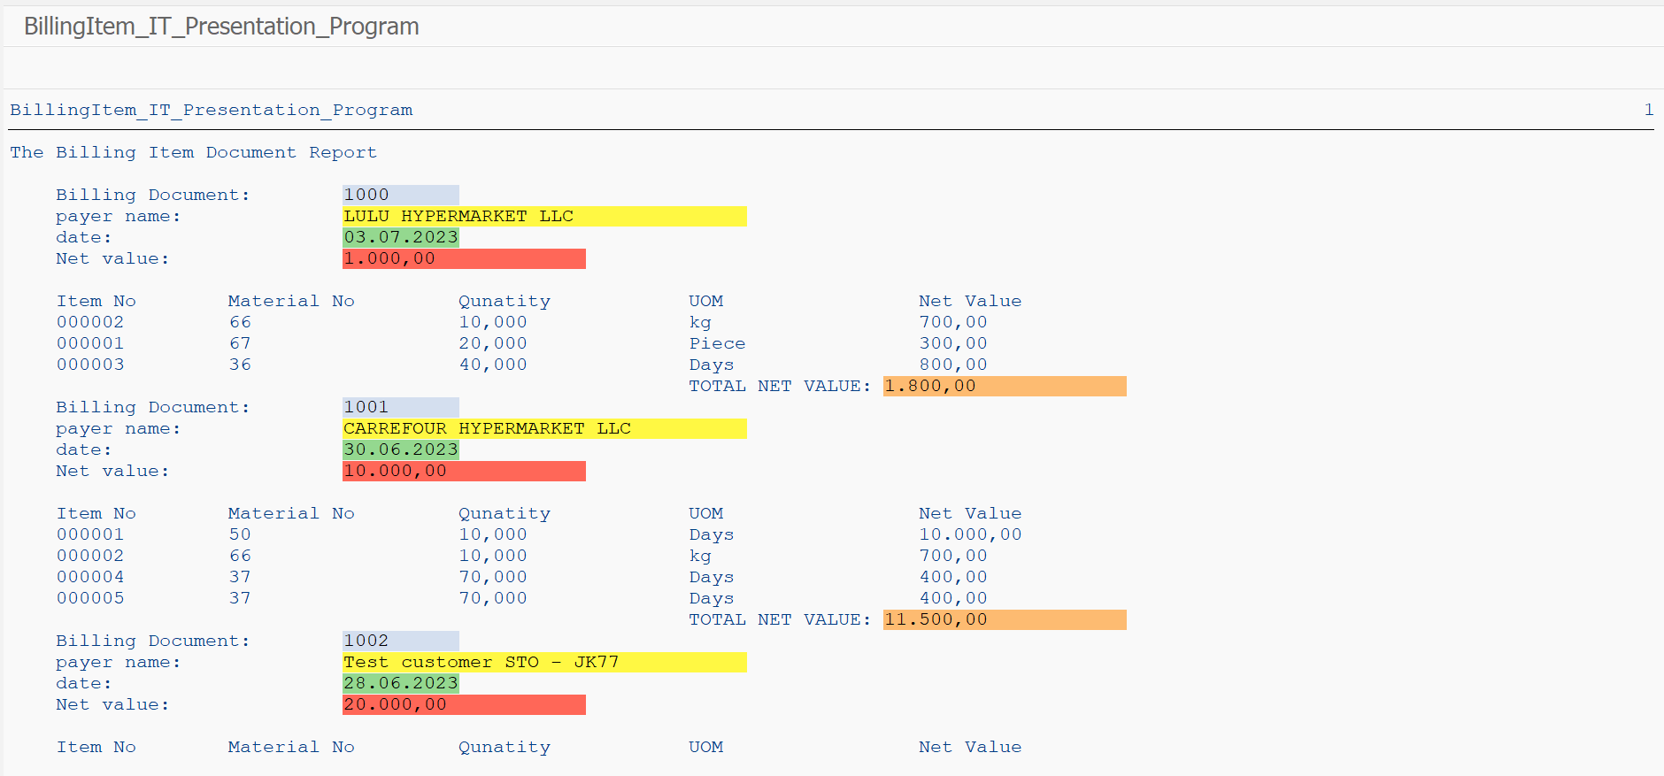

Program: ZJANA_BILLITEM_IT_SOP

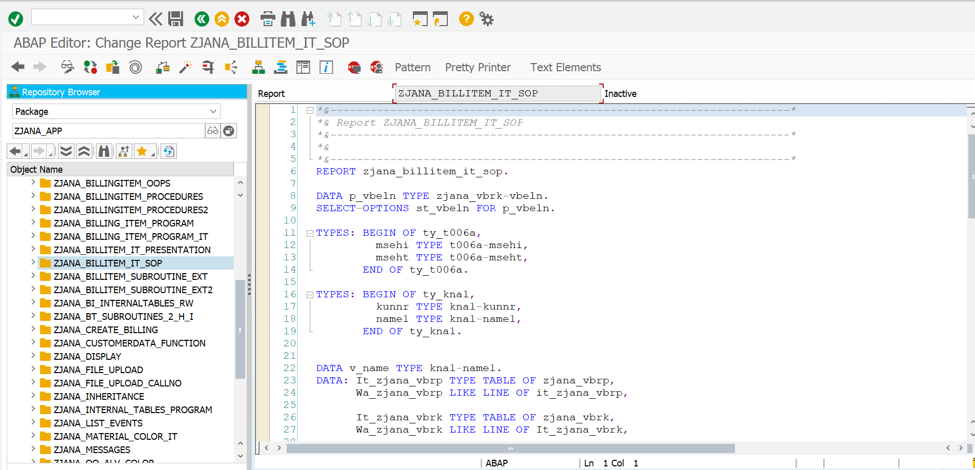

*\*&---------------------------------------------------------------------\**  
*\*& Report ZJANA_BILLITEM_IT_SOP*  
*\*&---------------------------------------------------------------------\**  
*\*&*  
*\*&---------------------------------------------------------------------\**  
REPORT zjana_billitem_it_sop.  
  
DATA p_vbeln TYPE zjana_vbrk-vbeln.  
SELECT-OPTIONS st_vbeln FOR p_vbeln.  
  
TYPES: BEGIN OF ty_t006a,  
 msehi TYPE t006a-msehi,  
 mseht TYPE t006a-mseht,  
 END OF ty_t006a.  
  
TYPES: BEGIN OF ty_kna1,  
 kunnr TYPE kna1-kunnr,  
 name1 TYPE kna1-name1,  
 END OF ty_kna1.  
  
  
DATA v_name TYPE kna1-name1.  
DATA: It_zjana_vbrp TYPE TABLE OF zjana_vbrp,  
 Wa_zjana_vbrp LIKE LINE OF it_zjana_vbrp,  
  
 It_zjana_vbrk TYPE TABLE OF zjana_vbrk,  
 Wa_zjana_vbrk LIKE LINE OF It_zjana_vbrk,  
  
 It_t006a TYPE TABLE OF ty_t006a,  
 Wa_t006a LIKE LINE OF It_t006a,  
 It_kna1 TYPE TABLE OF ty_kna1,  
 Wa_kna1 LIKE LINE OF It_kna1,  
  
 v_vbeln_temp LIKE Wa_zjana_vbrp-vbeln.  
  
 DATA v_Total_Value TYPE zjana_vbrp-fkimg VALUE = 0.  
  
*\*WRITE:'Document No:'.*  
*\*WRITE:'Payer NAME:'.*  
*\*WRITE:'Date:'.*  
*\*WRITE: 'NetValue:'.*  
  
  
*\*WRITE:/'ITEM No',*  
*\* 20 'MATERIAL',*  
*\* 40 'QTY',*  
*\* 60 'UOM',*  
*\* 80 'NETVALUE'.*  
  
SELECT * FROM zjana_vbrk INTO TABLE It_zjana_vbrk WHERE vbeln IN st_vbeln.  
  
SELECT kunnr name1 FROM kna1 INTO TABLE It_kna1 FOR ALL ENTRIES IN It_zjana_vbrk WHERE kunnr EQ it_zjana_vbrk-kunrg.  
  
SELECT * FROM zjana_vbrp INTO TABLE It_zjana_vbrp WHERE vbeln IN st_vbeln.  
SELECT msehi mseht FROM t006a INTO TABLE It_t006a FOR ALL ENTRIES IN It_zjana_vbrp WHERE spras EQ sy-langu AND msehi EQ It_zjana_vbrp-vrkme.  
  
  
  
SORT It_Zjana_VBRP by vbeln.  
LOOP AT It_zjana_vbrp INTO Wa_zjana_vbrp.  
  
 READ TABLE It_t006a INTO Wa_t006a WITH KEY msehi = Wa_zjana_vbrp-vrkme.  
  
  
if v_vbeln_temp NE Wa_zjana_vbrp-vbeln.  
 READ TABLE It_zjana_vbrk INTO wa_zjana_vbrk WITH KEY vbeln = Wa_zjana_vbrp-vbeln.  
 READ TABLE It_kna1 INTO Wa_kna1 WITH KEY kunnr = wa_zjana_vbrk-kunrg.  
  
 WRITE:/ 'Document No:',Wa_zjana_vbrk-vbeln.  
 WRITE:/'Payer_NAMe:',Wa_kna1-name1.  
 WRITE:/'Date:',Wa_zjana_vbrk-fkdat.  
 WRITE:/'NetWorth:',Wa_zjana_vbrk-netwr.  
  
WRITE:/ 'ITEM No', 20 'MATERIAL', 40 'QTY', 60 'UOM', 80 'NETVALUE'.  
 ENDIF.  
v_Total_Value=0.  
v_Total_Value=v_Total_Value+Wa_zjana_vbrp-fkimg.  
  
 WRITE : / Wa_zjana_vbrp-posnr,  
 20 Wa_zjana_vbrp-matnr,  
 40 Wa_zjana_vbrp-fkimg LEFT-JUSTIFIED,  
 60 Wa_t006a-mseht LEFT-JUSTIFIED,  
 80 Wa_zjana_vbrp-netwr LEFT-JUSTIFIED,  
 'Total Value:',v_Total_Value.  
  
 v_vbeln_temp = Wa_zjana_vbrp-vbeln.  
ENDLOOP.

RESULT:

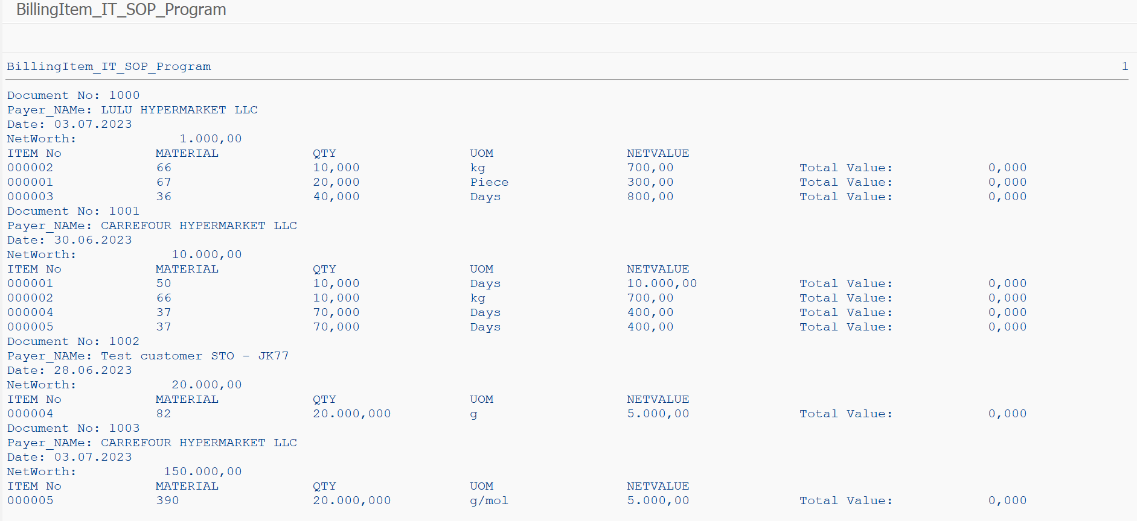

ProgramS: ZJANA_BILLITEM_SUBROUTINE_EXT

**ZJANA_PROCEDURES_SUBROUTINES**

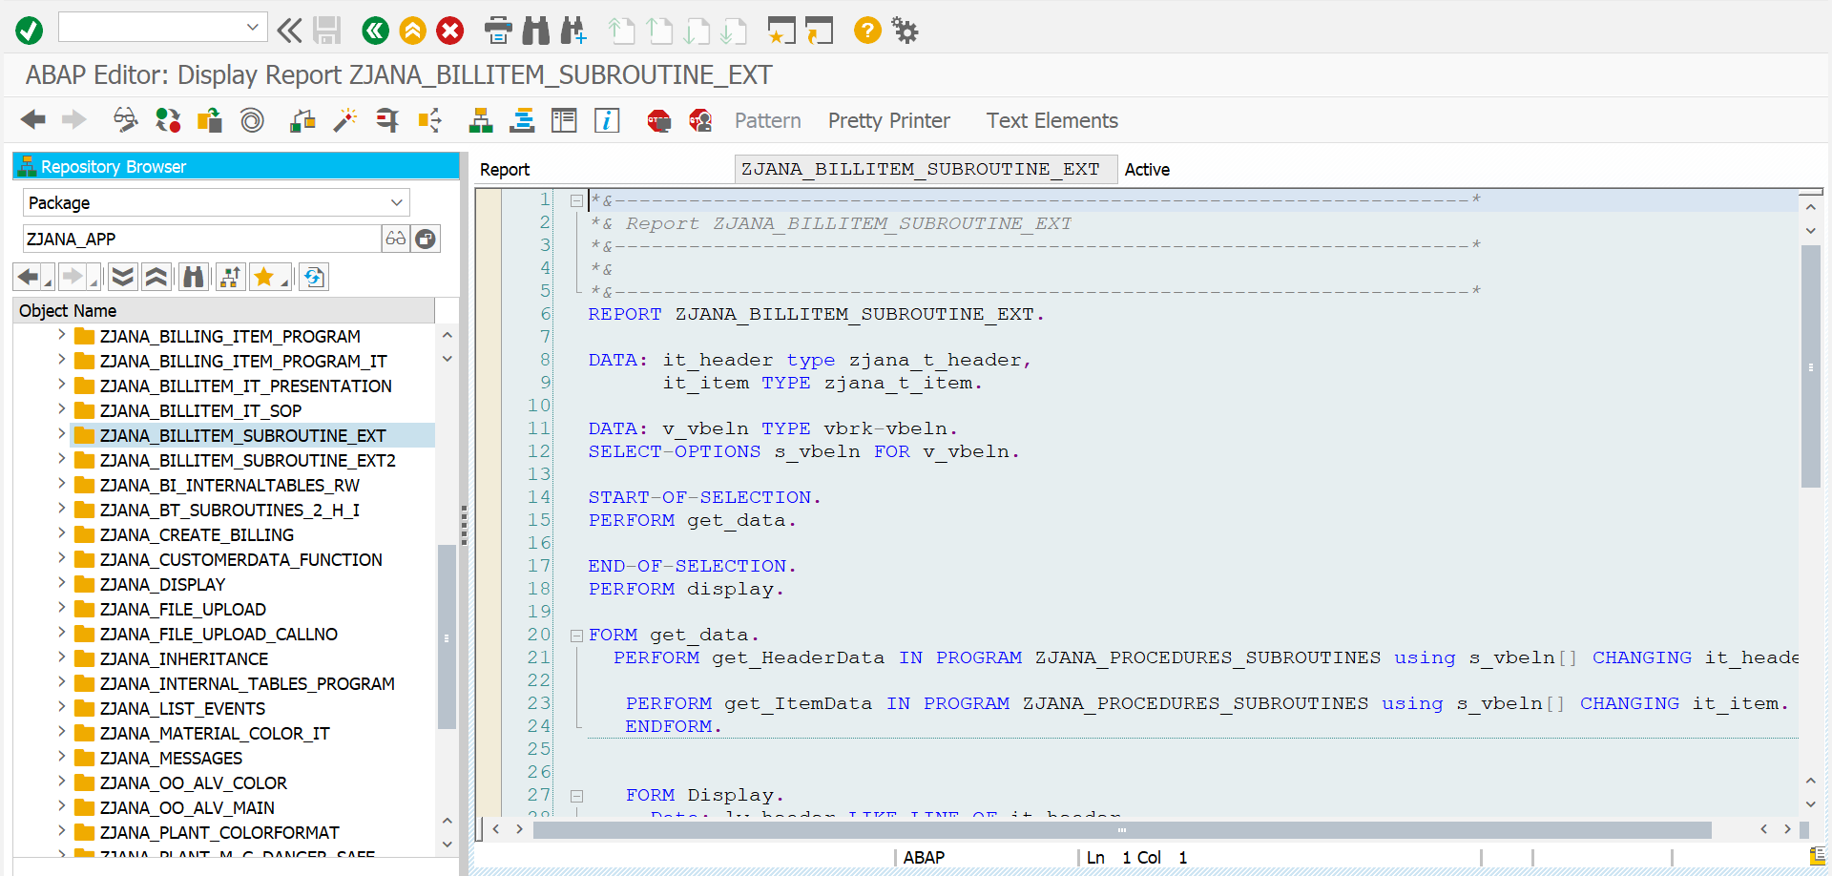

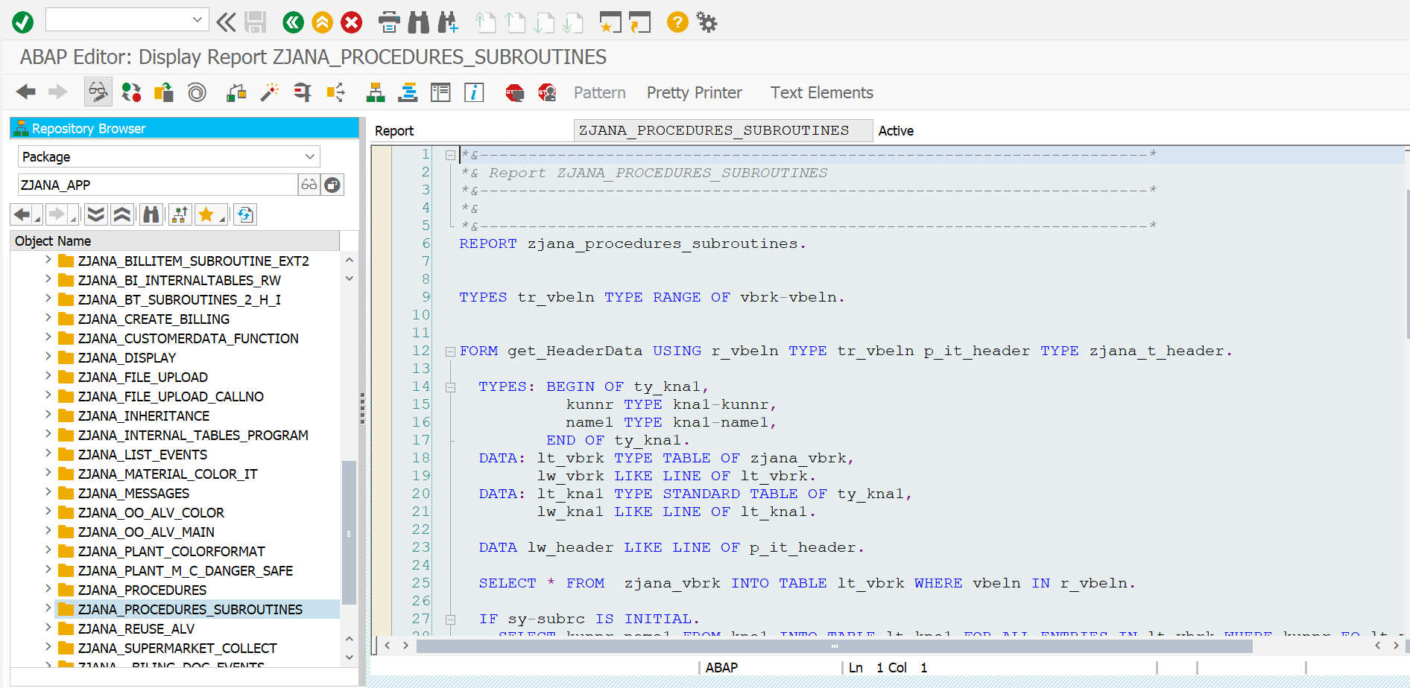

*\*&---------------------------------------------------------------------\**  
*\*& Report ZJANA_BILLITEM_SUBROUTINE_EXT*  
*\*&---------------------------------------------------------------------\**  
*\*&*  
*\*&---------------------------------------------------------------------\**  
REPORT ZJANA_BILLITEM_SUBROUTINE_EXT.  
  
DATA: it_header type zjana_t_header,  
 it_item TYPE zjana_t_item.  
  
DATA: v_vbeln TYPE vbrk-vbeln.  
SELECT-OPTIONS s_vbeln FOR v_vbeln.  
  
START-OF-SELECTION.  
PERFORM get_data.  
  
END-OF-SELECTION.  
PERFORM display.  
  
FORM get_data.  
 PERFORM get_HeaderData IN PROGRAM ZJANA_PROCEDURES_SUBROUTINES using s_vbeln[] CHANGING it_header.  
  
 PERFORM get_ItemData IN PROGRAM ZJANA_PROCEDURES_SUBROUTINES using s_vbeln[] CHANGING it_item.  
 ENDFORM.  
  
  
 FORM Display.  
 Data: lw_header LIKE LINE OF it_header,  
 lw_item LIKE LINE OF it_item.  
  
 SORT it_item by vbeln posnr.  
  
 LOOP AT it_item INTO lw_item.  
  
 AT NEW vbeln.  
 Read TABLE it_header INTO lw_header with KEY vbeln = lw_item-vbeln.  
  
 WRITE : / 'Doc No:', lw_header-vbeln,  
 / 'Payer:', lw_header-name1,  
 / 'Date:', lw_header-fkdat,  
 / 'Net Value:', lw_header-netwr.  
 SKIP.  
 WRITE : /5 'Item',  
 20 'Material',  
 50 'Quantity',  
 60 'UoM',  
 90 'Net Value'.  
  
 ENDAT.  
  
 WRITE : /5 lw_item-posnr,  
 20 lw_item-matnr,  
 40 lw_item-fkimg,  
 60 lw_item-mseht,  
 80 lw_item-netwr.  
 ENDLOOP.  
 ENDFORM.

*\*&---------------------------------------------------------------------\**  
*\*& Report ZJANA_PROCEDURES_SUBROUTINES*  
*\*&---------------------------------------------------------------------\**  
*\*&*  
*\*&---------------------------------------------------------------------\**  
REPORT zjana_procedures_subroutines.  
  
  
TYPES tr_vbeln TYPE RANGE OF vbrk-vbeln.  
  
  
FORM get_HeaderData USING r_vbeln TYPE tr_vbeln p_it_header TYPE zjana_t_header.  
  
 TYPES: BEGIN OF ty_kna1,  
 kunnr TYPE kna1-kunnr,  
 name1 TYPE kna1-name1,  
 END OF ty_kna1.  
 DATA: lt_vbrk TYPE TABLE OF zjana_vbrk,  
 lw_vbrk LIKE LINE OF lt_vbrk.  
 DATA: lt_kna1 TYPE STANDARD TABLE OF ty_kna1,  
 lw_kna1 LIKE LINE OF lt_kna1.  
  
 DATA lw_header LIKE LINE OF p_it_header.  
  
 SELECT * FROM zjana_vbrk INTO TABLE lt_vbrk WHERE vbeln IN r_vbeln.  
  
 IF sy-subrc IS INITIAL.  
 SELECT kunnr name1 FROM kna1 INTO TABLE lt_kna1 FOR ALL ENTRIES IN lt_vbrk WHERE kunnr EQ lt_vbrk-KUNRG.  
 ENDIF.  
  
  
 LOOP AT lt_vbrk INTO lw_vbrk.  
 READ TABLE lt_kna1 INTO lw_kna1 WITH KEY kunnr = lw_vbrk-kunrg.  
  
 MOVE-CORRESPONDING lw_vbrk TO lw_header.  
 MOVE-CORRESPONDING lw_kna1 TO lw_header.  
 APPEND lw_header TO p_it_header.  
 CLEAR lw_header.  
  
 ENDLOOP.  
 ENDFORM.  
  
  
 FORM get_ItemData USING r_vbeln type tr_vbeln CHANGING p_it_item type zjana_t_item.  
  
 TYPES: BEGIN OF ty_t006a,  
 msehi TYPE t006a-msehi,  
 mseht TYPE t006a-mseht,  
 END OF ty_t006a.  
  
 Data: lt_vbrp type table of zjana_vbrp,  
 lw_vbrp LIKE LINE OF lt_vbrp.  
 Data: lt_t006a type table of ty_t006a,  
 lw_t006a LIKE LINE OF lt_t006a.  
 DATA: it_item type zjana_t_item.  
Data lw_item LIKE LINE OF p_it_item.  
  
SELECT * from zjana_vbrp INTO table lt_vbrp where vbeln in r_vbeln.  
 SELECT msehi mseht from t006a into table lt_t006a FOR ALL ENTRIES IN lt_vbrp where msehi EQ lt_vbrp-vrkme.  
  
 LOOP At lt_vbrp INTO lw_vbrp.  
  
 READ TABLE lt_t006a into lw_t006a WITH KEY msehi = lw_vbrp-vrkme.  
  
 MOVE-CORRESPONDING lw_vbrp to lw_item.  
 MOVE-CORRESPONDING lw_t006a to lw_item.  
 AppEND lw_item to p_it_item.  
 clear lw_item.  
 ENDLOOP.  
  
  
ENDFORM.

**Result:**

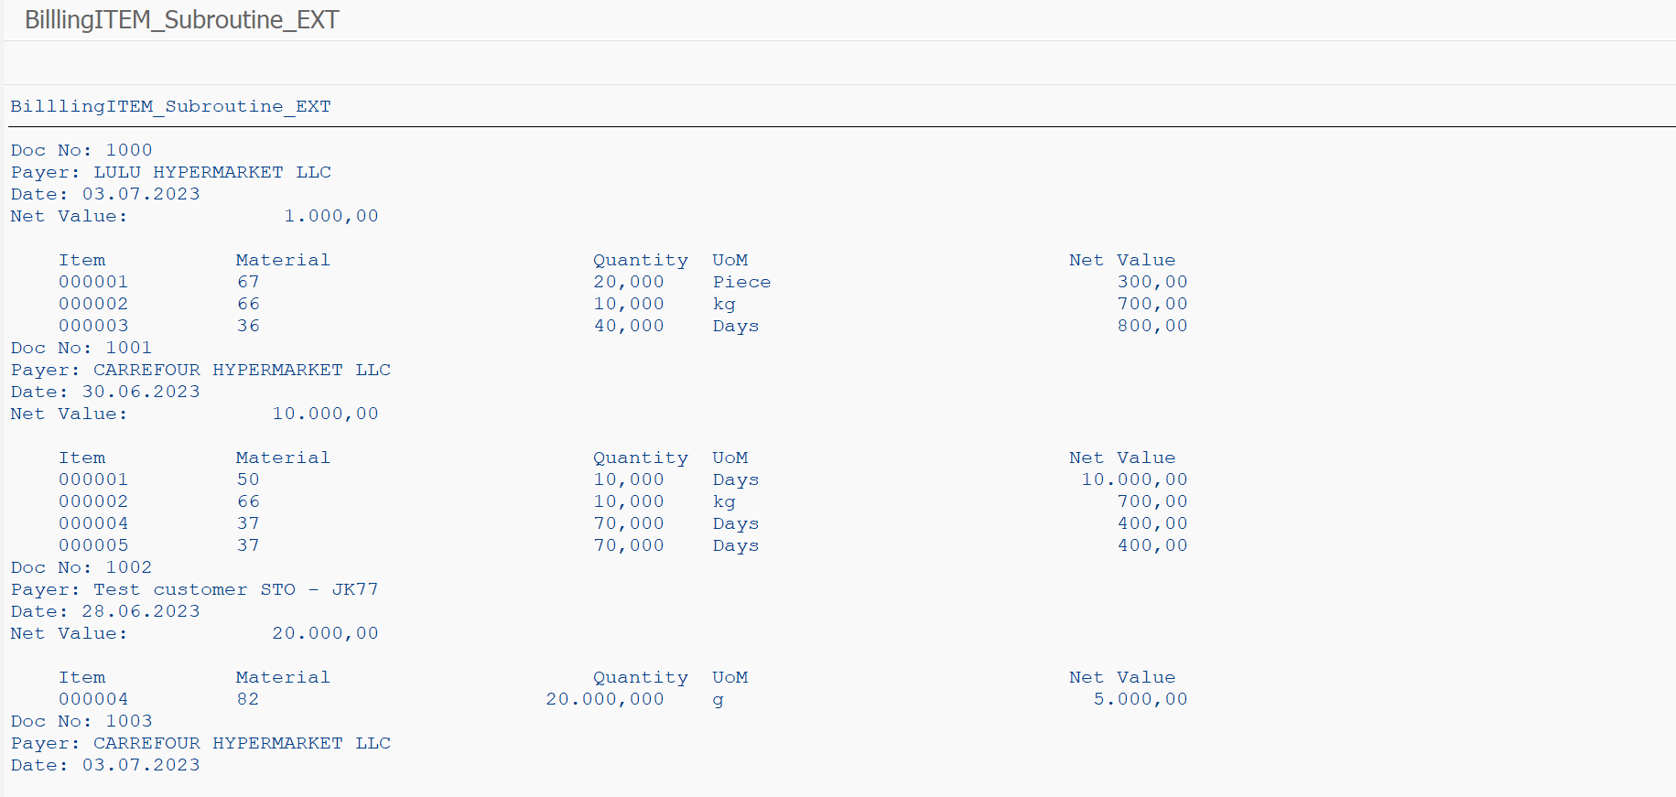

Program: ZJANA_BILLITEM_SUBROUTINE_EXT2

ZJANA_BT_SUBROUTINES_2_H_I

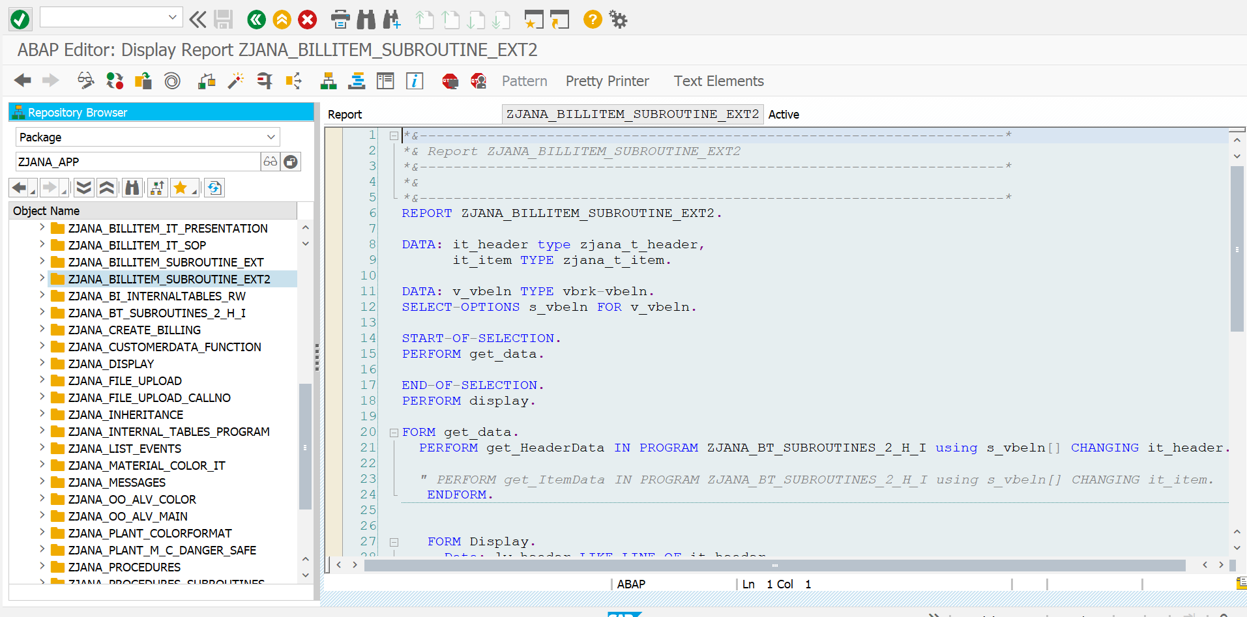

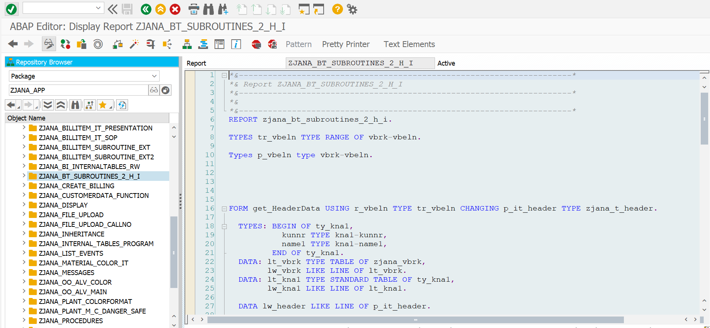

*\*&---------------------------------------------------------------------\**  
*\*& Report ZJANA_BILLITEM_SUBROUTINE_EXT2*  
*\*&---------------------------------------------------------------------\**  
*\*&*  
*\*&---------------------------------------------------------------------\**  
REPORT ZJANA_BILLITEM_SUBROUTINE_EXT2.  
  
DATA: it_header type zjana_t_header,  
 it_item TYPE zjana_t_item.  
  
DATA: v_vbeln TYPE vbrk-vbeln.  
SELECT-OPTIONS s_vbeln FOR v_vbeln.  
  
START-OF-SELECTION.  
PERFORM get_data.  
  
END-OF-SELECTION.  
PERFORM display.  
  
FORM get_data.  
 PERFORM get_HeaderData IN PROGRAM ZJANA_BT_SUBROUTINES_2_H_I using s_vbeln[] CHANGING it_header.  
  
 *" PERFORM get_ItemData IN PROGRAM ZJANA_BT_SUBROUTINES_2_H_I using s_vbeln[] CHANGING it_item.*  
 ENDFORM.  
  
  
 FORM Display.  
 Data: lw_header LIKE LINE OF it_header,  
 lw_item LIKE LINE OF it_item.  
  
 SORT it_item by vbeln posnr.  
  
 LOOP AT it_item INTO lw_item.  
  
 AT NEW vbeln.  
 Read TABLE it_header INTO lw_header with KEY vbeln = lw_item-vbeln.  
  
 WRITE : / 'Doc No:', lw_header-vbeln,  
 / 'Payer:', lw_header-name1,  
 / 'Date:', lw_header-fkdat,  
 / 'Net Value:', lw_header-netwr.  
 SKIP.  
 WRITE : /5 'Item',  
 20 'Material',  
 50 'Quantity',  
 60 'UoM',  
 90 'Net Value'.  
  
 ENDAT.  
  
 WRITE : /5 lw_item-posnr,  
 20 lw_item-matnr,  
 40 lw_item-fkimg,  
 60 lw_item-mseht,  
 80 lw_item-netwr.  
 ENDLOOP.  
 ENDFORM.

*\*&---------------------------------------------------------------------\**  
*\*& Report ZJANA_BT_SUBROUTINES_2_H_I*  
*\*&---------------------------------------------------------------------\**  
*\*&*  
*\*&---------------------------------------------------------------------\**  
REPORT zjana_bt_subroutines_2_h_i.  
  
TYPES tr_vbeln TYPE RANGE OF vbrk-vbeln.  
  
Types p_vbeln type vbrk-vbeln.  
  
  
  
  
  
FORM get_HeaderData USING r_vbeln TYPE tr_vbeln CHANGING p_it_header TYPE zjana_t_header.  
  
 TYPES: BEGIN OF ty_kna1,  
 kunnr TYPE kna1-kunnr,  
 name1 TYPE kna1-name1,  
 END OF ty_kna1.  
 DATA: lt_vbrk TYPE TABLE OF zjana_vbrk,  
 lw_vbrk LIKE LINE OF lt_vbrk.  
 DATA: lt_kna1 TYPE STANDARD TABLE OF ty_kna1,  
 lw_kna1 LIKE LINE OF lt_kna1.  
  
 DATA lw_header LIKE LINE OF p_it_header.  
  
 TYPES: BEGIN OF ty_t006a,  
 msehi TYPE t006a-msehi,  
 mseht TYPE t006a-mseht,  
 END OF ty_t006a.  
  
 DATA: lt_vbrp TYPE TABLE OF zjana_vbrp,  
 lw_vbrp LIKE LINE OF lt_vbrp.  
 DATA: lt_t006a TYPE TABLE OF ty_t006a,  
 lw_t006a LIKE LINE OF lt_t006a.  
 DATA: it_item TYPE zjana_t_item.  
 DATA lw_item LIKE LINE OF it_item.  
  
 SELECT * FROM zjana_vbrk INTO TABLE lt_vbrk WHERE vbeln IN r_vbeln.  
  
 IF sy-subrc IS INITIAL.  
 SELECT kunnr name1 FROM kna1 INTO TABLE lt_kna1 FOR ALL ENTRIES IN lt_vbrk WHERE kunnr EQ lt_vbrk-kunrg.  
 ENDIF.  
  
  
 *"SORT lt_vbrp BY vbeln.*  
 LOOP AT lt_vbrk INTO lw_vbrk.  
 READ TABLE lt_kna1 INTO lw_kna1 WITH KEY kunnr = lw_vbrk-kunrg.  
  
 MOVE-CORRESPONDING lw_vbrk TO lw_header.  
 MOVE-CORRESPONDING lw_kna1 TO lw_header.  
 APPEND lw_header TO p_it_header.  
 *"HIDE lw_vbrk-vbeln.*  
 CLEAR lw_header.  
  
  
 ENDLOOP.  
 CLEAR lw_header.  
ENDFORM.  
  
  
  
  
  
  
FORM get_ItemData USING p_p_vbeln type p_vbeln CHANGING p_it_item type zjana_t_item.  
  
 TYPES: BEGIN OF ty_t006a,  
 msehi TYPE t006a-msehi,  
 mseht TYPE t006a-mseht,  
 END OF ty_t006a.  
  
 Data: lt_vbrp type table of zjana_vbrp,  
 lw_vbrp LIKE LINE OF lt_vbrp.  
 Data: lt_t006a type table of ty_t006a,  
 lw_t006a LIKE LINE OF lt_t006a.  
 DATA: it_item type zjana_t_item.  
Data lw_item LIKE LINE OF p_it_item.  
  
  
 IF sy-subrc = 0.  
  
SELECT * from zjana_vbrp INTO table lt_vbrp where vbeln EQ p_p_vbeln.  
 if sy-subrc is INITIAL.  
 SELECT msehi mseht from t006a into table lt_t006a FOR ALL ENTRIES IN lt_vbrp where msehi EQ lt_vbrp-vrkme.  
 ENDIF.  
  
 LOOP At lt_vbrp INTO lw_vbrp.  
  
 READ TABLE lt_t006a into lw_t006a WITH KEY msehi = lw_vbrp-vrkme.  
  
 MOVE-CORRESPONDING lw_vbrp to lw_item.  
 MOVE-CORRESPONDING lw_t006a to lw_item.  
 AppEND lw_item to p_it_item.  
 clear lw_item.  
 ENDLOOP.  
endif.  
  
ENDFORM.

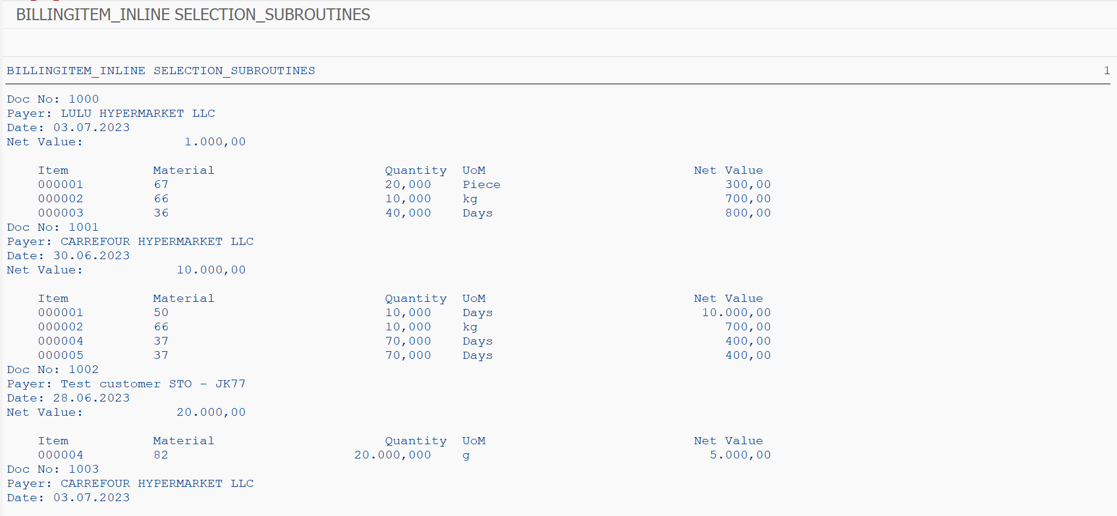

Program: ZJANA_CREATE_BILLING

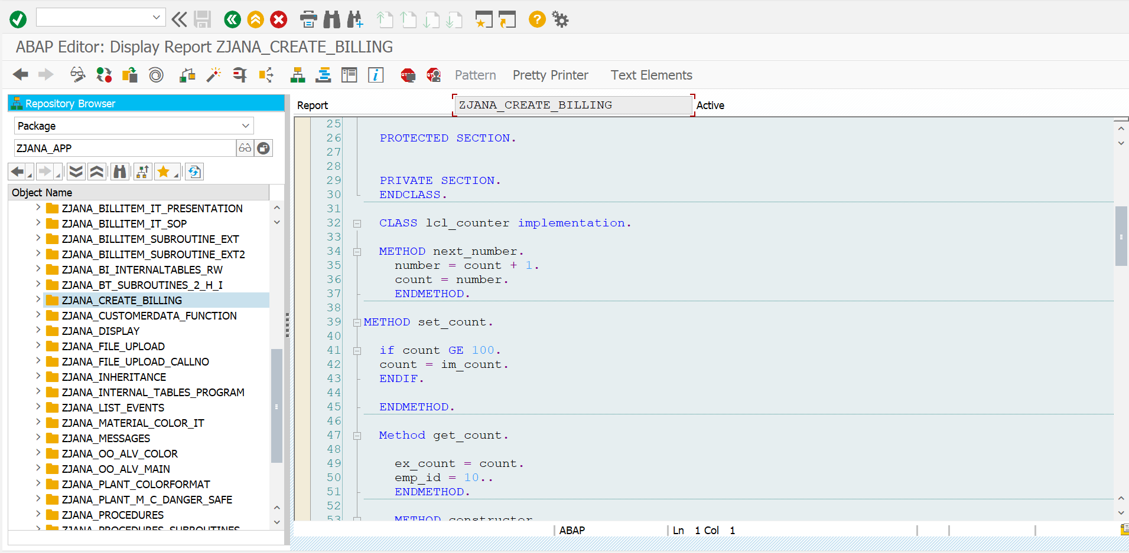

*\*&---------------------------------------------------------------------\**  
*\*& Report ZJANA_CREATE_BILLING*  
*\*&---------------------------------------------------------------------\**  
*\*&*  
*\*&---------------------------------------------------------------------\**  
REPORT ZJANA_CREATE_BILLING.  
  
  
  
CLASS lcl_counter DEFINITION.  
  
  
 PUBLIC SECTION.  
  
Class-data emp_id type i.  
 Data count type i.  
  
 methods next_number Exporting number type i.  
 METHODS set_count importing im_count TYPE i.  
 METHODS get_count exporting ex_count type i.  
 CLASS-METHODS set_emp_id IMPORTING im_emp_id type i.  
  
 METHODS constructor IMPORTING im_count type i.  
  
  
 PROTECTED SECTION.  
  
  
 PRIVATE SECTION.  
 ENDCLASS.  
  
 CLASS lcl_counter implementation.  
  
 METHOD next_number.  
 number = count + 1.  
 count = number.  
 ENDMETHOD.  
  
METHOD set_count.  
  
 if count GE 100.  
 count = im_count.  
 ENDIF.  
  
 ENDMETHOD.  
  
 Method get_count.  
  
 ex_count = count.  
 emp_id = 10..  
 ENDMETHOD.  
  
 METHOD constructor.  
 count = im_count.  
  
 ENDMETHOD.  
  
METHOD set_emp_id.  
  
 emp_id = im_emp_id.  
 ENDMETHOD.  
  
 ENDCLASS.  
  
 DATA o_doc type REF TO lcl_counter.  
 DATA o_tag type REF TO lcl_counter.  
 data v_doc type i.  
 data v_tag type i.  
  
 START-OF-SELECTION.  
 CREATE object o_doc  
 EXPORTING im_count = 1000.  
 .  
 CREATE OBJECT o_tag  
 EXPORTING im_count = 20.  
 .  
lcl_counter=>emp_id = 1001.  
  
 o_doc->next_number(  
 importing  
 number = v_doc  
 ).  
  
 o_tag->next_number(  
 importing  
  
 number = v_tag  
 ).  
 o_tag->next_number(  
 importing  
  
 number = v_tag  
 ).  
 o_tag->next_number(  
 importing  
  
 number = v_tag  
 ).  
  
 o_doc->next_number(  
 importing  
 number = v_doc  
 ).  
  
 o_tag->next_number(  
 importing  
  
 number = v_tag  
 ).  
  
 o_tag->next_number(  
 importing  
  
 number = v_tag  
 ).  
  
 o_tag->next_number(  
 importing  
  
 number = v_tag  
 ).  
  
 data v_document type i.  
data v_tagsNo type i.  
  
  
  
 WRITE :v_doc.  
 WRITE :v_tag.  
  
*\* CALL FUNCTION 'ZJANA_FM_COUNT'*  
*\* IMPORTING*  
*\* NEXT_NO = v_document.*  
*\**  
*\* CALL FUNCTION 'ZJANA_FM_COUNT'*  
*\* IMPORTING*  
*\* NEXT_NO = v_tagsNo.*  
*\* CALL FUNCTION 'ZJANA_FM_COUNT'*  
*\* IMPORTING*  
*\* NEXT_NO = v_tagsNo.*  
*\* CALL FUNCTION 'ZJANA_FM_COUNT'*  
*\* IMPORTING*  
*\* NEXT_NO = v_document.*  
*\**  
*\* CALL FUNCTION 'ZJANA_FM_COUNT'*  
*\* IMPORTING*  
*\* NEXT_NO = v_tagsNo.*  
*\* CALL FUNCTION 'ZJANA_FM_COUNT'*  
*\* IMPORTING*  
*\* NEXT_NO = v_document.*

**RESULT:**

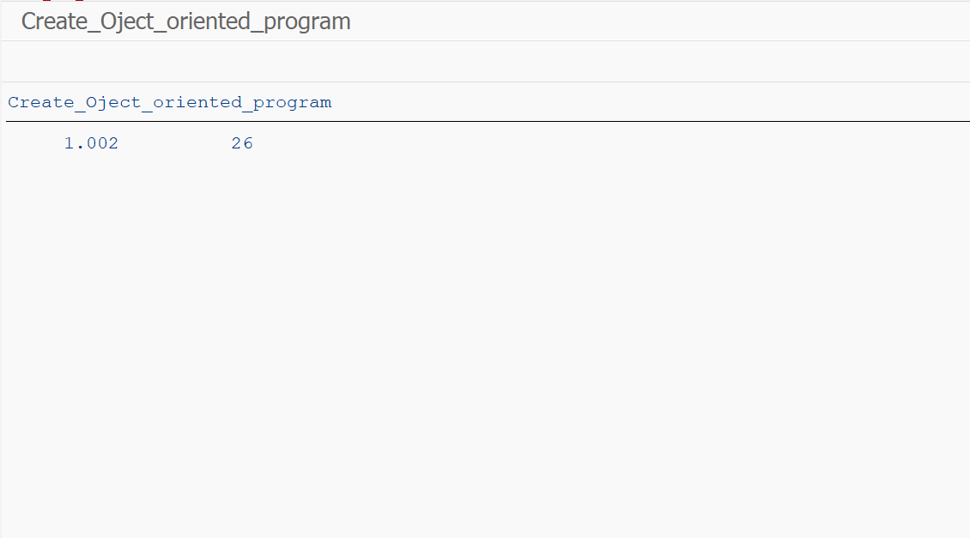

Program: ZJANA_FILE_UPLOAD

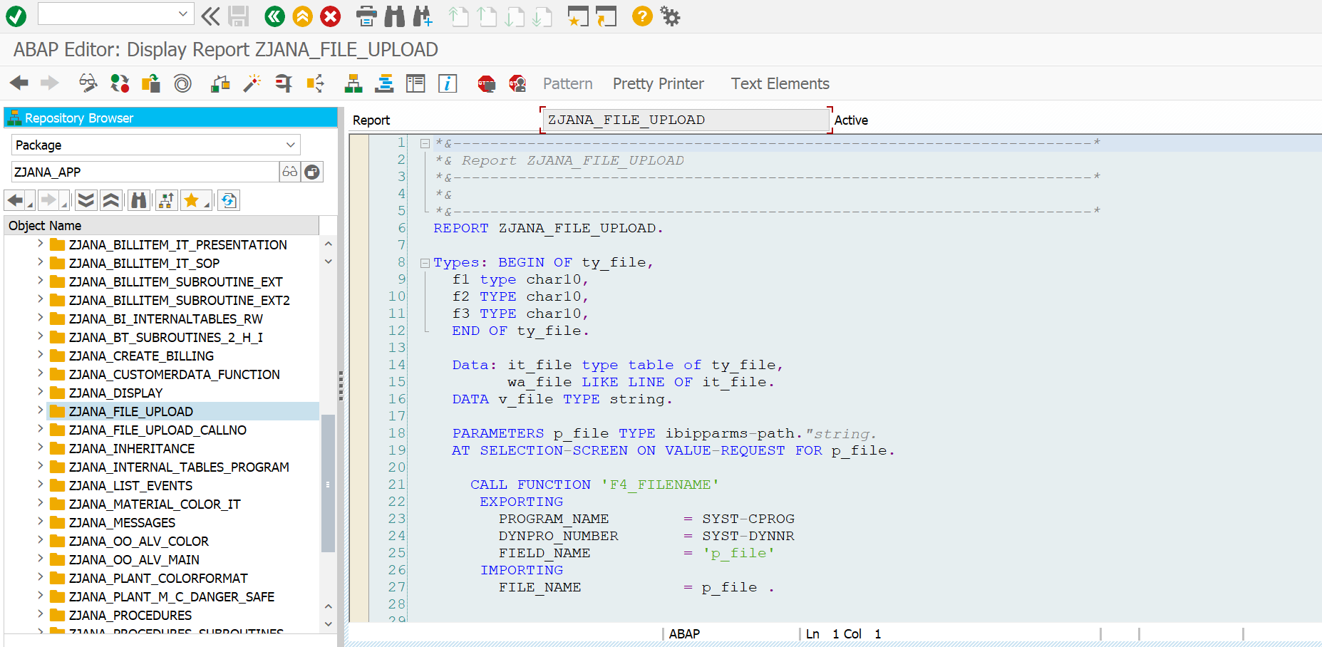

*\*&---------------------------------------------------------------------\**  
*\*& Report ZJANA_FILE_UPLOAD*  
*\*&---------------------------------------------------------------------\**  
*\*&*  
*\*&---------------------------------------------------------------------\**  
REPORT ZJANA_FILE_UPLOAD.  
  
Types: BEGIN OF ty_file,  
 f1 type char10,  
 f2 TYPE char10,  
 f3 TYPE char10,  
 END OF ty_file.  
  
 Data: it_file type table of ty_file,  
 wa_file LIKE LINE OF it_file.  
 DATA v_file TYPE string.  
  
 PARAMETERS p_file TYPE ibipparms-path.*"string.*  
 AT SELECTION-SCREEN ON VALUE-REQUEST FOR p_file.  
  
 CALL FUNCTION 'F4_FILENAME'  
 EXPORTING  
 PROGRAM_NAME = SYST-CPROG  
 DYNPRO_NUMBER = SYST-DYNNR  
 FIELD_NAME = 'p_file'  
 IMPORTING  
 FILE_NAME = p_file .  
  
  
 START-OF-SELECTION.  
 v_file = p_file.  
 CALL FUNCTION 'GUI_UPLOAD'  
 EXPORTING  
 filename = v_file  
 FILETYPE = 'ASC'  
 HAS_FIELD_SEPARATOR = 'X'  
*\* HEADER_LENGTH = 0*  
*\* READ_BY_LINE = 'X'*  
*\* DAT_MODE = ' '*  
*\* CODEPAGE = ' '*  
*\* IGNORE_CERR = ABAP_TRUE*  
*\* REPLACEMENT = '#'*  
*\* CHECK_BOM = ' '*  
*\* VIRUS_SCAN_PROFILE =*  
*\* NO_AUTH_CHECK = ' '*  
*\* IMPORTING*  
*\* FILELENGTH =*  
*\* HEADER =*  
 tables  
 data_tab = it_file  
*\* CHANGING*  
*\* ISSCANPERFORMED = ' '*  
  
 EXCEPTIONS  
 FILE_OPEN_ERROR = 1  
 FILE_READ_ERROR = 2  
 NO_BATCH = 3  
 GUI_REFUSE_FILETRANSFER = 4  
 INVALID_TYPE = 5  
 NO_AUTHORITY = 6  
 UNKNOWN_ERROR = 7  
 BAD_DATA_FORMAT = 8  
 HEADER_NOT_ALLOWED = 9  
 SEPARATOR_NOT_ALLOWED = 10  
 HEADER_TOO_LONG = 11  
 UNKNOWN_DP_ERROR = 12  
 ACCESS_DENIED = 13  
 DP_OUT_OF_MEMORY = 14  
 DISK_FULL = 15  
 DP_TIMEOUT = 16  
 OTHERS = 17  
 .  
 IF sy-subrc <> 0.  
*\* Implement suitable error handling here*  
 ENDIF.  
  
  
 LOOP AT it_file INTO wa_file.  
 write: / wa_file-f1, wa_file-f2, wa_file-f3.  
 ENDLOOP.

**RESULT:**

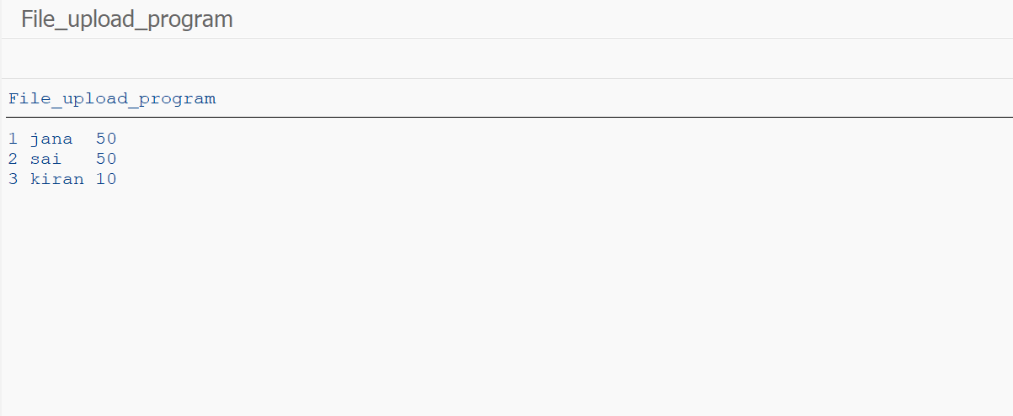  
  
 .

Program:

ZJANA_FILE_UPLOAD_CALLNO

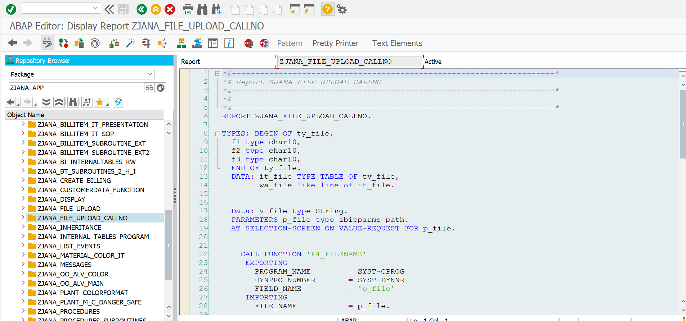

*\*&---------------------------------------------------------------------\**  
*\*& Report ZJANA_FILE_UPLOAD_CALLNO*  
*\*&---------------------------------------------------------------------\**  
*\*&*  
*\*&---------------------------------------------------------------------\**  
REPORT ZJANA_FILE_UPLOAD_CALLNO.  
  
TYPES: BEGIN OF ty_file,  
 f1 type char10,  
 f2 type char10,  
 f3 type char10,  
 END OF ty_file.  
 DATA: it_file TYPE TABLE OF ty_file,  
 wa_file like line of it_file.  
  
  
 Data: v_file type String.  
 PARAMETERS p_file type ibipparms-path.  
 AT SELECTION-SCREEN ON VALUE-REQUEST FOR p_file.  
  
  
 CALL FUNCTION 'F4_FILENAME'  
 EXPORTING  
 PROGRAM_NAME = SYST-CPROG  
 DYNPRO_NUMBER = SYST-DYNNR  
 FIELD_NAME = 'p_file'  
 IMPORTING  
 FILE_NAME = p_file.  
  
 START-OF-SELECTION.  
 v_file = p_file.  
 CALL FUNCTION 'GUI_UPLOAD'  
 EXPORTING  
 filename = v_file  
 FILETYPE = 'ASC'  
 HAS_FIELD_SEPARATOR = 'X'  
*\* HEADER_LENGTH = 0*  
*\* READ_BY_LINE = 'X'*  
*\* DAT_MODE = ' '*  
*\* CODEPAGE = ' '*  
*\* IGNORE_CERR = ABAP_TRUE*  
*\* REPLACEMENT = '#'*  
*\* CHECK_BOM = ' '*  
*\* VIRUS_SCAN_PROFILE =*  
*\* NO_AUTH_CHECK = ' '*  
*\* IMPORTING*  
*\* FILELENGTH =*  
*\* HEADER =*  
 tables  
 data_tab = it_file  
*\* CHANGING*  
*\* ISSCANPERFORMED = ' '*  
 EXCEPTIONS  
 FILE_OPEN_ERROR = 1  
 FILE_READ_ERROR = 2  
 NO_BATCH = 3  
 GUI_REFUSE_FILETRANSFER = 4  
 INVALID_TYPE = 5  
 NO_AUTHORITY = 6  
 UNKNOWN_ERROR = 7  
 BAD_DATA_FORMAT = 8  
 HEADER_NOT_ALLOWED = 9  
 SEPARATOR_NOT_ALLOWED = 10  
 HEADER_TOO_LONG = 11  
 UNKNOWN_DP_ERROR = 12  
 ACCESS_DENIED = 13  
 DP_OUT_OF_MEMORY = 14  
 DISK_FULL = 15  
 DP_TIMEOUT = 16  
 OTHERS = 17  
 .  
 IF sy-subrc <> 0.  
*\* Implement suitable error handling here*  
 ENDIF.  
  
 .  
  
 LOOP AT it_file INTO wa_file.  
 AT new f1.  
 write: / wa_file-f1, wa_file-f2, wa_file-f3.  
 ENDAT.  
 ENDLOOP.

**RESULT:**

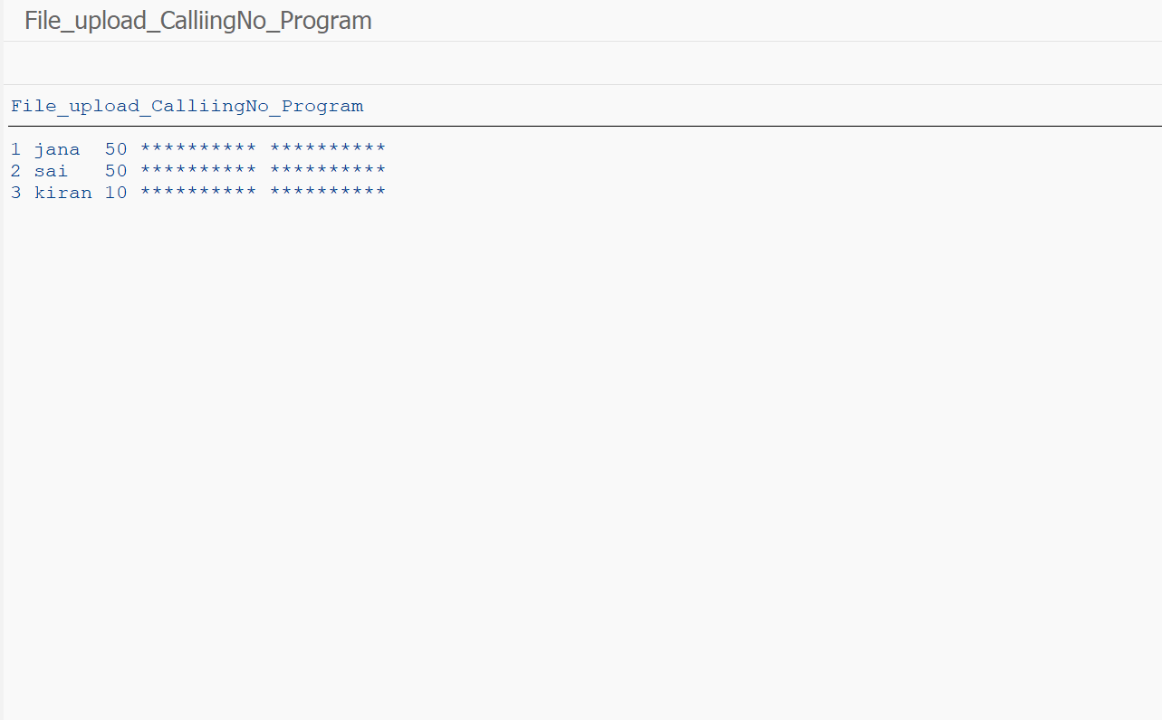

Program: ZJANA_INHERITANCE

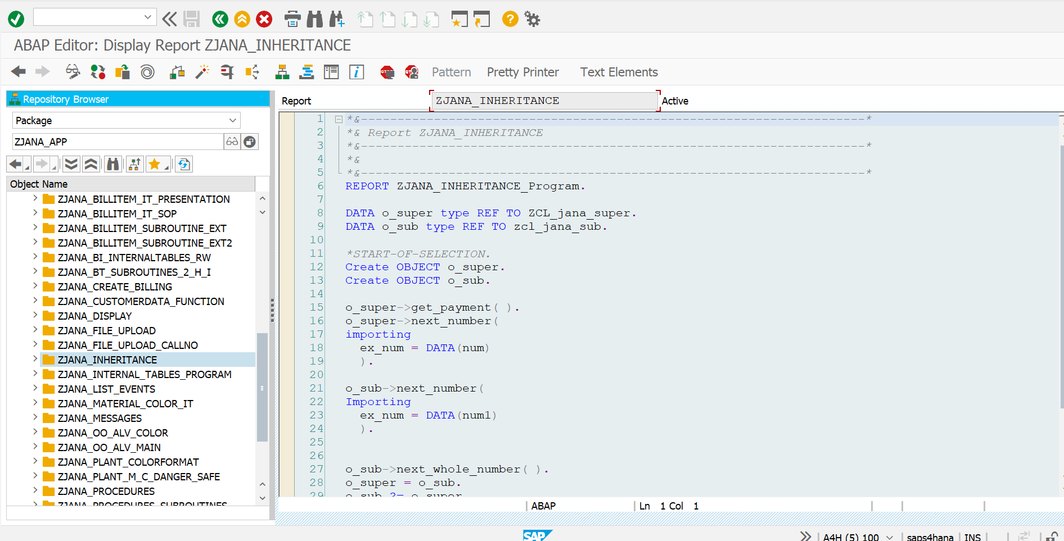

*\*&---------------------------------------------------------------------\**  
*\*& Report ZJANA_INHERITANCE*  
*\*&---------------------------------------------------------------------\**  
*\*&*  
*\*&---------------------------------------------------------------------\**  
REPORT ZJANA_INHERITANCE_Program.  
  
DATA o_super type REF TO ZCL_jana_super.  
DATA o_sub type REF TO zcl_jana_sub.  
  
*\*START-OF-SELECTION.*  
Create OBJECT o_super.  
Create OBJECT o_sub.  
  
o_super->get_payment( ).  
o_super->next_number(  
importing  
 ex_num = DATA(num)  
 ).  
  
o_sub->next_number(  
Importing  
 ex_num = DATA(num1)  
 ).  
  
  
o_sub->next_whole_number( ).  
o_super = o_sub.  
o_sub ?= o_super.  
o_super->next_number(  
IMPORTING  
ex_num = num  
).  
WRITE 'END'.

**RESULT:**

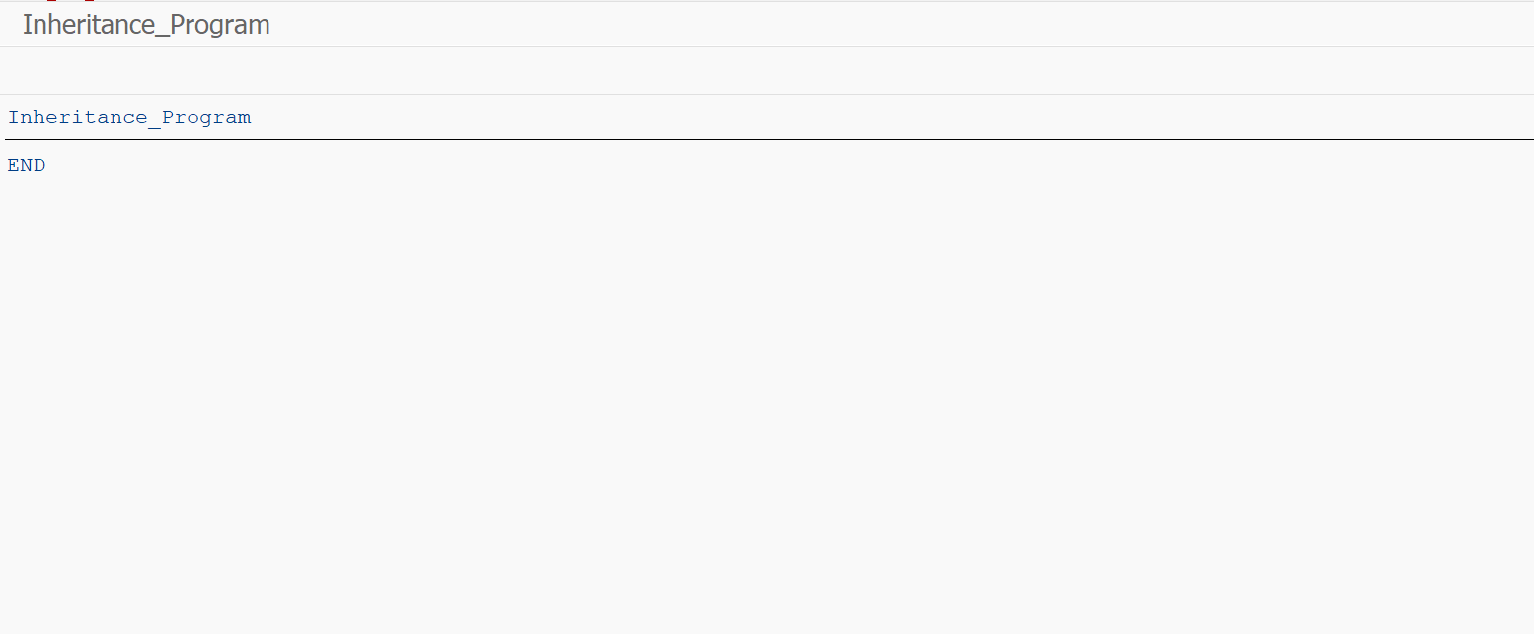

Program: ZJANA_INTERNAL_TABLES_PROGRAM

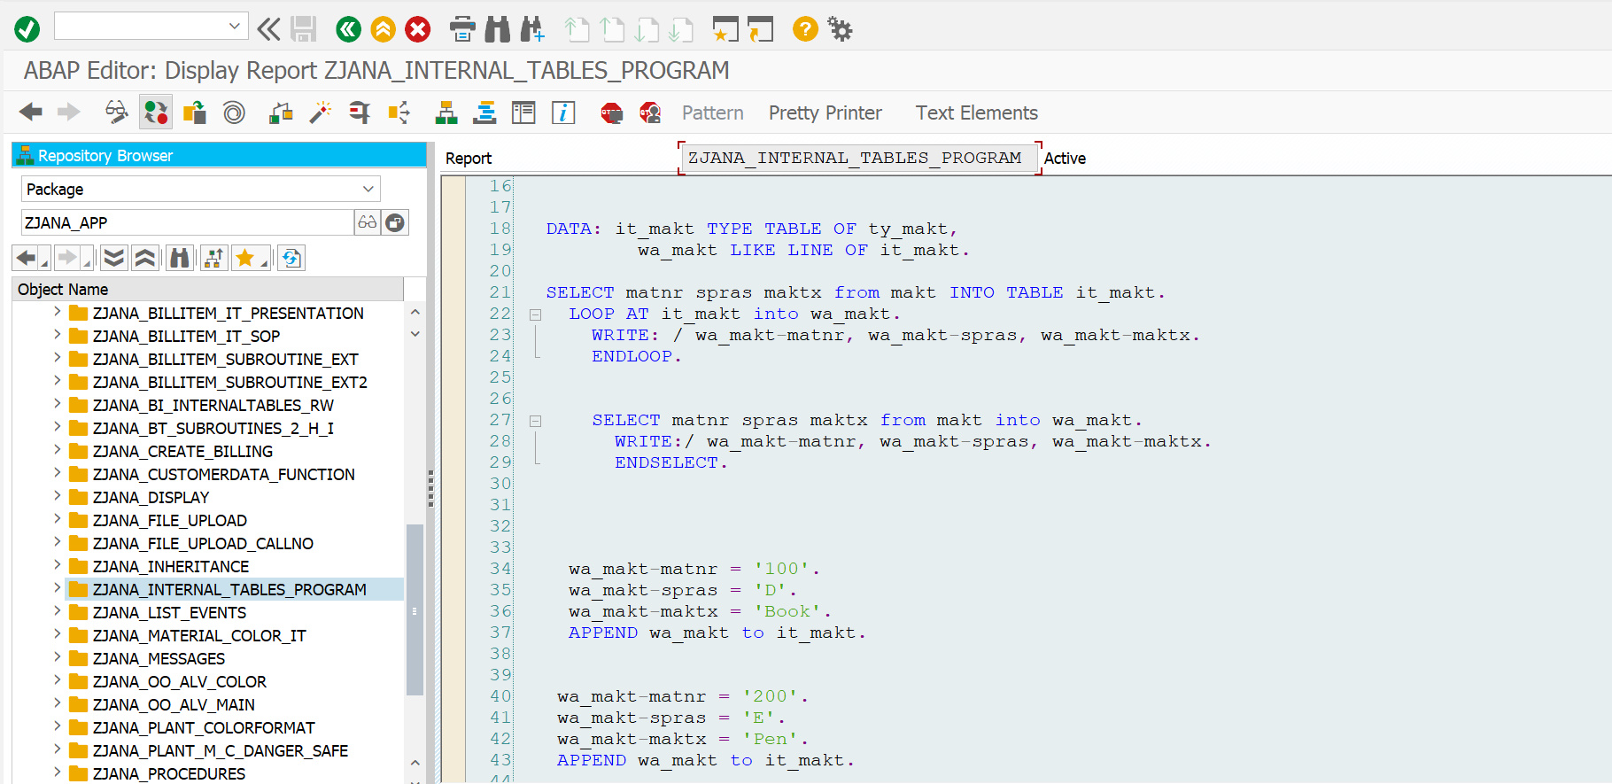

*\*&---------------------------------------------------------------------\**  
*\*& Report ZJANA_INTERNAL_TABLES_PROGRAM*  
*\*&---------------------------------------------------------------------\**  
*\*&*  
*\*&---------------------------------------------------------------------\**  
REPORT ZJANA_INTERNAL_TABLES_PROGRAM.  
  
  
TYPES: BEGIN OF ty_makt,  
 matnr TYPE matnr,  
 spras TYPE spras,  
 maktx TYPE maktx,  
 END OF ty_makt.  
  
  
  
  
DATA: it_makt TYPE TABLE OF ty_makt,  
 wa_makt LIKE LINE OF it_makt.  
  
SELECT matnr spras maktx from makt INTO TABLE it_makt.  
 LOOP AT it_makt into wa_makt.  
 WRITE: / wa_makt-matnr, wa_makt-spras, wa_makt-maktx.  
 ENDLOOP.  
  
  
 SELECT matnr spras maktx from makt into wa_makt.  
 WRITE:/ wa_makt-matnr, wa_makt-spras, wa_makt-maktx.  
 ENDSELECT.  
  
  
  
  
 wa_makt-matnr = '100'.  
 wa_makt-spras = 'D'.  
 wa_makt-maktx = 'Book'.  
 APPEND wa_makt to it_makt.  
  
  
 wa_makt-matnr = '200'.  
 wa_makt-spras = 'E'.  
 wa_makt-maktx = 'Pen'.  
 APPEND wa_makt to it_makt.  
  
  
 wa_makt-matnr = '200'.  
 wa_makt-spras = 'D'.  
 wa_makt-maktx = 'Pen'.  
 APPEND wa_makt to it_makt.  
  
 Read TABLE it_makt into wa_makt INDEX 3.  
  
 Read TABLE it_makt into wa_makt WITH KEY matnr = '200' Spras = 'D'.  
  
 LOOP At it_makt INTO wa_makt WHERE matnr EQ '200'.  
 ENDLOOP.  
 WRITE 'END'.

**RESULT:**

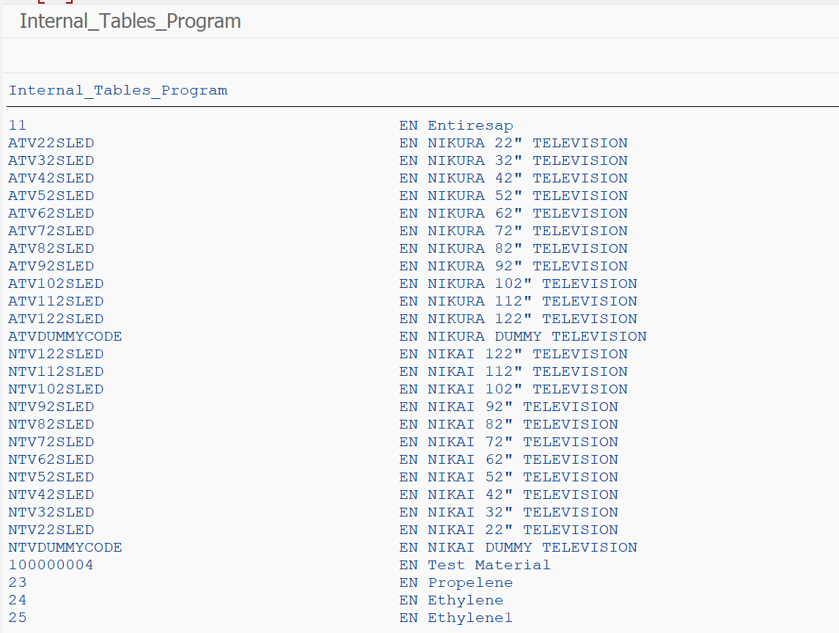

Program: ZJANA_LIST_EVENTS

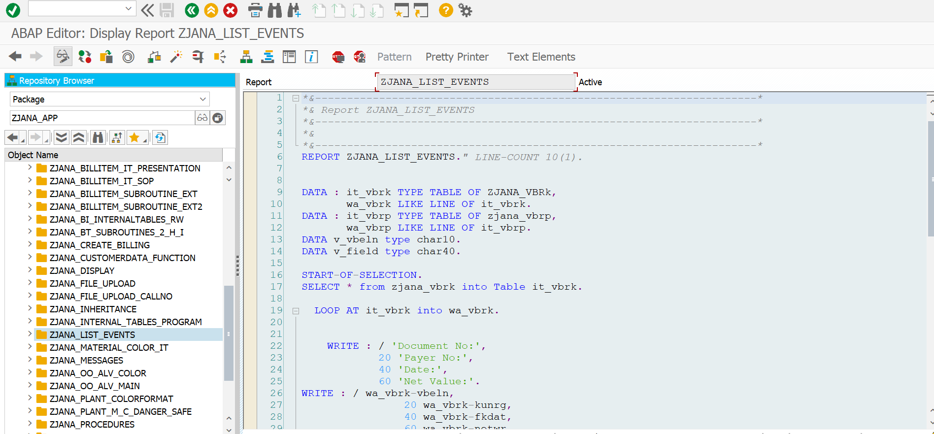

*\*&---------------------------------------------------------------------\**  
*\*& Report ZJANA_LIST_EVENTS*  
*\*&---------------------------------------------------------------------\**  
*\*&*  
*\*&---------------------------------------------------------------------\**  
REPORT ZJANA_LIST_EVENTS.*" LINE-COUNT 10(1).*  
  
  
DATA : it_vbrk TYPE TABLE OF ZJANA_VBRk,  
 wa_vbrk LIKE LINE OF it_vbrk.  
DATA : it_vbrp TYPE TABLE OF zjana_vbrp,  
 wa_vbrp LIKE LINE OF it_vbrp.  
DATA v_vbeln type char10.  
DATA v_field type char40.  
  
START-OF-SELECTION.  
SELECT * from zjana_vbrk into Table it_vbrk.  
  
 LOOP AT it_vbrk into wa_vbrk.  
  
  
 WRITE : / 'Document No:',  
 20 'Payer No:',  
 40 'Date:',  
 60 'Net Value:'.  
WRITE : / wa_vbrk-vbeln,  
 20 wa_vbrk-kunrg,  
 40 wa_vbrk-fkdat,  
 60 wa_vbrk-netwr.  
 HIDE wa_vbrk-vbeln.  
 SKIP.  
 Clear wa_vbrk.  
  
 ENDLOOP.  
 Clear wa_vbrk.  
  
 AT LINE-SELECTION.  
 Read LINE sy-lilli.  
 if sy-subrc = 0.  
 select * FROM zjana_vbrp INTO TABLE it_vbrp where vbeln EQ wa_vbrk-vbeln.  
  
 WRITE AT:/5 'Item No',  
 20 'Material No',  
 40 'Qunatity',  
 60 'UOM',  
 80 'Net Value'.  
LOOP AT it_vbrp INTO wa_vbrp.  
 WRITE AT:/5 wa_vbrp-posnr LEFT-JUSTIFIED,  
 20 wa_vbrp-matnr LEFT-JUSTIFIED,  
 40 wa_vbrp-fkimg LEFT-JUSTIFIED,  
 60 wa_vbrp-vrkme LEFT-JUSTIFIED,  
 80 wa_vbrp-netwr LEFT-JUSTIFIED.  
  
 ENDLOOP.  
  
ENDIF.  
  
TOP-OF-PAGE.  
WRITE: 'UST GloBAL'.  
ULINE.  
  
END-OF-PAGE.  
RESERVE 10 LINES.  
WRITE:/'The bill is generated by system'.  
  
  
ULINE.

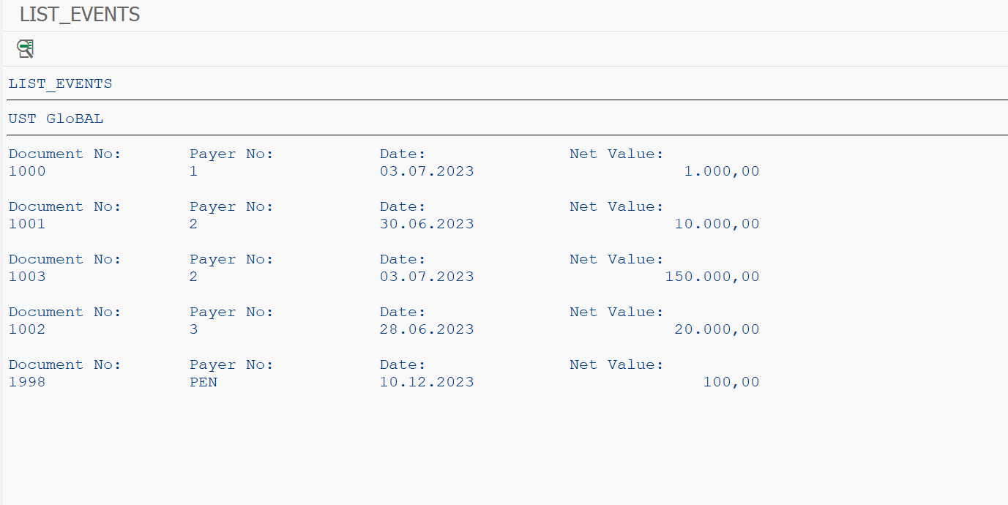

Program: ZJANA_MATERIAL_COLOR_IT

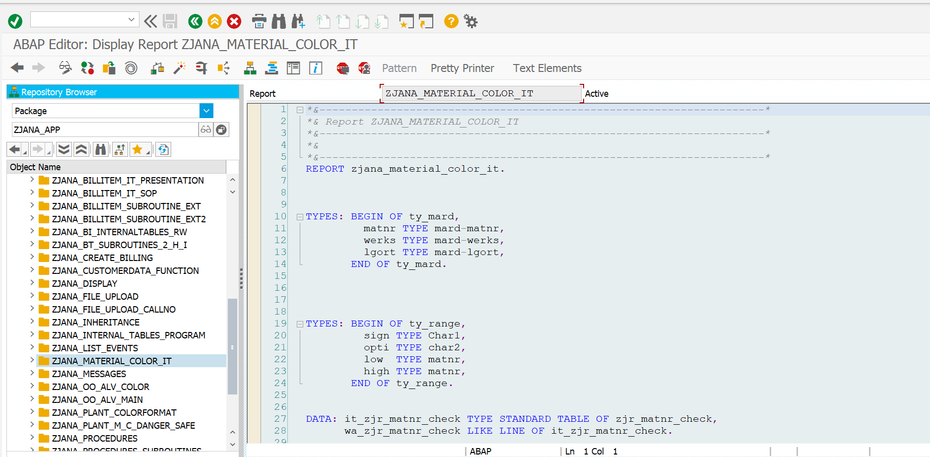

*\*&---------------------------------------------------------------------\**  
*\*& Report ZJANA_MATERIAL_COLOR_IT*  
*\*&---------------------------------------------------------------------\**  
*\*&*  
*\*&---------------------------------------------------------------------\**  
REPORT zjana_material_color_it.  
  
  
  
TYPES: BEGIN OF ty_mard,  
 matnr TYPE mard-matnr,  
 werks TYPE mard-werks,  
 lgort TYPE mard-lgort,  
 END OF ty_mard.  
  
  
  
  
TYPES: BEGIN OF ty_range,  
 sign TYPE Char1,  
 opti TYPE char2,  
 low TYPE matnr,  
 high TYPE matnr,  
 END OF ty_range.  
  
  
DATA: it_zjr_matnr_check TYPE STANDARD TABLE OF zjr_matnr_check,  
 wa_zjr_matnr_check LIKE LINE OF it_zjr_matnr_check.  
  
DATA: it_mard TYPE TABLE OF ty_mard,  
 wa_mard LIKE LINE OF it_mard.  
  
  
  
DATA: It_range_s TYPE STANDARD TABLE OF ty_range,  
 it_range_d TYPE STANDARD TABLE OF ty_range,  
 wa_range TYPE ty_range.  
  
  
  
SELECT-OPTIONS st_werks FOR wa_mard-werks.  
  
  
WRITE:/ 'Material',  
20 'PLANTNO',  
  
40 'StorageLocation'.  
  
  
  
SELECT matnr werks lgort FROM mard INTO TABLE it_mard WHERE werks IN st_werks.  
  
  
SELECT * FROM zjr_matnr_check INTO TABLE it_zjr_matnr_check.  
  
LOOP AT it_zjr_matnr_check INTO wa_zjr_matnr_check.  
  
 IF wa_zjr_matnr_check-name EQ 'DANGER'.  
 MOVE-CORRESPONDING wa_zjr_matnr_check TO wa_range.  
 APPEND wa_range TO it_range_d.  
 ENDIF.  
 IF wa_zjr_matnr_check-name EQ 'SAFE'.  
 MOVE-CORRESPONDING wa_zjr_matnr_check TO wa_range.  
 APPEND wa_range TO it_range_s.  
 ENDIF.  
 CLEAR wa_range.  
ENDLOOP.  
  
  
LOOP AT it_mard INTO wa_mard.  
  
 IF wa_mard-matnr IN It_range_d.  
  
 FORMAT COLOR COL_NEGATIVE.  
  
 WRITE:/ wa_mard-matnr,  
 20 wa_mard-werks,  
 40 wa_mard-lgort.  
  
  
 ELSEIF wa_mard-matnr IN It_range_s.  
 FORMAT COLOR COL_POSITIVE.  
 WRITE:/ wa_mard-matnr,  
 20 wa_mard-werks,  
 40 wa_mard-lgort.  
  
  
 ELSE.  
  
 WRITE:/ wa_mard-matnr,  
 20 wa_mard-werks,  
 40 wa_mard-lgort.  
  
 ENDIF.  
  
 FORMAT COLOR OFF.  
ENDLOOP.

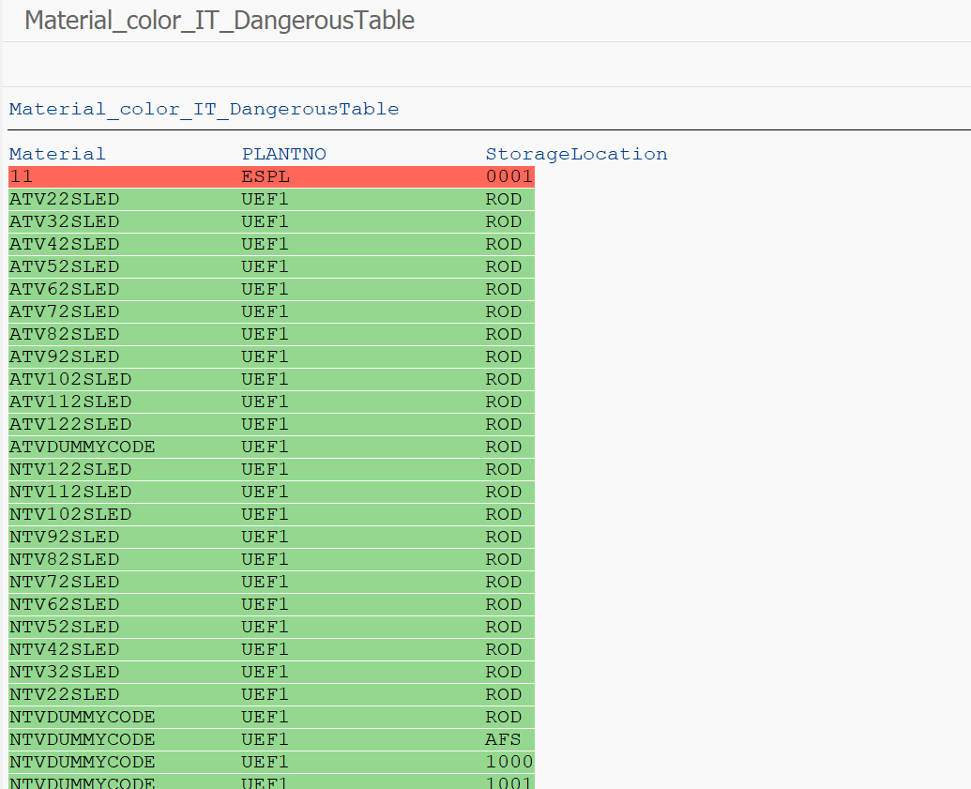

Program: ZJANA_MESSAGES

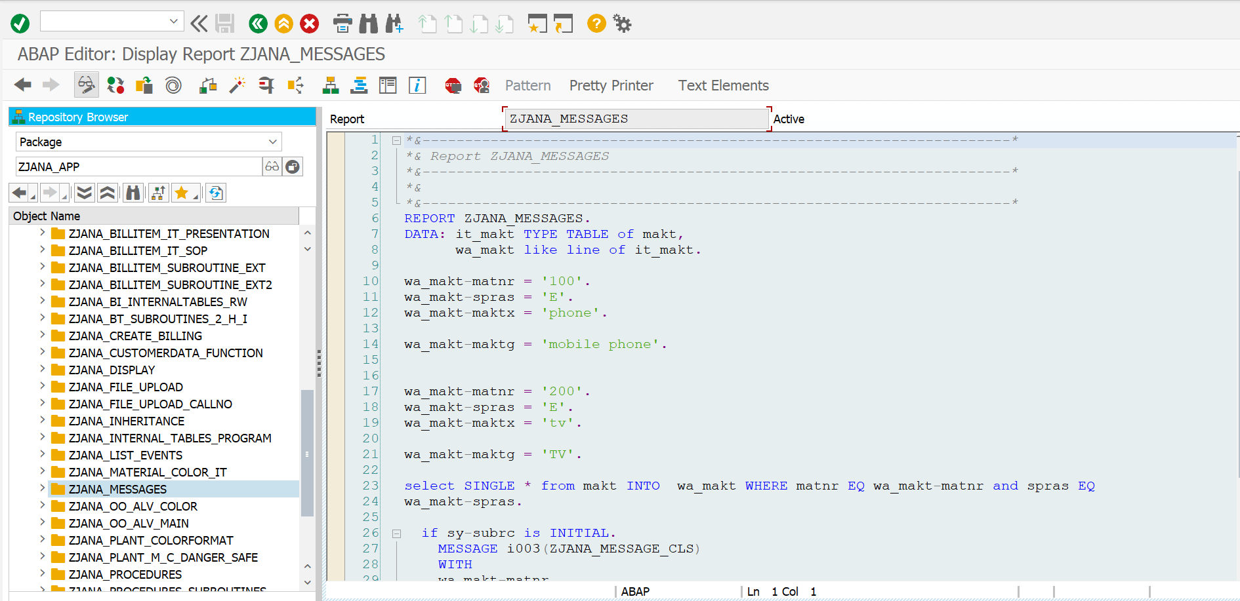

*\*&---------------------------------------------------------------------\**  
*\*& Report ZJANA_MESSAGES*  
*\*&---------------------------------------------------------------------\**  
*\*&*  
*\*&---------------------------------------------------------------------\**  
REPORT ZJANA_MESSAGES.  
DATA: it_makt TYPE TABLE of makt,  
 wa_makt like line of it_makt.  
  
wa_makt-matnr = '100'.  
wa_makt-spras = 'E'.  
wa_makt-maktx = 'phone'.  
  
wa_makt-maktg = 'mobile phone'.  
  
  
wa_makt-matnr = '200'.  
wa_makt-spras = 'E'.  
wa_makt-maktx = 'tv'.  
  
wa_makt-maktg = 'TV'.  
  
select SINGLE * from makt INTO wa_makt WHERE matnr EQ wa_makt-matnr and spras EQ  
wa_makt-spras.  
  
 if sy-subrc is INITIAL.  
 MESSAGE i003(ZJANA_MESSAGE_CLS)  
 WITH  
 wa_makt-matnr  
 wa_makt-spras.  
 else.  
  
 MESSAGE text-002 TYPE 'E'.  
 ENDIF.

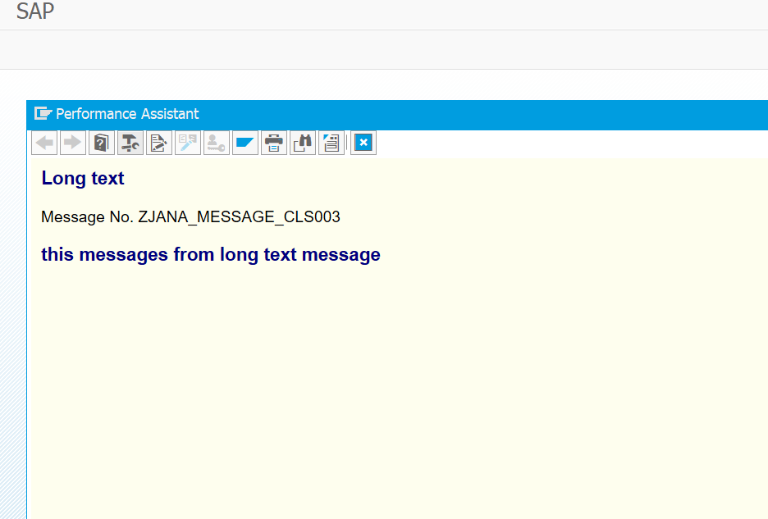

Program: ZJANA_PLANT_COLORFORMAT

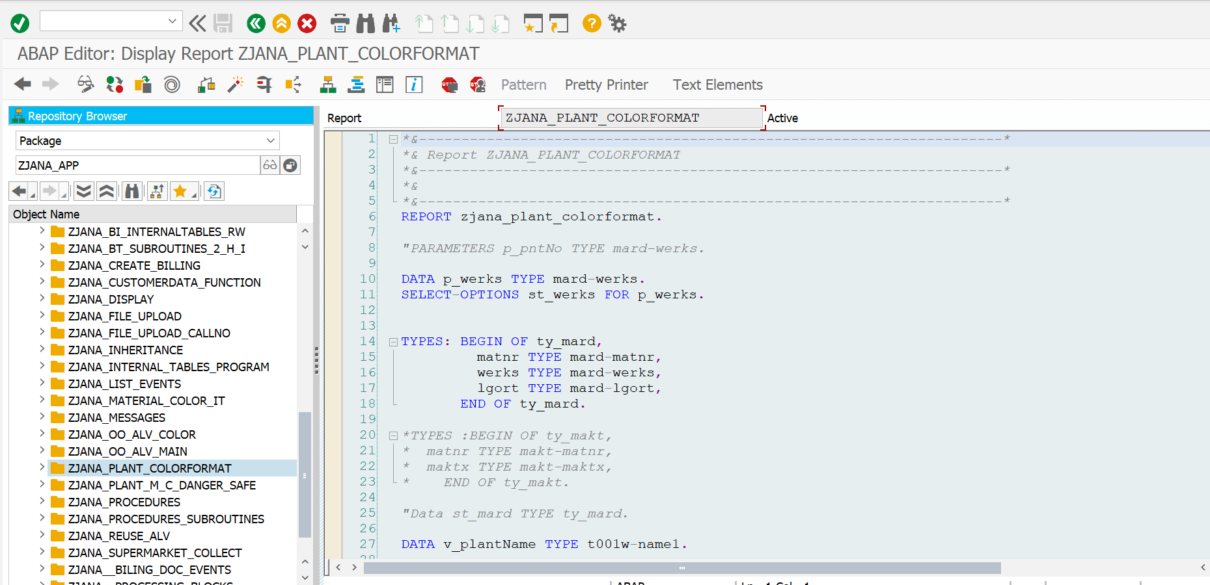

*\*&---------------------------------------------------------------------\**  
*\*& Report ZJANA_PLANT_COLORFORMAT*  
*\*&---------------------------------------------------------------------\**  
*\*&*  
*\*&---------------------------------------------------------------------\**  
REPORT zjana_plant_colorformat.  
  
*"PARAMETERS p_pntNo TYPE mard-werks.*  
  
DATA p_werks TYPE mard-werks.  
SELECT-OPTIONS st_werks FOR p_werks.  
  
  
TYPES: BEGIN OF ty_mard,  
 matnr TYPE mard-matnr,  
 werks TYPE mard-werks,  
 lgort TYPE mard-lgort,  
 END OF ty_mard.  
  
*\*TYPES :BEGIN OF ty_makt,*  
*\* matnr TYPE makt-matnr,*  
*\* maktx TYPE makt-maktx,*  
*\* END OF ty_makt.*  
  
*"Data st_mard TYPE ty_mard.*  
  
DATA v_plantName TYPE t001w-name1.  
  
  
  
TYPES: BEGIN OF ty_makt,  
 matnr TYPE makt-matnr,  
 maktx TYPE makt-maktx,  
 END OF ty_makt.  
  
TYPES: BEGIN OF ty_t001w,  
 werks TYPE t001w-werks,  
 name1 TYPE t001w-werks,  
 END OF ty_t001w.  
  
  
  
DATA: it_mard TYPE TABLE OF ty_mard,  
 wa_mard LIKE LINE OF it_mard.  
  
  
DATA: it_makt TYPE TABLE OF ty_makt,  
 wa_makt LIKE LINE OF it_makt,  
 it_t001w TYPE TABLE OF ty_t001w,  
 wa_t001w LIKE LINE OF it_t001w.  
  
  
  
  
  
WRITE:/ 'Material',  
20 'MaterialDescription',  
60 'PLANTNO',  
80 'PLANTNAME',  
100 'StorageLocation'.  
  
*"SELECT SINGLE name1 FROM t001w INTO v_plantName WHERE werks in st_werks.*  
  
  
SELECT matnr werks lgort FROM mard INTO TABLE it_mard WHERE werks IN st_werks.  
SELECT werks name1 FROM t001w INTO TABLE it_t001w FOR ALL ENTRIES IN it_mard WHERE werks EQ it_mard-werks.  
SELECT matnr maktx FROM makt INTO TABLE it_makt FOR ALL ENTRIES IN it_mard WHERE matnr EQ it_mard-matnr AND spras EQ sy-langu.  
  
LOOP AT it_mard INTO wa_mard.  
 READ TABLE it_makt INTO wa_makt WITH KEY matnr = wa_mard-matnr.  
 READ TABLE it_t001w INTO wa_t001w WITH KEY werks = wa_mard-werks.  
  
 IF wa_mard-matnr EQ 'ATV112SLED' OR wa_mard-matnr EQ 'NTV22SLED' OR wa_mard-matnr EQ 'ATV92SLED'.  
  
  
 FORMAT COLOR COL_NEGATIVE.  
  
 WRITE:/ wa_mard-matnr,  
 20 wa_makt-maktx,  
 60 wa_mard-werks,  
 80 v_plantName,  
 120 wa_mard-lgort.  
 FORMAT COLOR OFF.  
 ELSE.  
  
 WRITE:/ wa_mard-matnr,  
20 wa_makt-maktx,  
60 wa_mard-werks,  
80 v_plantName,  
120 wa_mard-lgort.  
 ENDIF.  
  
ENDLOOP.

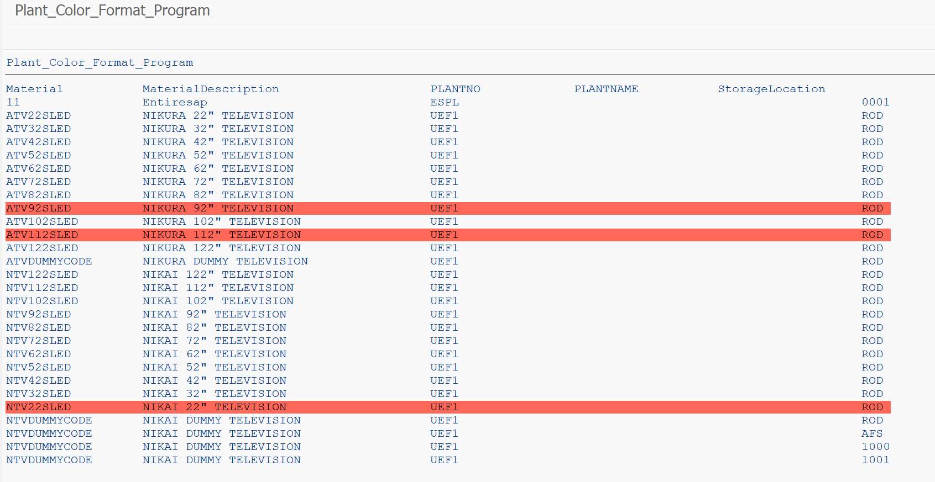

Program: ZJANA_PLANT_M_C_DANGER_SAFE

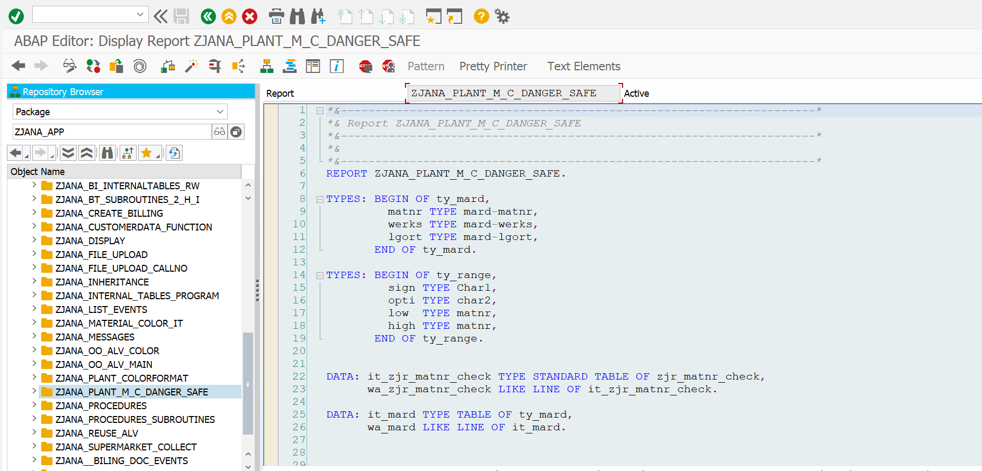

*\*&---------------------------------------------------------------------\**  
*\*& Report ZJANA_PLANT_M_C_DANGER_SAFE*  
*\*&---------------------------------------------------------------------\**  
*\*&*  
*\*&---------------------------------------------------------------------\**  
REPORT ZJANA_PLANT_M_C_DANGER_SAFE.  
  
TYPES: BEGIN OF ty_mard,  
 matnr TYPE mard-matnr,  
 werks TYPE mard-werks,  
 lgort TYPE mard-lgort,  
 END OF ty_mard.  
  
TYPES: BEGIN OF ty_range,  
 sign TYPE Char1,  
 opti TYPE char2,  
 low TYPE matnr,  
 high TYPE matnr,  
 END OF ty_range.  
  
  
DATA: it_zjr_matnr_check TYPE STANDARD TABLE OF zjr_matnr_check,  
 wa_zjr_matnr_check LIKE LINE OF it_zjr_matnr_check.  
  
DATA: it_mard TYPE TABLE OF ty_mard,  
 wa_mard LIKE LINE OF it_mard.  
  
  
  
DATA: It_range_s TYPE STANDARD TABLE OF ty_range,  
 it_range_d TYPE STANDARD TABLE OF ty_range,  
 wa_range TYPE ty_range.  
  
  
  
SELECT-OPTIONS st_werks FOR wa_mard-werks.  
  
  
WRITE:/ 'Material',  
20 'PLANTNO',  
40 'StorageLocation'.  
  
  
  
SELECT matnr werks lgort FROM mard INTO TABLE it_mard WHERE werks IN st_werks.  
  
  
SELECT * FROM zjr_matnr_check INTO TABLE it_zjr_matnr_check.  
  
LOOP AT it_zjr_matnr_check INTO wa_zjr_matnr_check.  
  
 IF wa_zjr_matnr_check-name EQ 'DANGER'.  
 MOVE-CORRESPONDING wa_zjr_matnr_check TO wa_range.  
 APPEND wa_range TO it_range_d.  
 ENDIF.  
 IF wa_zjr_matnr_check-name EQ 'SAFE'.  
 MOVE-CORRESPONDING wa_zjr_matnr_check TO wa_range.  
 APPEND wa_range TO it_range_s.  
 ENDIF.  
 CLEAR wa_range.  
ENDLOOP.  
  
  
LOOP AT it_mard INTO wa_mard.  
  
 IF wa_mard-matnr IN It_range_d.  
  
 FORMAT COLOR COL_NEGATIVE.  
  
 WRITE:/ wa_mard-matnr,  
 20 wa_mard-werks,  
 40 wa_mard-lgort.  
  
  
 ELSEIF wa_mard-matnr IN It_range_s.  
 FORMAT COLOR COL_POSITIVE.  
 WRITE:/ wa_mard-matnr,  
 20 wa_mard-werks,  
 40 wa_mard-lgort.  
  
  
 ELSE.  
  
 WRITE:/ wa_mard-matnr,  
 20 wa_mard-werks,  
 40 wa_mard-lgort.  
  
 ENDIF.  
  
 FORMAT COLOR OFF.  
ENDLOOP.

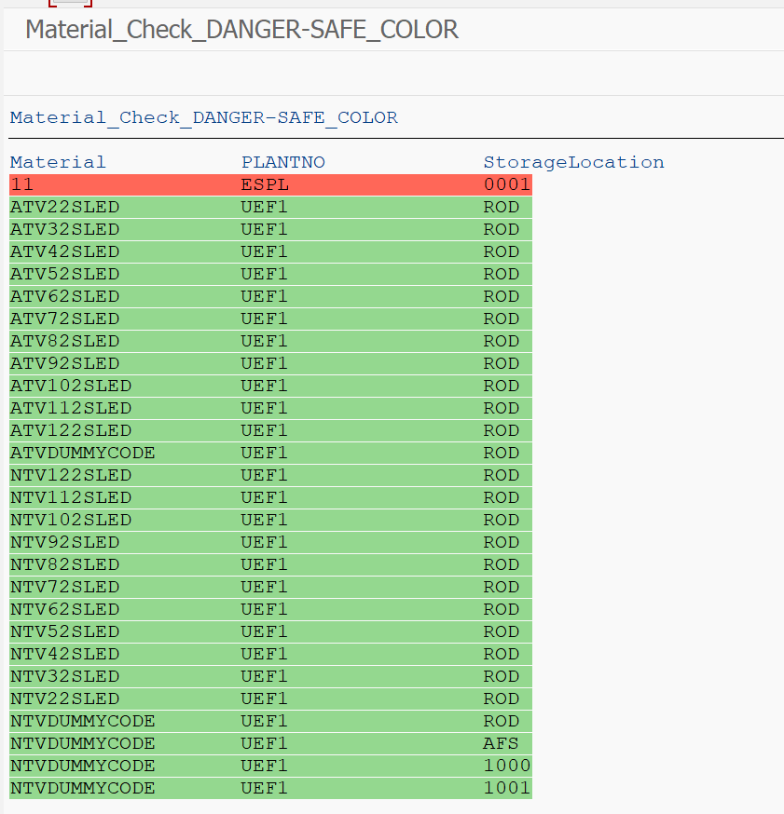

Program: ZJANA_PROCEDURES

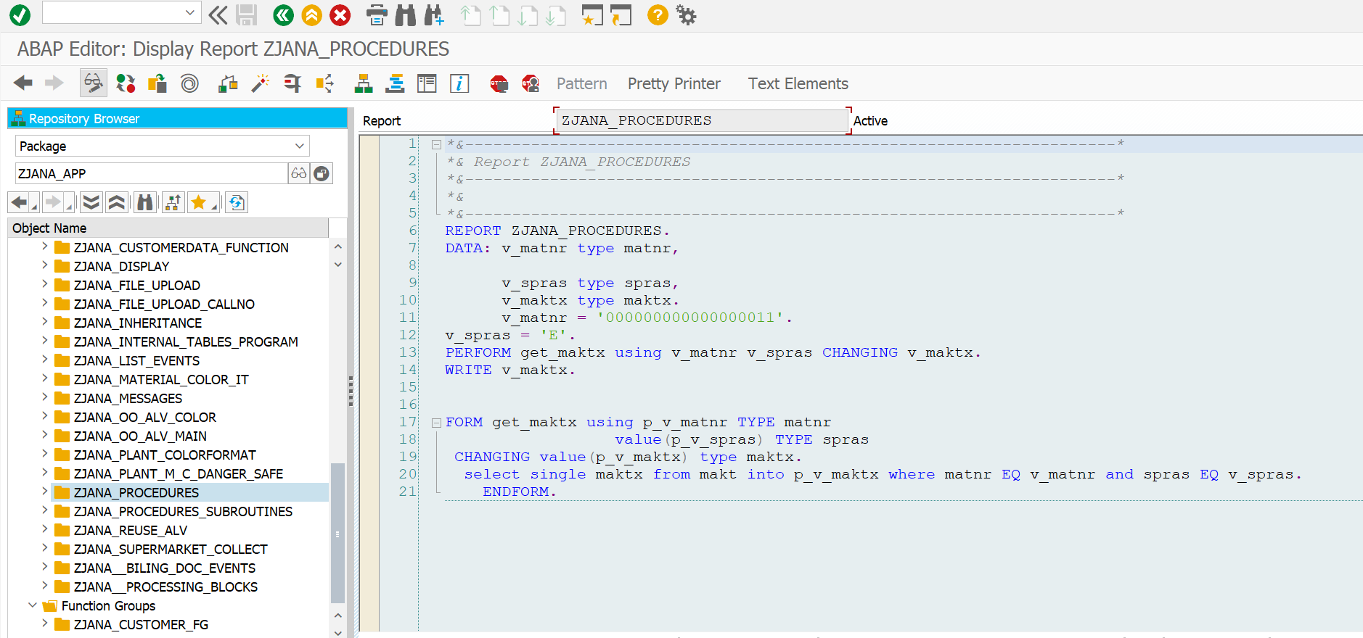

*\*&---------------------------------------------------------------------\**  
*\*& Report ZJANA_PROCEDURES*  
*\*&---------------------------------------------------------------------\**  
*\*&*  
*\*&---------------------------------------------------------------------\**  
REPORT ZJANA_PROCEDURES.  
DATA: v_matnr type matnr,  
  
 v_spras type spras,  
 v_maktx type maktx.  
 v_matnr = '000000000000000011'.  
v_spras = 'E'.  
PERFORM get_maktx using v_matnr v_spras CHANGING v_maktx.  
WRITE v_maktx.  
  
  
FORM get_maktx using p_v_matnr TYPE matnr  
 value(p_v_spras) TYPE spras  
 CHANGING value(p_v_maktx) type maktx.  
 select single maktx from makt into p_v_maktx where matnr EQ v_matnr and spras EQ v_spras.  
 ENDFORM.

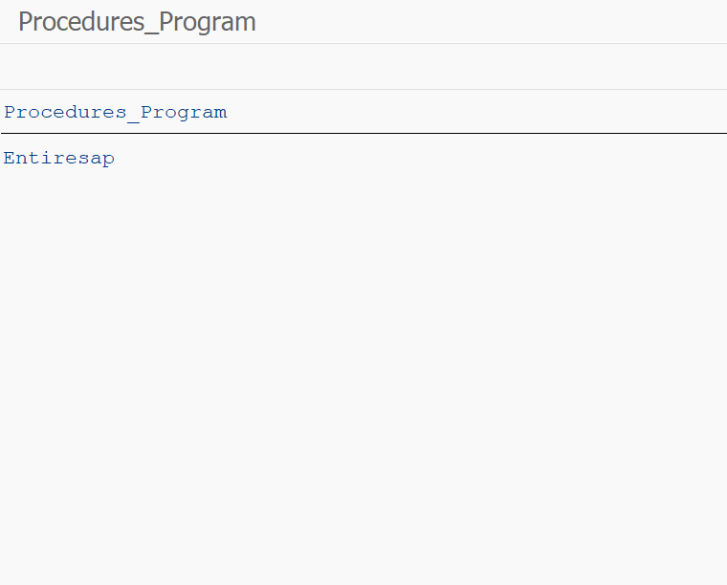

Program: ZJANA_SUPERMARKET_COLLECT

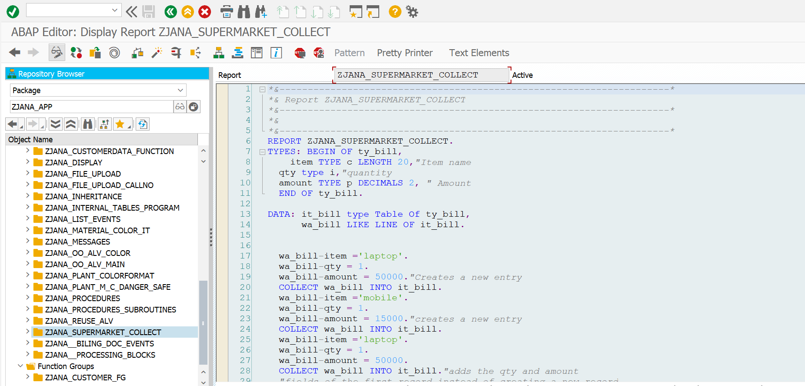

*\*&---------------------------------------------------------------------\**  
*\*& Report ZJANA_SUPERMARKET_COLLECT*  
*\*&---------------------------------------------------------------------\**  
*\*&*  
*\*&---------------------------------------------------------------------\**  
REPORT ZJANA_SUPERMARKET_COLLECT.  
TYPES: BEGIN OF ty_bill,  
 item TYPE c LENGTH 20,*"Item name*  
 qty type i,*"quantity*  
 amount TYPE p DECIMALS 2, *" Amount*  
 END OF ty_bill.  
  
DATA: it_bill type Table Of ty_bill,  
 wa_bill LIKE LINE OF it_bill.  
  
  
 wa_bill-item ='laptop'.  
 wa_bill-qty = 1.  
 wa_bill-amount = 50000.*"Creates a new entry*  
 COLLECT wa_bill INTO it_bill.  
 wa_bill-item ='mobile'.  
 wa_bill-qty = 1.  
 wa_bill-amount = 15000.*"creates a new entry*  
 COLLECT wa_bill INTO it_bill.  
 wa_bill-item ='laptop'.  
 wa_bill-qty = 1.  
 wa_bill-amount = 50000.  
 COLLECT wa_bill INTO it_bill.*"adds the qty and amount*  
 *"fields of the first record instead of creating a new record*  
  
 LOOP AT it_bill INTO wa_bill.  
AT FIRST.  
 WRITE AT:/'Item Name',  
 20 'Qunatity',  
 40 'Amount'.  
 ENDAT.  
  
 WRITE AT:/5 wa_bill-item LEFT-JUSTIFIED,  
 20 wa_bill-qty LEFT-JUSTIFIED,  
 40 wa_bill-amount LEFT-JUSTIFIED.  
  
 ENDLOOP.

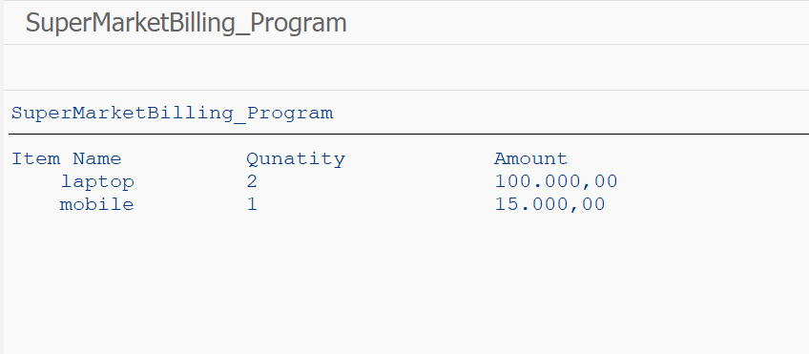

Program: ZJANA__BILING_DOC_EVENTS

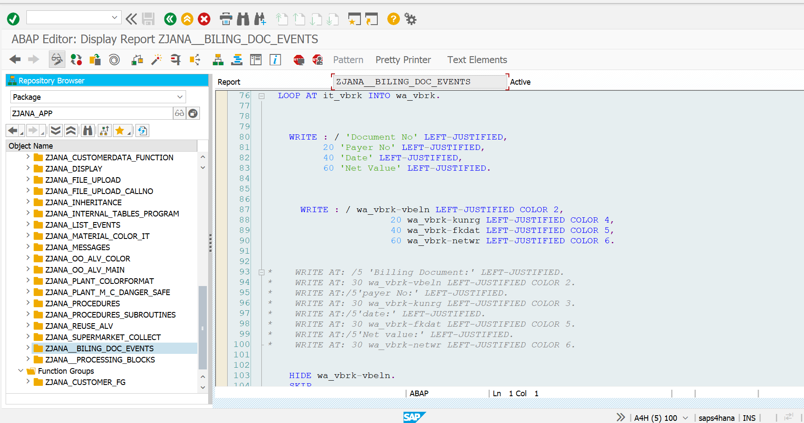

*\*&---------------------------------------------------------------------\**  
*\*& Report ZJANA__BILING_DOC_EVENTS*  
*\*&---------------------------------------------------------------------\**  
*\*&*  
*\*&---------------------------------------------------------------------\**  
*\*1.Find out to print the Footer if the page is Incompleted*  
*\**  
*\*2. Find out the how the AT line Selectiona and AT USER works.*  
*\**  
*\*33.Click on the Doc No then it has to show the Iteam Description.*  
*\**  
*\*4.Use all the Events in the single program and debug.*  
  
*"\*\*\*\*\*\*\*\*\*\*\*\*\*\*\*\*\*\*\*\*\*\*\*\*\*\*\*\*\*\*\*\*\*\*\*\*\*\*\*\*\*\*\*\*\*\*\*\*\*\*\*\*\*\*\*\*\*\*\*\*\*\*\*\*\*\*\*\*\*\*\*\*\*\*\*\*\*\*\**  
*\*1. Program Constructor Event*  
*\* LOAD-OF-PROGRAM*  
*\**  
*\**  
*\**  
*\*2. Reporting Events (Executable Type Program)*  
*\* INITIALIZATION*  
*\* START-OF-SELECTION*  
*\* END-OF-SELECTION*  
*\**  
*\**  
*\**  
*\*3. SELECTION SCREEN EVENTS*  
*\* AT SELECTION-SCREEN OUTPUT.*  
*\* AT SELECTION-SCREEN*  
*\* AT SELECTION-SCREEN ON field*  
*\* AT SELECTION-SCREEN ON block*  
*\* AT SELECTION-SCREEN ON HELP-REQUEST*  
*\* AT SELECTION-SCREEN ON VALUE-REQUEST*  
*\**  
*\**  
*\**  
*\*4.LIST EVENTS*  
*\* TOP-OF-PAGE*  
*\* END-OF-PAGE*  
*\* AT LINE-SELECTION*  
*\* AT USER-COMMAND*  
  
REPORT zjana__biling_doc_events LINE-COUNT 10(1).  
*" Data Objects*  
DATA : it_vbrk TYPE TABLE OF ZJANA_VBRk,  
 wa_vbrk LIKE LINE OF it_vbrk.  
DATA : it_vbrp TYPE TABLE OF zjana_vbrp,  
 wa_vbrp LIKE LINE OF it_vbrp.  
*"provide the selection screen for the user.*  
DATA p_vbeln TYPE zjana_vbrk-vbeln.  
SELECT-OPTIONS s_vbeln FOR p_vbeln.  
  
  
  
TYPES: BEGIN OF ty_makt,  
 matnr TYPE makt-matnr,  
 maktx TYPE makt-maktx,  
 END OF ty_makt.  
DATA: it_makt TYPE TABLE OF ty_makt,  
 wa_makt LIKE LINE OF it_makt.  
  
  
START-OF-SELECTION.  
 SELECT * FROM zjana_vbrk INTO TABLE it_vbrk WHERE vbeln IN s_vbeln.  
 SELECT * FROM zjana_vbrp INTO TABLE it_vbrp WHERE vbeln IN s_vbeln.  
  
  
END-OF-SELECTION.  
  
DATA : v_endPrint TYPE i VALUE 0.  
  
 SORT it_vbrp BY vbeln.  
  
  
  
 LOOP AT it_vbrk INTO wa_vbrk.  
  
  
  
 WRITE : / 'Document No' LEFT-JUSTIFIED,  
 20 'Payer No' LEFT-JUSTIFIED,  
 40 'Date' LEFT-JUSTIFIED,  
 60 'Net Value' LEFT-JUSTIFIED.  
  
  
  
 WRITE : / wa_vbrk-vbeln LEFT-JUSTIFIED COLOR 2,  
 20 wa_vbrk-kunrg LEFT-JUSTIFIED COLOR 4,  
 40 wa_vbrk-fkdat LEFT-JUSTIFIED COLOR 5,  
 60 wa_vbrk-netwr LEFT-JUSTIFIED COLOR 6.  
  
  
*\* WRITE AT: /5 'Billing Document:' LEFT-JUSTIFIED.*  
*\* WRITE AT: 30 wa_vbrk-vbeln LEFT-JUSTIFIED COLOR 2.*  
*\* WRITE AT:/5'payer No:' LEFT-JUSTIFIED.*  
*\* WRITE AT: 30 wa_vbrk-kunrg LEFT-JUSTIFIED COLOR 3.*  
*\* WRITE AT:/5'date:' LEFT-JUSTIFIED.*  
*\* WRITE AT: 30 wa_vbrk-fkdat LEFT-JUSTIFIED COLOR 5.*  
*\* WRITE AT:/5'Net value:' LEFT-JUSTIFIED.*  
*\* WRITE AT: 30 wa_vbrk-netwr LEFT-JUSTIFIED COLOR 6.*  
  
  
 HIDE wa_vbrk-vbeln.  
 SKIP.  
 CLEAR wa_vbrk.  
  
 ENDLOOP.  
 CLEAR wa_vbrk.  
  
 SKIP.  
  
AT LINE-SELECTION.  
 *"Read LINE sy-lilli.*  
 IF sy-subrc = 0.  
 SELECT * FROM zjana_vbrp INTO TABLE it_vbrp WHERE vbeln EQ wa_vbrk-vbeln.  
  
 WRITE AT:/5 'Item No',  
 20 'Material No',  
 40 'Qunatity',  
 60 'UOM',  
 80 'Net Value'.  
 LOOP AT it_vbrp INTO wa_vbrp.  
  
 WRITE AT:/5 wa_vbrp-posnr LEFT-JUSTIFIED,  
 20 wa_vbrp-matnr LEFT-JUSTIFIED,  
 40 wa_vbrp-fkimg LEFT-JUSTIFIED,  
 60 wa_vbrp-vrkme LEFT-JUSTIFIED,  
 80 wa_vbrp-netwr LEFT-JUSTIFIED.  
 AT END OF vbeln.  
 SUM.  
 WRITE: /60 'TOTAL NET VALUE:', wa_vbrp-netwr LEFT-JUSTIFIED COLOR 7.  
 ENDAT.  
 AT LAST.  
 *" the code here will be excuted in the last loop pass*  
 WRITE: /'END OF REPORT'.  
 ENDAT.  
  
 *"WRITE: sy-linct, sy-linno.*  
 ENDLOOP.  
  
  
 ENDIF.  
  
TOP-OF-PAGE.  
 WRITE 'UST GLOBAL'.  
 ULINE.  
  
RESERVE v_endPrint lines.  
  
  
END-OF-PAGE.  
  
 *"RESERVE 10 Lines.*  
 WRITE /'this is electronic genereated'.  
 ULINE.  
  
AT USER-COMMAND.  
 CASE sy-ucomm.  
 WHEN 'PDF'.  
 WHEN 'EXCEL'.  
  
 WHEN OTHERS.  
 ENDCASE.  
  
  
  
  
 *"output the data*  
 SET PF-STATUS 'LIST'.

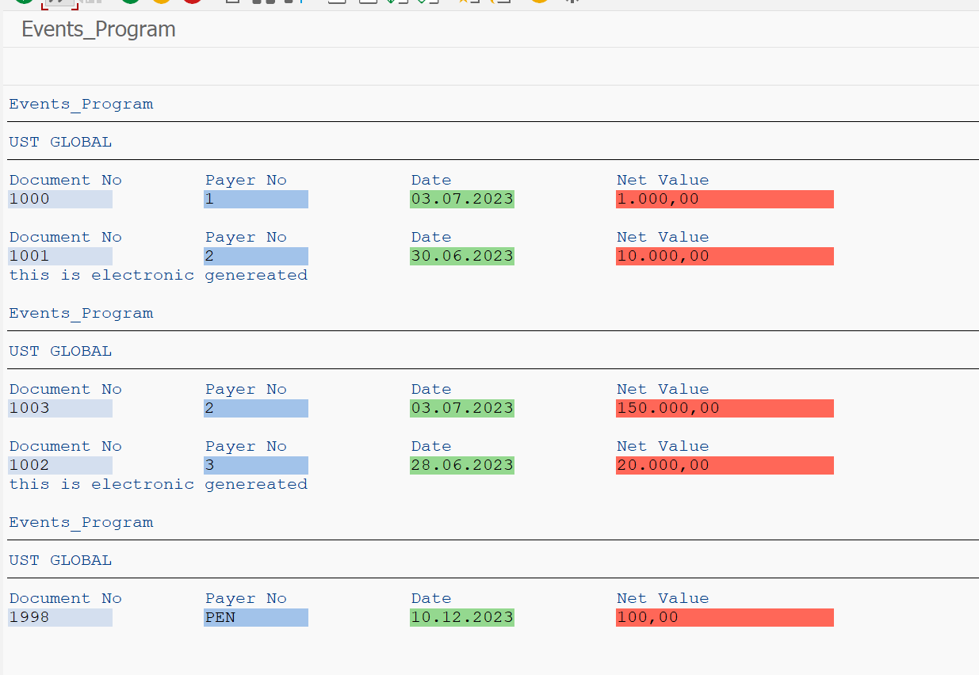

Program: ZJANA__PROCESSING_BLOCKS

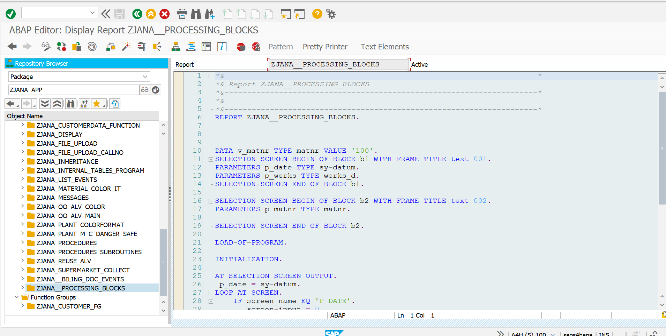

*\*&---------------------------------------------------------------------\**  
*\*& Report ZJANA__PROCESSING_BLOCKS*  
*\*&---------------------------------------------------------------------\**  
*\*&*  
*\*&---------------------------------------------------------------------\**  
REPORT ZJANA__PROCESSING_BLOCKS.  
  
  
  
DATA v_matnr TYPE matnr VALUE '100'.  
SELECTION-SCREEN BEGIN OF BLOCK b1 WITH FRAME TITLE text-001.  
PARAMETERS p_date TYPE sy-datum.  
PARAMETERS p_werks TYPE werks_d.  
SELECTION-SCREEN END OF BLOCK b1.  
  
SELECTION-SCREEN BEGIN OF BLOCK b2 WITH FRAME TITLE text-002.  
PARAMETERS p_matnr TYPE matnr.  
  
SELECTION-SCREEN END OF BLOCK b2.  
  
LOAD-OF-PROGRAM.  
  
INITIALIZATION.  
  
AT SELECTION-SCREEN OUTPUT.  
 p_date = sy-datum.  
LOOP AT SCREEN.  
 IF screen-name EQ 'P_DATE'.  
 screen-input = 0.  
 MODIFY SCREEN.  
  
 ENDIF.  
 ENDLOOP.  
  
 WRITE v_matnr.  
  
AT SELECTION-SCREEN ON BLOCK b1.  
 IF p_werks IS INITIAL.  
 MESSAGE 'Please endter a value' TYPE 'E'.  
 ENDIF.  
  
START-OF-SELECTION.  
  
  
 DATA v_name TYPE c.  
 WRITE v_matnr.  
  
AT LINE-SELECTION.  
 CALL SELECTION-SCREEN 1000.

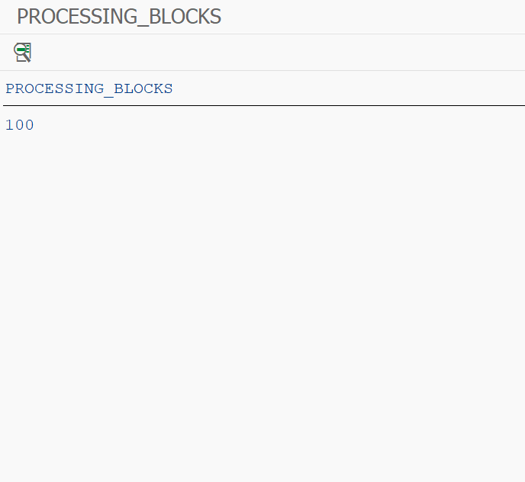

Program: ZJANA_ALV

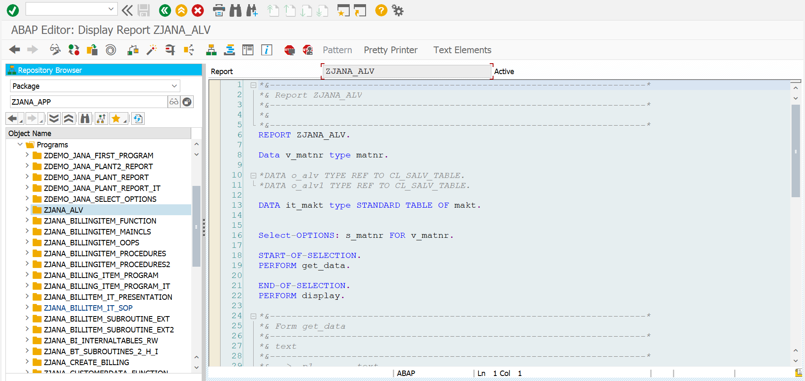

*\*&---------------------------------------------------------------------\**  
*\*& Report ZJANA_ALV*  
*\*&---------------------------------------------------------------------\**  
*\*&*  
*\*&---------------------------------------------------------------------\**  
REPORT ZJANA_ALV.  
  
Data v_matnr type matnr.  
  
*\*DATA o_alv TYPE REF TO CL_SALV_TABLE.*  
*\*DATA o_alv1 TYPE REF TO CL_SALV_TABLE.*  
  
DATA it_makt type STANDARD TABLE OF makt.  
  
  
Select-OPTIONS: s_matnr FOR v_matnr.  
  
START-OF-SELECTION.  
PERFORM get_data.  
  
END-OF-SELECTION.  
PERFORM display.  
  
*\*&---------------------------------------------------------------------\**  
*\*& Form get_data*  
*\*&---------------------------------------------------------------------\**  
*\*& text*  
*\*&---------------------------------------------------------------------\**  
*\*& --> p1 text*  
*\*& <-- p2 text*  
*\*&---------------------------------------------------------------------\**  
FORM get_data .  
  
 Select * from makt into TABLE it_makt where matnr in s_matnr.  
  
ENDFORM.  
  
  
*\*&---------------------------------------------------------------------\**  
*\*& Form display*  
*\*&---------------------------------------------------------------------\**  
*\*& text*  
*\*&---------------------------------------------------------------------\**  
*\*& --> p1 text*  
*\*& <-- p2 text*  
*\*&---------------------------------------------------------------------\**  
FORM display .  
 CL_SALV_TABLE=>factory(  
*\* EXPORTING*  
*\* list_display = if_salv_c_bool_sap=>false " ALV Displayed in List Mode*  
*\* r_container = " Abstract Container for GUI Controls*  
*\* container_name =*  
 IMPORTING  
 r_salv_table = DATA(o_alv) *" Basis Class Simple ALV Tables*  
 CHANGING  
 t_table = it_makt  
  
 ).  
  
 DATA: o_function TYPE REF TO CL_SALV_FUNCTIONS_LIST.  
 o_alv->set_screen_status(  
 report = 'ZJANA_ALV'  
 pfstatus = 'ZJANA_ALV_STATUS'  
*\* set_functions = cl_salv_model_base=>c_functions_none*  
 ).  
  
*\*CATCH cx_salv_msg. " ALV: General Error Class with Message*  
  
 o_alv->display( ).  
  
ENDFORM.

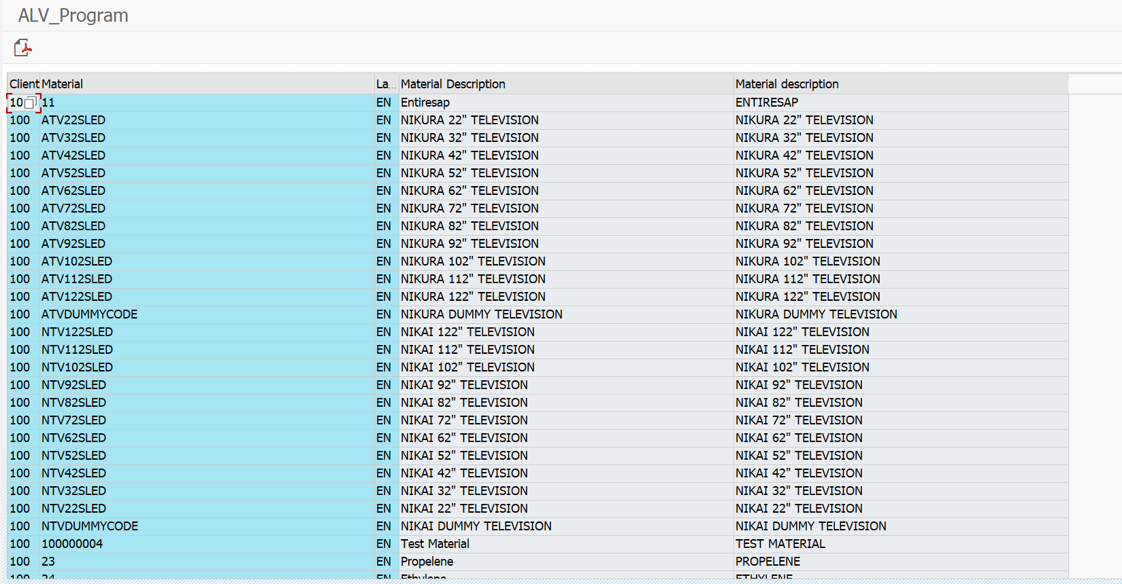

REPORT: ZJANA_BILLINGITEM_MAINCLS

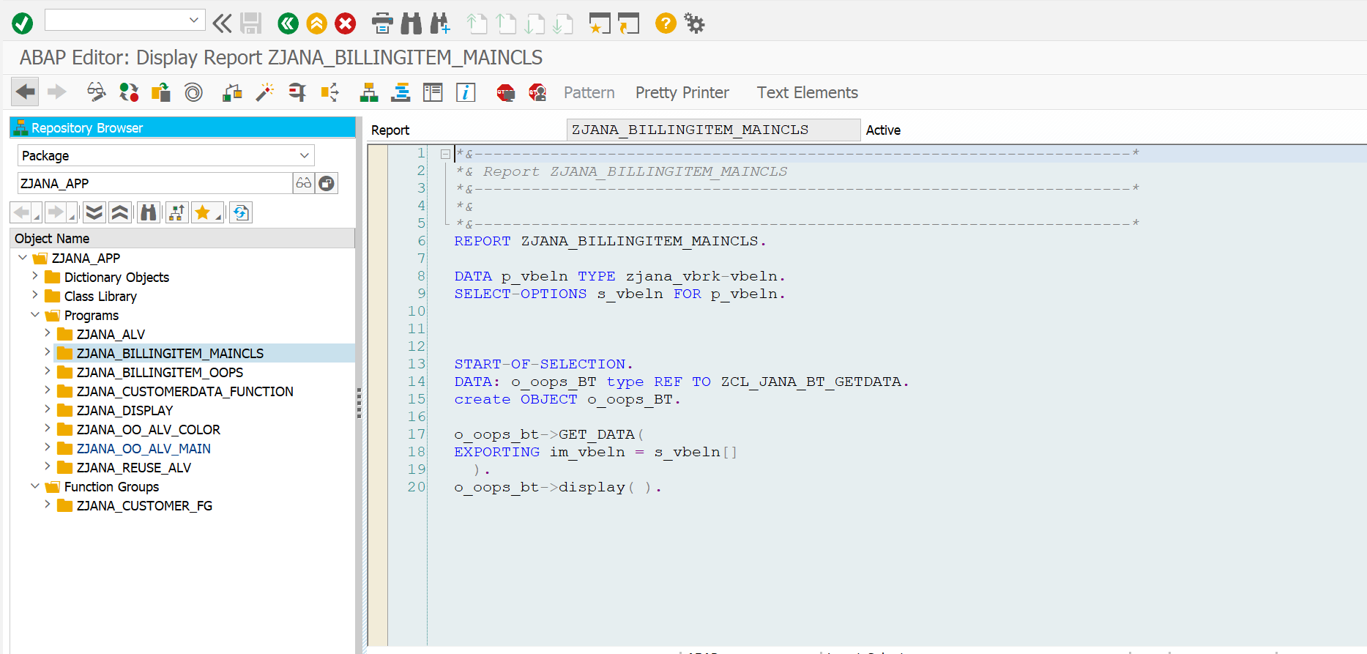

*\*&---------------------------------------------------------------------\**  
*\*& Report ZJANA_BILLINGITEM_MAINCLS*  
*\*&---------------------------------------------------------------------\**  
*\*&*  
*\*&---------------------------------------------------------------------\**  
REPORT ZJANA_BILLINGITEM_MAINCLS.  
  
DATA p_vbeln TYPE zjana_vbrk-vbeln.  
SELECT-OPTIONS s_vbeln FOR p_vbeln.  
  
  
  
START-OF-SELECTION.  
DATA: o_oops_BT type REF TO ZCL_JANA_BT_GETDATA.  
create OBJECT o_oops_BT.  
  
o_oops_bt->GET_DATA(  
EXPORTING im_vbeln = s_vbeln[]  
 ).  
o_oops_bt->display( ).

**RESULT:**

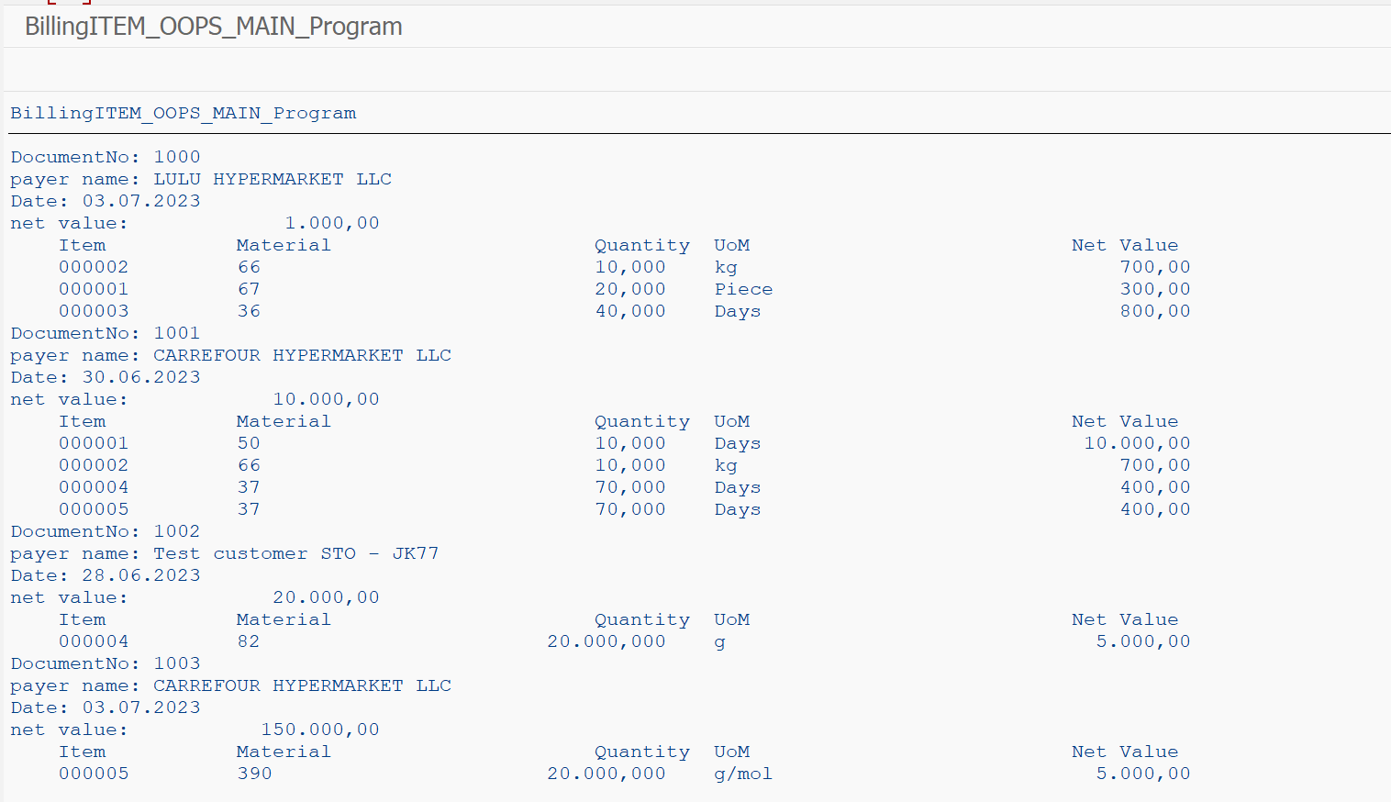

REPORT: zcl_jana_bt_getdata

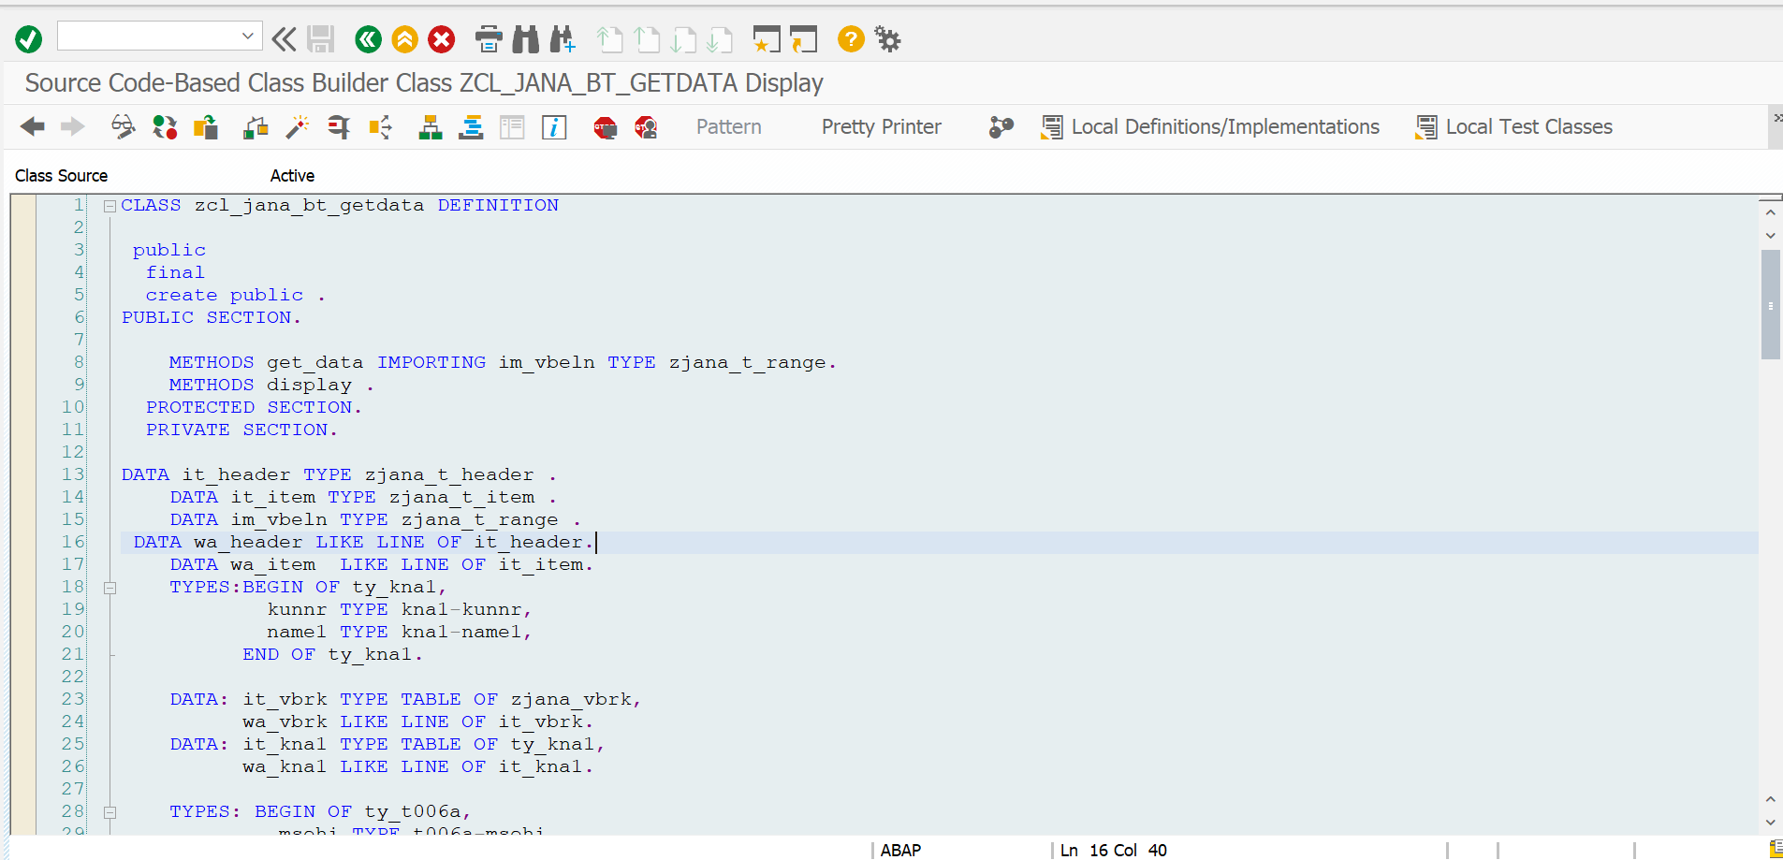

CLASS zcl_jana_bt_getdata DEFINITION  
  
 public  
 final  
 create public .  
PUBLIC SECTION.  
  
 METHODS get_data IMPORTING im_vbeln TYPE zjana_t_range.  
 METHODS display .  
 PROTECTED SECTION.  
 PRIVATE SECTION.  
  
DATA it_header TYPE zjana_t_header .  
 DATA it_item TYPE zjana_t_item .  
 DATA im_vbeln TYPE zjana_t_range .  
 DATA wa_header LIKE LINE OF it_header.  
 DATA wa_item LIKE LINE OF it_item.  
 TYPES:BEGIN OF ty_kna1,  
 kunnr TYPE kna1-kunnr,  
 name1 TYPE kna1-name1,  
 END OF ty_kna1.  
  
 DATA: it_vbrk TYPE TABLE OF zjana_vbrk,  
 wa_vbrk LIKE LINE OF it_vbrk.  
 DATA: it_kna1 TYPE TABLE OF ty_kna1,  
 wa_kna1 LIKE LINE OF it_kna1.  
  
 TYPES: BEGIN OF ty_t006a,  
 msehi TYPE t006a-msehi,  
 mseht TYPE t006a-mseht,  
 END OF ty_t006a.  
  
  
  
 DATA: it_vbrp TYPE TABLE OF zjana_vbrp,  
 wa_vbrp LIKE LINE OF it_vbrp.  
 DATA: it_t006a TYPE STANDARD TABLE OF ty_t006a,  
 wa_t006a LIKE LINE OF it_t006a.  
  
ENDCLASS.  
  
  
  
CLASS ZCL_JANA_BT_GETDATA IMPLEMENTATION.  
  
  
*\* <SIGNATURE>---------------------------------------------------------------------------------------+*  
*\* | Instance Public Method ZCL_JANA_BT_GETDATA->DISPLAY*  
*\* +-------------------------------------------------------------------------------------------------+*  
*\* +--------------------------------------------------------------------------------------</SIGNATURE>*  
 METHOD display.  
 SORT it_item BY vbeln.  
  
 LOOP AT it_item INTO wa_item.  
  
 AT NEW vbeln.  
 READ TABLE it_header INTO wa_header WITH KEY vbeln = wa_item-vbeln.  
  
 WRITE: /'DocumentNo:',wa_header-vbeln.  
 WRITE:/'payer name:',wa_header-name1.  
 WRITE:/'Date:',wa_header-fkdat.  
 WRITE:/'net value:',wa_header-netwr.  
 WRITE : /5 'Item',  
 20 'Material',  
 50 'Quantity',  
 60 'UoM',  
 90 'Net Value'.  
 ENDAT.  
  
  
  
 WRITE : /5 wa_item-posnr,  
 20 wa_item-matnr,  
 40 wa_item-fkimg,  
 60 wa_item-mseht,  
 80 wa_item-netwr.  
  
  
 ENDLOOP.  
 ENDMETHOD.  
  
  
*\* <SIGNATURE>---------------------------------------------------------------------------------------+*  
*\* | Instance Public Method ZCL_JANA_BT_GETDATA->GET_DATA*  
*\* +-------------------------------------------------------------------------------------------------+*  
*\* | [--->] IM_VBELN TYPE ZJANA_T_RANGE*  
*\* +--------------------------------------------------------------------------------------</SIGNATURE>*  
 METHOD get_data.  
 SELECT * FROM zjana_vbrk INTO TABLE it_vbrk WHERE vbeln IN im_vbeln[].  
  
 IF sy-subrc IS INITIAL.  
 SELECT kunnr name1 FROM kna1 INTO TABLE it_kna1 FOR ALL ENTRIES IN it_vbrk WHERE kunnr EQ it_vbrk-kunrg.  
 ENDIF.  
  
 LOOP AT it_vbrk INTO wa_vbrk.  
  
 READ TABLE it_kna1 INTO wa_kna1 WITH KEY kunnr = wa_vbrk-kunrg.  
  
  
 MOVE-CORRESPONDING wa_vbrk TO wa_header.  
 MOVE-CORRESPONDING wa_kna1 TO wa_header.  
 APPEND wa_header TO it_header.  
  
  
 ENDLOOP.  
  
 SELECT * FROM zjana_vbrp INTO TABLE it_vbrp WHERE vbeln IN im_vbeln[].  
  
 IF sy-subrc IS INITIAL.  
 SELECT msehi mseht FROM t006a INTO TABLE it_t006a FOR ALL ENTRIES IN it_vbrp WHERE msehi = it_vbrp-vrkme.  
  
 ENDIF.  
  
 LOOP AT it_vbrp INTO wa_vbrp.  
  
 READ TABLE it_t006a INTO wa_t006a WITH KEY msehi = wa_vbrp-vrkme.  
  
  
 MOVE-CORRESPONDING wa_vbrp TO wa_item.  
 MOVE-CORRESPONDING wa_t006a TO wa_item.  
  
  
 APPEND wa_item TO it_item.  
  
  
 ENDLOOP.  
  
  
 ENDMETHOD.  
ENDCLASS.

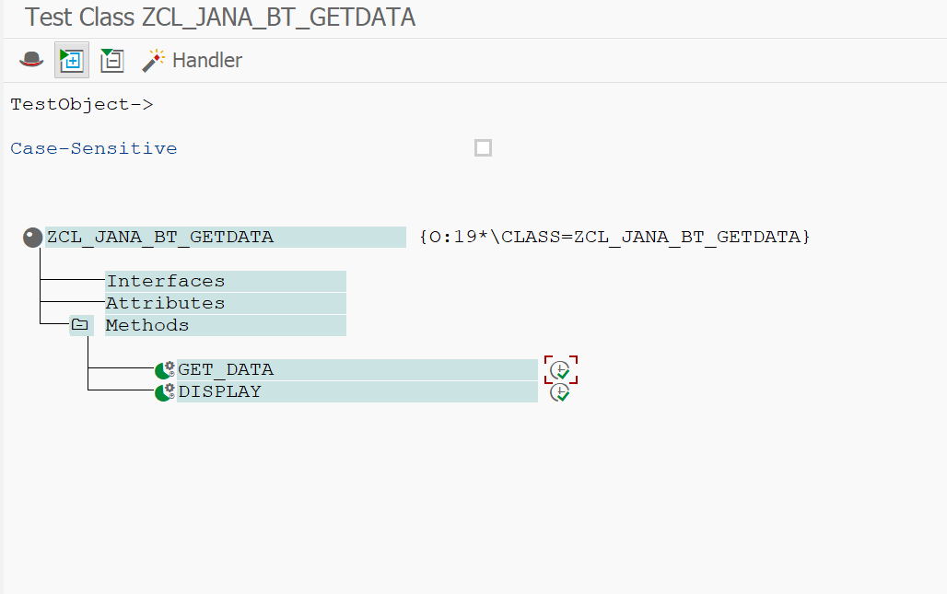

REPORT: ZJANA_BILLINGITEM_OOPS

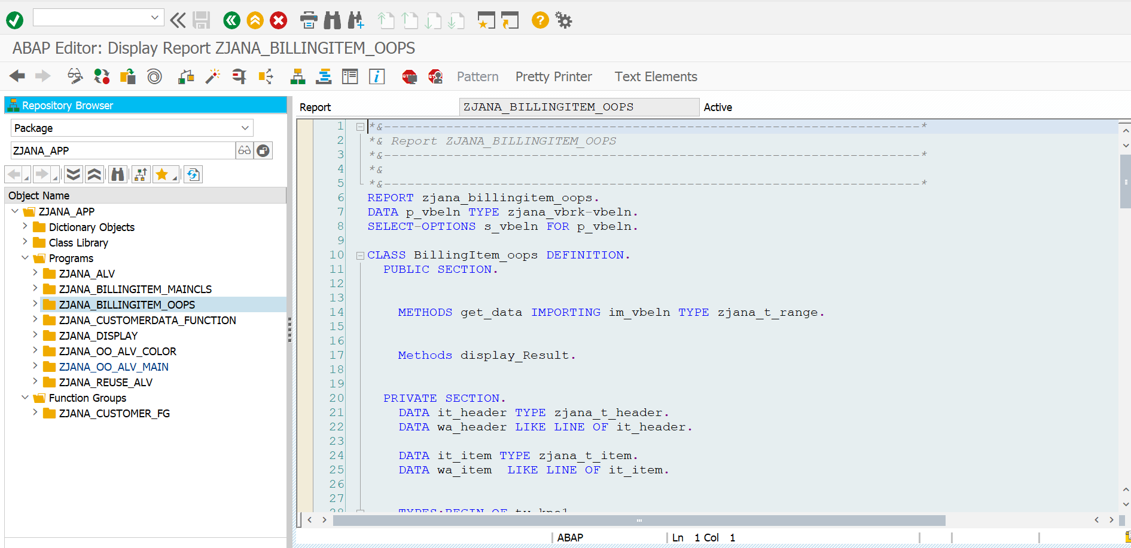

*\*&---------------------------------------------------------------------\**  
*\*& Report ZJANA_BILLINGITEM_OOPS*  
*\*&---------------------------------------------------------------------\**  
*\*&*  
*\*&---------------------------------------------------------------------\**  
REPORT zjana_billingitem_oops.  
DATA p_vbeln TYPE zjana_vbrk-vbeln.  
SELECT-OPTIONS s_vbeln FOR p_vbeln.  
  
CLASS BillingItem_oops DEFINITION.  
 PUBLIC SECTION.  
  
  
 METHODS get_data IMPORTING im_vbeln TYPE zjana_t_range.  
  
  
 Methods display_Result.  
  
  
 PRIVATE SECTION.  
 DATA it_header TYPE zjana_t_header.  
 DATA wa_header LIKE LINE OF it_header.  
  
 DATA it_item TYPE zjana_t_item.  
 DATA wa_item LIKE LINE OF it_item.  
  
  
 TYPES:BEGIN OF ty_kna1,  
 kunnr TYPE kna1-kunnr,  
 name1 TYPE kna1-name1,  
 END OF ty_kna1.  
  
 DATA: it_vbrk TYPE TABLE OF zjana_vbrk,  
 wa_vbrk LIKE LINE OF it_vbrk.  
 DATA: it_kna1 TYPE TABLE OF ty_kna1,  
 wa_kna1 LIKE LINE OF it_kna1.  
  
 TYPES: BEGIN OF ty_t006a,  
 msehi TYPE t006a-msehi,  
 mseht TYPE t006a-mseht,  
 END OF ty_t006a.  
  
  
  
 DATA: it_vbrp TYPE TABLE OF zjana_vbrp,  
 wa_vbrp LIKE LINE OF it_vbrp.  
 DATA: it_t006a TYPE STANDARD TABLE OF ty_t006a,  
 wa_t006a LIKE LINE OF it_t006a.  
  
  
ENDCLASS.  
*\**  
*\*SELECTION-SCREEN BEGIN OF BLOCK b1 WITH FRAME TITLE text-001.*  
*\* SELECT-OPTIONS s_vbeln FOR p_vbeln MEMORY ID vbe.*  
*\**  
*\*SELECTION-SCREEN END OF BLOCK b1.*  
  
  
CLASS billingitem_oops IMPLEMENTATION.  
  
  
  
 METHOD get_data.  
  
 select * FROM zjana_vbrk into table it_vbrk where vbeln in im_vbeln[].  
  
 if sy-subrc is INITIAL.  
 select kunnr name1 from kna1 into TABLE it_kna1 FOR ALL ENTRIES IN it_vbrk WHERE kunnr EQ it_vbrk-kunrg.  
 ENDIF.  
  
 Loop At it_vbrk into wa_vbrk.  
  
 READ TABLE it_kna1 INTO wa_kna1 with key kunnr = wa_vbrk-kunrg.  
  
  
 MOVE-CORRESPONDING wa_vbrk to wa_header.  
 MOVE-CORRESPONDING wa_kna1 to wa_header.  
 append wa_header to it_header.  
 *" ex_header = it_header.*  
  
 ENDLOOP.  
  
 Select * from zjana_vbrp into table it_vbrp where vbeln in im_vbeln[].  
  
 if sy-subrc is INITIAL.  
 select msehi mseht from t006a into table it_t006a FOR ALL ENTRIES IN it_vbrp where msehi = it_vbrp-vrkme.  
  
 ENDIF.  
  
 Loop at it_vbrp INTO wa_vbrp.  
  
 READ TABLE it_t006a into wa_t006a with key msehi = wa_vbrp-vrkme.  
  
  
 MOVE-CORRESPONDING wa_vbrp to wa_item.  
 MOVE-CORRESPONDING wa_t006a to wa_item.  
  
  
 APPEND wa_item to it_item.  
 *" ex_item = it_item.*  
  
 ENDLOOP.  
  
  
  
 ENDMETHOD.  
  
 METHOD display_Result.  
  
 Sort it_item by vbeln.  
  
 Loop At it_item INTO wa_item.  
  
 AT NEW vbeln.  
 READ TABLE it_header into wa_header with key vbeln = wa_vbrp-vbeln.  
  
 Write: /'DocumentNo:',wa_header-vbeln.  
 Write:/'payer name:',wa_header-name1.  
 write:/'Date:',wa_header-fkdat.  
 write:/'net value:',wa_header-netwr.  
 WRITE : /5 'Item',  
 20 'Material',  
 50 'Quantity',  
 60 'UoM',  
 90 'Net Value'.  
 ENDAT.  
  
  
  
 WRITE : /5 wa_item-posnr,  
 20 wa_item-matnr,  
 40 wa_item-fkimg,  
 60 wa_item-mseht,  
 80 wa_item-netwr.  
  
  
 ENDLOOP.  
  
 ENDMETHOD.  
  
  
ENDCLASS.  
  
DATA O_billingItem_OOPS type REF TO billingitem_oops.  
  
  
START-OF-SELECTION.  
create OBJECT o_billingitem_oops.  
  
o_billingitem_oops->get_data(  
EXPORTING im_vbeln = s_vbeln[]  
).  
  
o_billingItem_oops->display_Result( ).

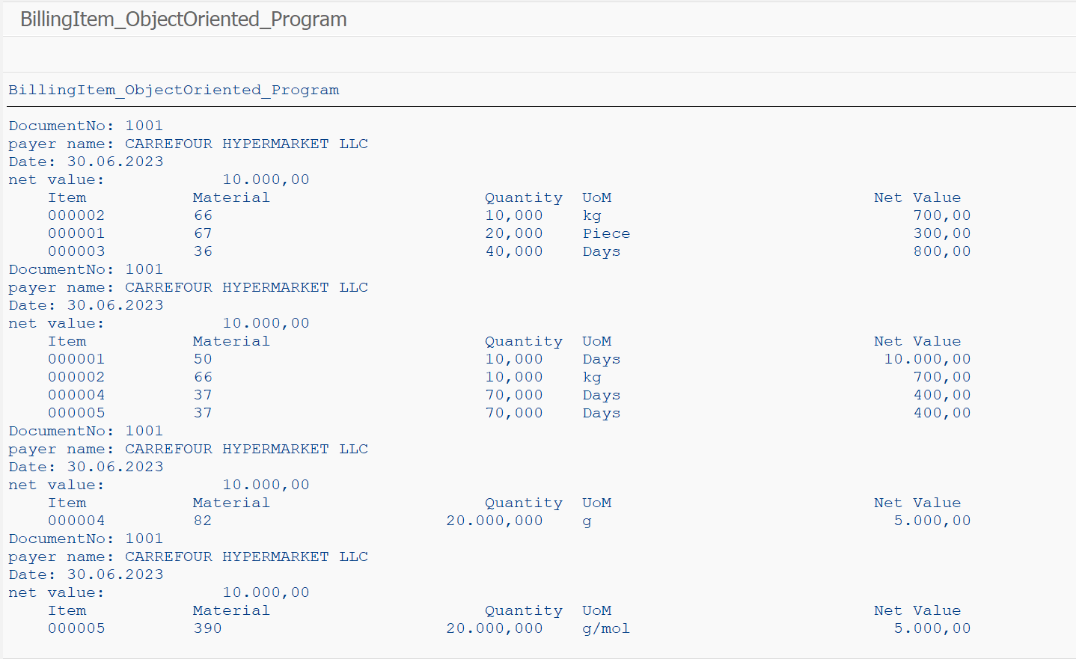

REPORT: ZJANA_DISPLAY

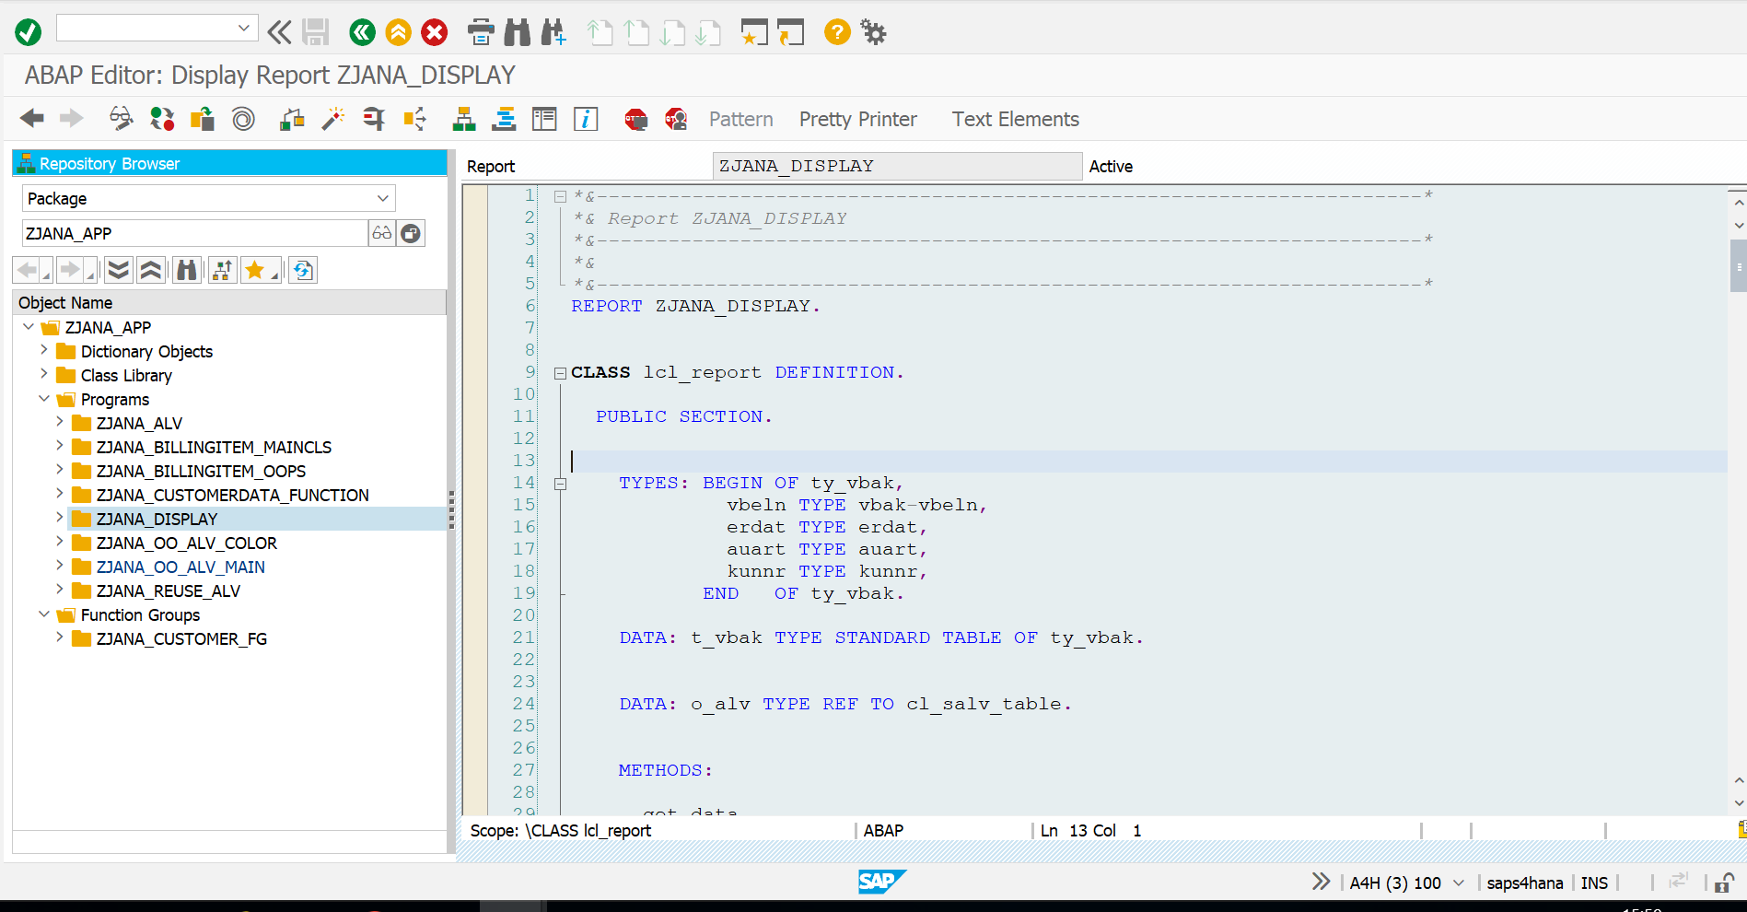

*\*&---------------------------------------------------------------------\**  
*\*& Report ZJANA_DISPLAY*  
*\*&---------------------------------------------------------------------\**  
*\*&*  
*\*&---------------------------------------------------------------------\**  
REPORT ZJANA_DISPLAY.  
  
  
CLASS lcl_report DEFINITION.  
  
 PUBLIC SECTION.  
  
  
 TYPES: BEGIN OF ty_vbak,  
 vbeln TYPE vbak-vbeln,  
 erdat TYPE erdat,  
 auart TYPE auart,  
 kunnr TYPE kunnr,  
 END OF ty_vbak.  
  
 DATA: t_vbak TYPE STANDARD TABLE OF ty_vbak.  
  
  
 DATA: o_alv TYPE REF TO cl_salv_table.  
  
  
 METHODS:  
  
 get_data,  
  
  
 generate_output.  
  
 PRIVATE SECTION.  
  
 METHODS:  
 set_pf_status  
 CHANGING  
 co_alv TYPE REF TO cl_salv_table.  
*\**  
 METHODS:  
 set_layout  
 CHANGING  
 co_alv TYPE REF TO cl_salv_table.  
  
 METHODS:  
 set_top_of_page  
 CHANGING  
 co_alv TYPE REF TO cl_salv_table.  
 METHODS:  
 set_end_of_page  
 CHANGING  
 co_alv TYPE REF TO cl_salv_table.  
  
 METHODS:  
 set_display_setting  
 CHANGING  
 co_alv TYPE REF TO cl_salv_table.  
  
  
  
  
  
ENDCLASS.  
  
START-OF-SELECTION.  
 DATA: lo_report TYPE REF TO lcl_report.  
  
 CREATE OBJECT lo_report.  
  
 lo_report->get_data( ).  
  
 lo_report->generate_output( ).  
  
CLASS lcl_report IMPLEMENTATION.  
*\**  
 METHOD get_data.  
  
 SELECT vbeln erdat auart kunnr  
 INTO TABLE t_vbak  
 FROM vbak  
 UP TO 20 ROWS.  
  
 ENDMETHOD.  
  
 METHOD generate_output.  
  
 DATA: lx_msg TYPE REF TO cx_salv_msg.  
 TRY.  
 cl_salv_table=>factory(  
 IMPORTING  
 r_salv_table = o_alv  
 CHANGING  
 t_table = t_vbak ).  
 CATCH cx_salv_msg INTO lx_msg.  
 ENDTRY.  
  
 DATA: lc_sort TYPE REF TO cl_salv_sorts.  
try.  
 lc_sort = O_alv->get_sorts( ).  
  
 lc_sort->add_sort( columnname = 'VBELN'  
 subtotal = abap_true  
 sequence = if_salv_c_sort=>sort_up ).  
  
 CATCH:cx_salv_not_found cx_salv_data_error cx_salv_existing.  
 endtry.  
  
  
 CALL METHOD set_pf_status  
 CHANGING  
 co_alv = o_alv.  
  
 CALL METHOD set_layout  
 CHANGING  
 co_alv = o_alv.  
  
 CALL METHOD me->set_top_of_page  
 CHANGING  
 co_alv = o_alv.  
  
 CALL METHOD me->set_end_of_page  
 CHANGING  
 co_alv = o_alv.  
  
 CALL METHOD set_display_setting  
 CHANGING  
 co_alv = o_alv.  
  
  
 DATA: lo_functions TYPE REF TO cl_salv_functions_list.  
  
 lo_functions = o_alv->get_functions( ).  
 lo_functions->set_default( abap_true ).  
 o_alv->display( ).  
  
  
  
  
 ENDMETHOD.  
 METHOD set_pf_status.  
 co_alv->set_screen_status(  
 report = 'ZJANA_DISPLAY'  
 pfstatus = 'STANDARD'  
  
 ).  
 ENDMETHOD.  
 METHOD set_layout.  
  
 DATA: lo_layout TYPE REF TO cl_salv_layout,  
 lf_variant TYPE slis_vari,  
 ls_key TYPE salv_s_layout_key.  
  
 lo_layout = co_alv->get_layout( ).  
  
 ls_key-report = sy-repid.  
 lo_layout->set_key( ls_key ).  
  
 lo_layout->set_save_restriction( if_salv_c_layout=>restrict_none ).  
  
 lf_variant = 'DEFAULT'.  
 lo_layout->set_initial_layout( lf_variant ).  
  
  
 ENDMETHOD.  
 METHOD set_top_of_page.  
*\**  
 DATA: lo_header TYPE REF TO cl_salv_form_layout_grid,  
 lo_h_label TYPE REF TO cl_salv_form_label,  
 lo_h_flow TYPE REF TO cl_salv_form_layout_flow.  
*\**  
*\* header object*  
 CREATE OBJECT lo_header.  
*\**  
*\* To create a Lable or Flow we have to specify the target*  
*\* row and column number where we need to set up the output*  
*\* text.*  
*\**  
*\* information in Bold*  
 lo_h_label = lo_header->create_label( row = 1 column = 1 ).  
 lo_h_label->set_text( 'Header in Bold' ).  
*\**  
*\* information in tabular format*  
 lo_h_flow = lo_header->create_flow( row = 2 column = 1 ).  
 lo_h_flow->create_text( text = 'This is text of flow' ).  
*\**  
 lo_h_flow = lo_header->create_flow( row = 3 column = 1 ).  
 lo_h_flow->create_text( text = 'Number of Records in the output' ).  
*\**  
 lo_h_flow = lo_header->create_flow( row = 3 column = 2 ).  
 lo_h_flow->create_text( text = 20 ).  
*\**  
*\* set the top of list using the header for Online.*  
 co_alv->set_top_of_list( lo_header ).  
*\**  
*\* set the top of list using the header for Print.*  
 co_alv->set_top_of_list_print( lo_header ).  
*\**  
 ENDMETHOD. *"set_top_of_page*  
*\**  
 METHOD set_end_of_page.  
*\**  
 DATA: lo_footer TYPE REF TO cl_salv_form_layout_grid,  
 lo_f_label TYPE REF TO cl_salv_form_label,  
 lo_f_flow TYPE REF TO cl_salv_form_layout_flow.  
*\**  
*\* footer object*  
 CREATE OBJECT lo_footer.  
*\**  
*\* information in bold*  
 lo_f_label = lo_footer->create_label( row = 1 column = 1 ).  
 lo_f_label->set_text( 'Footer .. here it goes' ).  
*\**  
*\* tabular information*  
 lo_f_flow = lo_footer->create_flow( row = 2 column = 1 ).  
 lo_f_flow->create_text( text = 'This is text of flow in footer' ).  
*\**  
 lo_f_flow = lo_footer->create_flow( row = 3 column = 1 ).  
 lo_f_flow->create_text( text = 'Footer number' ).  
*\**  
 lo_f_flow = lo_footer->create_flow( row = 3 column = 2 ).  
 lo_f_flow->create_text( text = 1 ).  
*\**  
*\* Online footer*  
 co_alv->set_end_of_list( lo_footer ).  
*\**  
*\* Footer in print*  
 co_alv->set_end_of_list_print( lo_footer ).  
*\**  
  
 ENDMETHOD.  
 METHOD set_display_setting.  
*\**  
 DATA: lo_display TYPE REF TO cl_salv_display_settings.  
*\**  
*\* get display object*  
 lo_display = co_alv->get_display_settings( ).  
*\**  
*\* set ZEBRA pattern*  
 lo_display->set_striped_pattern( 'X' ).  
*\**  
*\* Title to ALV*  
 lo_display->set_list_header( 'ALV Test for Display Settings' ).  
*\**  
  
  
 o_alv->display( ).  
  
 ENDMETHOD.  
  
  
  
ENDCLASS.

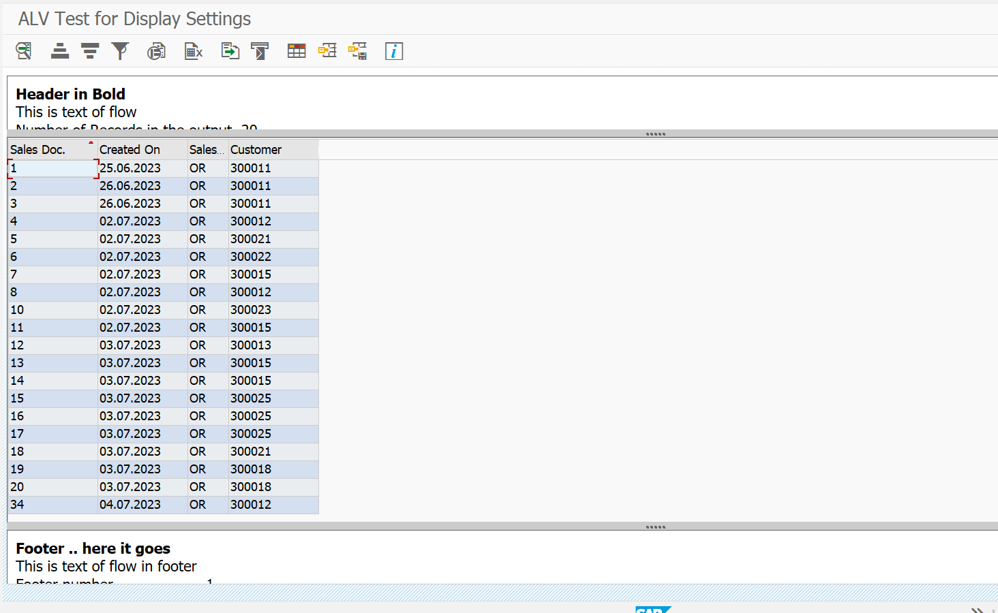

REPORT: ZJANA_OO_ALV_COLOR

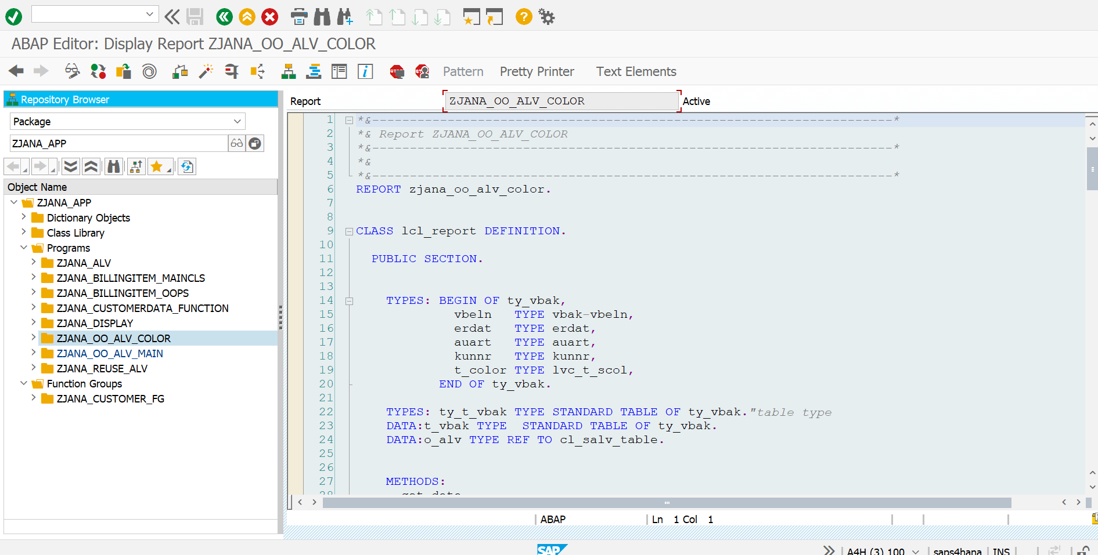

*\*&---------------------------------------------------------------------\**  
*\*& Report ZJANA_OO_ALV_COLOR*  
*\*&---------------------------------------------------------------------\**  
*\*&*  
*\*&---------------------------------------------------------------------\**  
REPORT zjana_oo_alv_color.  
  
  
CLASS lcl_report DEFINITION.  
  
 PUBLIC SECTION.  
  
  
 TYPES: BEGIN OF ty_vbak,  
 vbeln TYPE vbak-vbeln,  
 erdat TYPE erdat,  
 auart TYPE auart,  
 kunnr TYPE kunnr,  
 t_color TYPE lvc_t_scol,  
 END OF ty_vbak.  
  
 TYPES: ty_t_vbak TYPE STANDARD TABLE OF ty_vbak.*"table type*  
 DATA:t_vbak TYPE STANDARD TABLE OF ty_vbak.  
 DATA:o_alv TYPE REF TO cl_salv_table.  
  
  
 METHODS:  
 get_data,  
 generate_output.  
  
  
 PRIVATE SECTION.  
 METHODS:  
 set_pf_status  
  
 CHANGING  
 co_alv TYPE REF TO cl_salv_table.  
 METHODS:  
 set_colors  
 CHANGING  
  
 co_alv TYPE REF TO cl_salv_table  
 ct_vbak TYPE ty_t_vbak.  
  
  
  
ENDCLASS.  
  
  
  
  
  
  
  
CLASS lcl_report IMPLEMENTATION.  
  
 METHOD get_data.  
 SELECT vbeln erdat auart kunnr INTO CORRESPONDING FIELDS OF TABLE t_vbak FROM vbak UP TO 20 ROWS.  
 ENDMETHOD.  
  
  
 METHOD generate_output.  
 DATA:lx_msg TYPE REF TO cx_salv_msg  
 .  
 TRY.  
 cl_salv_table=>factory(  
*\* EXPORTING*  
*\* list_display = if_salv_c_bool_sap=>false " ALV Displayed in List Mode*  
*\* r_container = " Abstract Container for GUI Controls*  
*\* container_name =*  
 IMPORTING  
 r_salv_table = o_alv *" Basis Class Simple ALV Tables*  
 CHANGING  
 t_table = t_vbak  
 ).  
 CATCH cx_salv_msg. *" ALV: General Error Class with Message*  
  
  
  
  
  
  
 ENDTRY.  
  
 CALL METHOD set_pf_status  
 CHANGING  
 co_alv = o_alv.  
  
  
  
  
 CALL METHOD set_colors  
 CHANGING  
 co_alv = o_alv  
 ct_vbak = t_vbak.  
 o_alv->display( ).  
  
  
  
 ENDMETHOD.  
  
 METHOD set_pf_status.  
 DATA: lo_functions TYPE REF TO cl_salv_functions_list.  
  
 lo_functions = co_alv->get_functions( ).  
  
 lo_functions->set_default( abap_true ).  
  
 ENDMETHOD.  
 METHOD set_colors.  
 DATA: lo_cols_tab TYPE REF TO cl_salv_columns_table,  
 lo_col_tab TYPE REF TO cl_salv_column_table,  
 ls_color TYPE lvc_s_colo.  
  
  
 lo_cols_tab = co_alv->get_columns( ).  
  
 INCLUDE <color>.  
 TRY.  
 lo_col_tab ?= lo_cols_tab->get_column( 'ERDAT' ).  
 ls_color-col = col_total.  
 lo_col_tab->set_color( ls_color ).  
 CATCH cx_salv_not_found.  
 ENDTRY.  
 DATA: lt_s_color TYPE lvc_t_scol,  
 ls_s_color TYPE lvc_s_scol,  
 la_vbak LIKE LINE OF ct_vbak,  
 l_count TYPE i.  
  
  
 LOOP AT ct_vbak INTO la_vbak.  
 l_count = l_count + 1.  
  
 CASE l_count.  
 WHEN 3.  
 ls_s_color-fname ='AUART'.  
 ls_s_color-color-col = col_negative.  
 ls_s_color-color-int = 0.  
 ls_s_color-color-inv = 0.  
  
 APPEND ls_s_color TO lt_s_color.  
  
 CLEAR ls_s_color.  
  
 WHEN 5.  
 ls_s_color-color-col = col_positive.  
 ls_s_color-color-int = 0.  
 ls_s_color-color-inv = 0.  
  
 APPEND ls_s_color TO lt_s_color.  
 CLEAR ls_s_color.  
 ENDCASE.  
 la_vbak-t_color = lt_s_color.  
 MODIFY ct_vbak FROM la_vbak.  
 CLEAR la_vbak.  
 CLEAR lt_s_color.  
 ENDLOOP.  
  
  
 TRY.  
 lo_cols_tab->set_color_column( 'T_color' ).  
  
  
 CATCH CX_SALV_data_error.  
  
 ENDTRY.  
  
  
  
 ENDMETHOD.  
  
ENDCLASS.  
  
  
  
START-OF-SELECTION.  
 DATA:lo_report TYPE REF TO lcl_report.  
  
  
  
 CREATE OBJECT lo_report.  
 lo_report->get_data( ).  
 lo_report->generate_output( ).

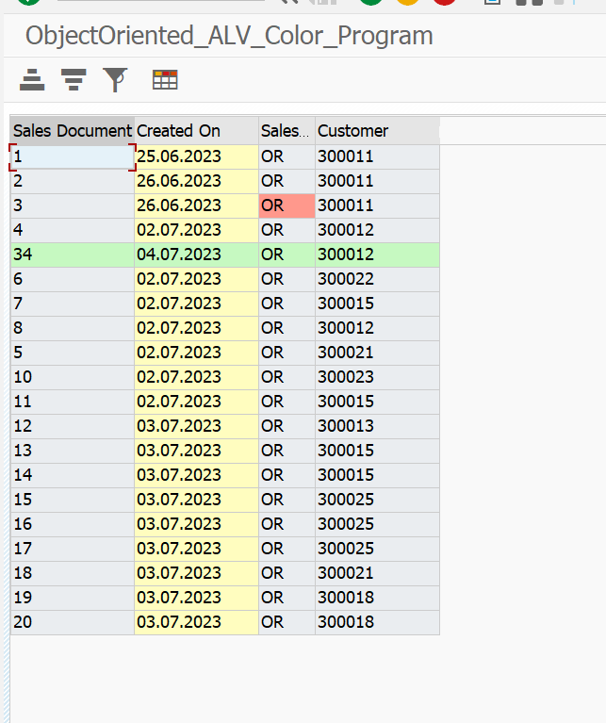

REPORT: ZJANA_REUSE_ALV

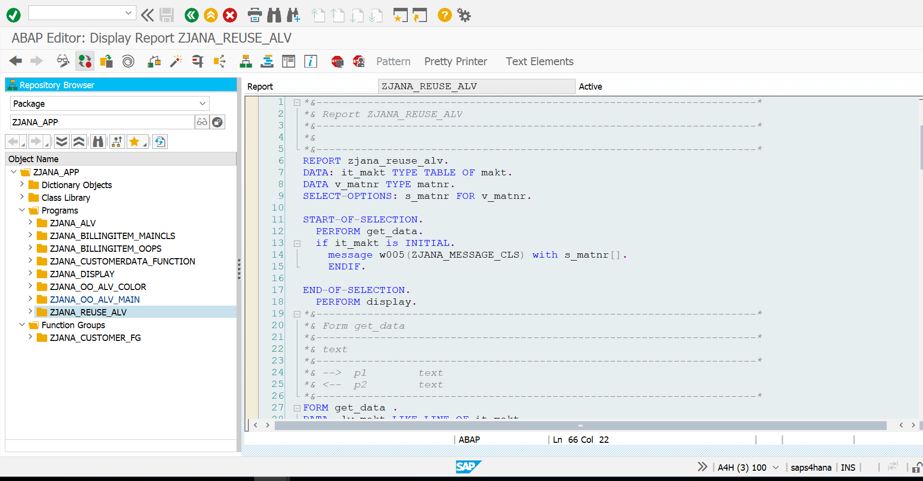

*\*&---------------------------------------------------------------------\**  
*\*& Report ZJANA_REUSE_ALV*  
*\*&---------------------------------------------------------------------\**  
*\*&*  
*\*&---------------------------------------------------------------------\**  
REPORT zjana_reuse_alv.  
DATA: it_makt TYPE TABLE OF makt.  
DATA v_matnr TYPE matnr.  
SELECT-OPTIONS: s_matnr FOR v_matnr.  
  
START-OF-SELECTION.  
 PERFORM get_data.  
 if it_makt is INITIAL.  
 message w005(ZJANA_MESSAGE_CLS) with s_matnr[].  
 ENDIF.  
  
END-OF-SELECTION.  
 PERFORM display.  
*\*&---------------------------------------------------------------------\**  
*\*& Form get_data*  
*\*&---------------------------------------------------------------------\**  
*\*& text*  
*\*&---------------------------------------------------------------------\**  
*\*& --> p1 text*  
*\*& <-- p2 text*  
*\*&---------------------------------------------------------------------\**  
FORM get_data .  
DATA lw_makt LIKE LINE OF it_makt.  
  
 select * FROM makt into table it_makt where matnr in s_matnr.  
  
LOOP AT it_makt into lw_makt.  
  
 CALL FUNCTION 'CONVERSION_EXIT_MATN1_OUTPUT'  
 EXPORTING  
 input = lw_makt-matnr  
 IMPORTING  
 OUTPUT = lw_makt-matnr  
 .  
MODIFY it_makt FROM lw_makt INDEX sy-tabix.  
 ENDLOOP.  
 *"SELECT * FROM mard INTO TABLE it_mard FOR ALL ENTRIES IN it_makt WHERE matnr EQ it_makt-matnr.*  
  
ENDFORM.  
*\*&---------------------------------------------------------------------\**  
*\*& Form display*  
*\*&---------------------------------------------------------------------\**  
*\*& text*  
*\*&---------------------------------------------------------------------\**  
*\*& --> p1 text*  
*\*& <-- p2 text*  
*\*&---------------------------------------------------------------------\**  
FORM display .  
 Data: lt_fcat type SLIS_T_FIELDCAT_ALV,  
 lw_fcat like LINE OF lt_fcat.  
  
 lw_fcat-col_pos = 1.  
 lw_fcat-fieldname = 'MATNR'.  
 lw_fcat-tabname = 'IT_MAKT'.  
 lw_fcat-seltext_m = 'Material Number'.  
 lw_fcat-outputlen = 20.  
 lw_fcat-edit_mask = '==MATN1'.  
 APPEND lw_fcat to lt_fcat.  
  
  
 lw_fcat-col_pos = 1.  
 lw_fcat-fieldname = 'SPRAS'.  
 lw_fcat-tabname = 'IT_MAKT'.  
 lw_fcat-seltext_m = 'LANGUAGE'.  
 lw_fcat-outputlen = 15.  
 lw_fcat-edit_mask = '==ISOLA'.  
 APPEND lw_fcat to lt_fcat.  
 clear lw_fcat.  
  
lw_fcat-col_pos = 1.  
 lw_fcat-fieldname = 'MAKTX'.  
 lw_fcat-tabname = 'IT_MAKT'.  
 lw_fcat-seltext_m = 'Material Description'.  
 lw_fcat-outputlen = 20.  
*\* lw_fcat-edit_mask = '==ISOLA'.*  
 APPEND lw_fcat to lt_fcat.  
  
  
  
 CALL FUNCTION 'REUSE_ALV_GRID_DISPLAY'  
 EXPORTING  
*\* I_INTERFACE_CHECK = ' '*  
*\* I_BYPASSING_BUFFER = ' '*  
*\* I_BUFFER_ACTIVE = ' '*  
 I_CALLBACK_PROGRAM = 'ZJANA_REUSE_ALV'  
 I_CALLBACK_PF_STATUS_SET = 'ZJANA_PF_STATUS'  
 I_CALLBACK_USER_COMMAND = 'USER_COMMAND '  
*\* I_CALLBACK_TOP_OF_PAGE = ' '*  
*\* I_CALLBACK_HTML_TOP_OF_PAGE = ' '*  
*\* I_CALLBACK_HTML_END_OF_LIST = ' '*  
*\* I_STRUCTURE_NAME = 'MAKT'*  
*\* I_BACKGROUND_ID = ' '*  
*\* I_GRID_TITLE =*  
*\* I_GRID_SETTINGS =*  
*\* IS_LAYOUT =*  
 IT_FIELDCAT = lt_fcat  
*\* IT_EXCLUDING =*  
*\* IT_SPECIAL_GROUPS =*  
*\* IT_SORT =*  
*\* IT_FILTER =*  
*\* IS_SEL_HIDE =*  
*\* I_DEFAULT = 'X'*  
*\* I_SAVE = ' '*  
*\* IS_VARIANT =*  
*\* IT_EVENTS =*  
*\* IT_EVENT_EXIT =*  
*\* IS_PRINT =*  
*\* IS_REPREP_ID =*  
*\* I_SCREEN_START_COLUMN = 0*  
*\* I_SCREEN_START_LINE = 0*  
*\* I_SCREEN_END_COLUMN = 0*  
*\* I_SCREEN_END_LINE = 0*  
*\* I_HTML_HEIGHT_TOP = 0*  
*\* I_HTML_HEIGHT_END = 0*  
*\* IT_ALV_GRAPHICS =*  
*\* IT_HYPERLINK =*  
*\* IT_ADD_FIELDCAT =*  
*\* IT_EXCEPT_QINFO =*  
*\* IR_SALV_FULLSCREEN_ADAPTER =*  
*\* O_PREVIOUS_SRAL_HANDLER =*  
*\* IMPORTING*  
*\* E_EXIT_CAUSED_BY_CALLER =*  
*\* ES_EXIT_CAUSED_BY_USER =*  
 TABLES  
 t_outtab = it_makt  
 EXCEPTIONS  
 PROGRAM_ERROR = 1  
 OTHERS = 2  
 .  
 IF sy-subrc <> 0.  
*\* Implement suitable error handling here*  
 ENDIF.  
ENDFORM.  
  
FORM USER_COMMAND USING r_ucomm LIKE sy-ucomm  
 rs_selfield TYPE slis_selfield.  
  
IF r_ucomm EQ '&IC1' AND rs_selfield-fieldname EQ 'MATNR' .  
 SET PARAMETER ID 'MAT' FIELD rs_selfield-value.  
 CALL TRANSACTION 'MM03'.  
  
ENDIF.  
ENDFORM.  
  
FORM ZJANA_PF_STATUS USING rt_extab TYPE slis_t_extab.  
 SET PF-STATUS 'STANDARD_FULLSCREEN'.  
  
ENDFORM.

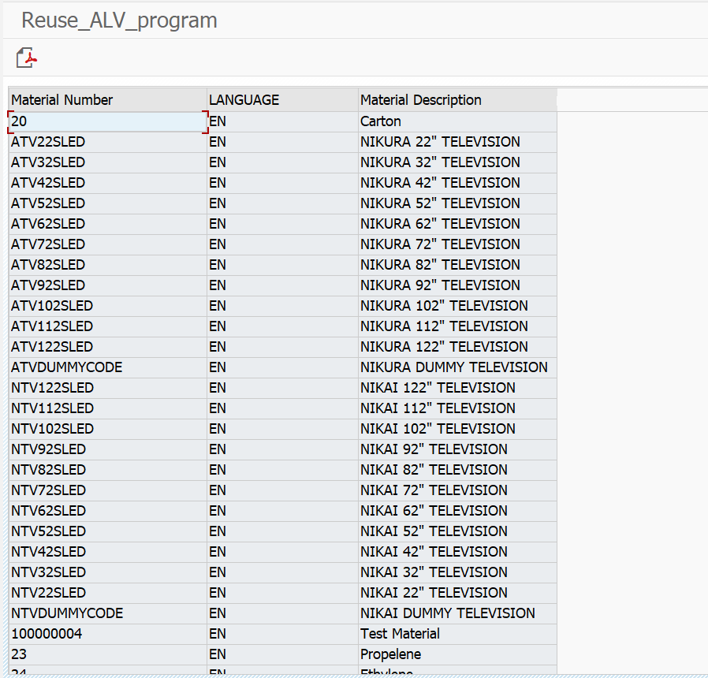

Program: ZJANA_OO_ALV_MAIN

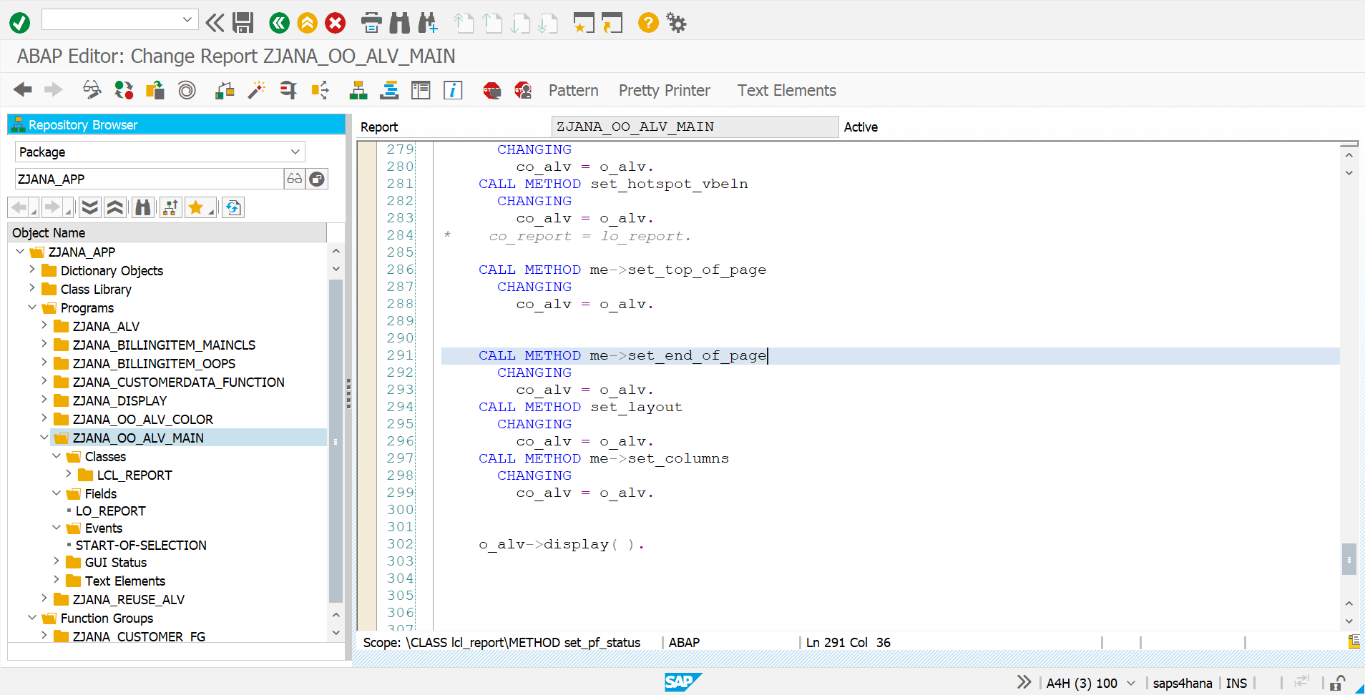

*\*&---------------------------------------------------------------------\**  
*\*& Report ZJANA_OO_ALV_MAIN*  
*\*&---------------------------------------------------------------------\**  
*\*&*  
*\*&---------------------------------------------------------------------\**  
REPORT zjana_oo_alv_main.  
  
CLASS lcl_report DEFINITION.  
  
 PUBLIC SECTION.  
  
 TYPES:BEGIN OF ty_vbak,  
 vbeln TYPE vbak-vbeln,  
 erdat TYPE vbak-erdat,  
 auart TYPE vbak-auart,  
 kunnr TYPE vbak-kunnr,  
  
 END OF ty_vbak.  
  
 DATA: t_vbak TYPE STANDARD TABLE OF ty_vbak.  
  
  
  
  
 *" alv reference*  
 DATA o_alv TYPE REF TO cl_salv_table.  
  
  
  
 METHODS:  
 get_data,  
 generate_output.  
  
 PROTECTED SECTION.  
  
 PRIVATE SECTION.  
 METHODS:  
  
 set_pf_status  
  
 CHANGING  
 co_alv TYPE REF TO cl_salv_table.  
  
  
 METHODS:  
 set_top_of_page  
  
 CHANGING  
 co_alv TYPE REF TO cl_salv_table.  
  
 METHODS:  
 set_end_of_page  
 CHANGING  
 co_alv TYPE REF TO cl_salv_table.  
  
 METHODS:  
 set_layout  
 CHANGING  
 co_alv TYPE REF TO cl_salv_table.  
 METHODS:  
 set_display_setting  
 CHANGING co_alv TYPE REF TO cl_salv_table.  
  
 METHODS:  
 set_columns  
 CHANGING  
 co_alv TYPE REF TO cl_salv_table.  
  
 METHODS:  
 set_hotspot_vbeln  
 CHANGING  
 co_alv TYPE REF TO cl_salv_table.  
*\* co_report TYPE REF TO lcl_report.*  
  
 METHODS:  
 on_link_click  
 FOR EVENT link_click OF cl_salv_events_table  
 IMPORTING  
 row  
 column.  
  
  
  
ENDCLASS.  
  
CLASS lcl_report IMPLEMENTATION.  
  
 METHOD set_pf_status.  
  
 DATA:lo_functions TYPE REF TO cl_salv_functions_list.  
 lo_functions = co_alv->get_functions( ).  
 lo_functions->set_default( abap_true ).  
  
 co_alv->set_screen_status(  
 report = 'SALV_DEMO_TABLE_SELECTIONS'  
 pfstatus = 'SALV_STANDARD'  
set_functions = co_alv->c_functions_all ).  
 ENDMETHOD.  
  
 METHOD set_columns.  
  
 DATA:lo_cols TYPE REF TO cl_salv_columns.  
 lo_cols = o_alv->get_columns( ).  
  
  
 lo_cols->set_optimize( 'X' ).  
  
 DATA: lo_column TYPE REF TO cl_salv_column.  
  
 TRY.  
  
 lo_column = lo_cols->get_column( 'KUNNR').  
 lo_column->set_long_text( 'SOLD-to party').  
 lo_column->set_medium_text( 'SOLD-to Party').  
 lo_column->set_short_text( 'SOLD-TO').  
 lo_column->set_output_length( 10 ).  
 CATCH cx_salv_not_found.  
  
 ENDTRY.  
 ENDMETHOD.  
  
 METHOD SET_DISPLAY_setting.  
 DATA: lo_display TYPE REF TO cl_salv_display_settings.  
  
 lo_display = co_alv->get_display_settings( ).  
 lo_display->set_striped_pattern( 'X' ).  
 lo_display->set_list_header(' ALV Test for display settings' ).  
  
 ENDMETHOD.  
  
 METHOD set_hotspot_vbeln.  
  
 DATA: lo_cols_tab TYPE REF TO cl_salv_columns_table,  
 lo_col_tab TYPE REF TO cl_salv_column_table.  
  
 lo_cols_tab = co_alv->get_columns( ).  
  
 TRY.  
  
 lo_col_tab ?= lo_cols_tab->get_column( 'VBELN').  
 CATCH cx_salv_not_found.  
 ENDTRY.  
  
  
  
 TRY.  
 CALL METHOD lo_col_tab->set_cell_type  
 EXPORTING  
 value = if_salv_c_cell_type=>hotspot.  
 CATCH cx_salv_data_error.  
 ENDTRY.  
*\* DATA: lo_events TYPE REF TO cl_salv_events_table.*  
*\* lo_events = o_alv->get_event( ).*  
*\* SET HANDLER co_report->on_link_click for lo_events.*  
 ENDMETHOD.  
  
 METHOD on_link_click.  
DATA: lo_report TYPE REF TO lcl_report.  
 DATA: la_vbak TYPE ty_vbak.  
  
  
 READ TABLE lo_report->t_vbak INTO la_vbak INDEX row.  
 IF la_vbak-vbeln IS NOT INITIAL.  
 MESSAGE i398(00) WITH 'you have selected' la_vbak-vbeln.  
 ENDIF.  
 ENDMETHOD.  
  
  
  
  
METHOD set_top_of_page.  
 DATA: lo_header TYPE REF TO cl_salv_form_layout_grid,  
 lo_h_label TYPE REF TO cl_salv_form_label,  
 lo_h_flow TYPE REF TO cl_salv_form_layout_flow.  
  
  
 *"header object.*  
 CREATE OBJECT lo_header.  
  
  
 lo_h_label = lo_header->create_label( row = 1 column = 1 ).  
 lo_h_label->set_text('Header in Bold').  
  
 lo_h_flow = lo_header->create_flow( row = 2 column = 1 ).  
 lo_h_flow->create_text( text = 'this is text of flow' ).  
  
 lo_h_flow = lo_header->create_flow( row = 3 column = 1 ).  
 lo_h_flow->create_text( text = ' Number of Records in the output ').  
  
 lo_h_flow = lo_header->create_flow( row = 3 column = 2 ).  
 lo_h_flow->create_text( text = 20 ).  
  
 co_alv->set_top_of_list( lo_header ).  
 co_alv->set_top_of_list_print( lo_header ).  
  
  
ENDMETHOD.  
  
METHOD set_end_of_page.  
 DATA: lo_footer TYPE REF TO cl_salv_form_layout_grid,  
 lo_f_label TYPE REF TO cl_salv_form_label,  
 lo_f_flow TYPE REF TO cl_salv_form_layout_flow.  
  
 CREATE OBJECT lo_footer.  
  
  
  
 lo_f_label = lo_footer->create_label( row = 1 column = 1 ).  
 lo_f_label->set_text( 'Footer ..here it goes' ).  
  
  
 lo_f_flow = lo_footer->create_flow( row = 2 column = 1 ).  
 lo_f_flow->create_text( text = 'this is the text of the flow in footer').  
  
  
 lo_f_flow = lo_footer->create_flow( row = 3 column = 1 ).  
 lo_f_flow->create_text( text = 'Footer Number').  
  
  
  
 lo_f_flow = lo_footer->create_flow( row = 3 column = 2 ).  
 lo_f_flow->create_text( text = 1 ).  
  
 co_alv->set_end_of_list( lo_footer ).  
 co_alv->set_end_of_list_print( lo_footer ).  
  
  
ENDMETHOD.  
  
  
  
METHOD set_layout.  
*\**  
 DATA: lo_layout TYPE REF TO cl_salv_layout,  
 lf_variant TYPE slis_vari,  
 ls_key TYPE salv_s_layout_key.  
*\**  
*\* get layout object*  
 lo_layout = co_alv->get_layout( ).  
*\**  
*\* set Layout save restriction*  
*\* 1. Set Layout Key .. Unique key identifies the Differenet ALVs*  
 ls_key-report = sy-repid.  
 lo_layout->set_key( ls_key ).  
*\* 2. Remove Save layout the restriction.*  
 lo_layout->set_save_restriction( if_salv_c_layout=>restrict_none ).  
*\**  
*\* set initial Layout*  
 lf_variant = 'DEFAULT'.  
 lo_layout->set_initial_layout( lf_variant ).  
*\**  
ENDMETHOD.  
METHOD get_data.  
 SELECT vbeln erdat auart kunnr INTO TABLE t_vbak FROM vbak UP TO 20 ROWS.  
 ENDMETHOD.  
  
 METHOD generate_output.  
 DATA: lx_msg TYPE REF TO cx_salv_msg.  
  
  
 TRY.  
  
 cl_salv_table=>factory(  
 IMPORTING  
  
 r_salv_table = o_alv  
 CHANGING  
 t_table = t_vbak  
  
 ).  
  
  
 CATCH cx_salv_msg INTO lx_msg.  
 ENDTRY.  
 CALL METHOD set_pf_status  
 CHANGING  
 co_alv = o_alv.  
 CALL METHOD set_display_setting  
 CHANGING  
 co_alv = o_alv.  
 CALL METHOD set_hotspot_vbeln  
 CHANGING  
 co_alv = o_alv.  
*\* co_report = lo_report.*  
  
 CALL METHOD me->set_top_of_page  
 CHANGING  
 co_alv = o_alv.  
  
  
 CALL METHOD me->set_end_of_page  
 CHANGING  
 co_alv = o_alv.  
 CALL METHOD set_layout  
 CHANGING  
 co_alv = o_alv.  
 CALL METHOD me->set_columns  
 CHANGING  
 co_alv = o_alv.  
  
  
 o_alv->display( ).  
  
  
  
  
  
 ENDMETHOD.  
  
  
ENDCLASS.  
  
  
  
 DATA: lo_report TYPE REF TO lcl_report.  
START-OF-SELECTION.  
 CREATE OBJECT lo_report.  
 lo_report->get_data( ).  
 lo_report->generate_output( ).

